For the interface as below:

1. Display initialization

Discount Percent, Discount Amount, Invoice Total disable(User can’t input value) and all have value = 0.00

1. Click button Caculate

Display value Subtotal, Percent, Amount, Total.

(Total = Subtotal * Percent – Amount)

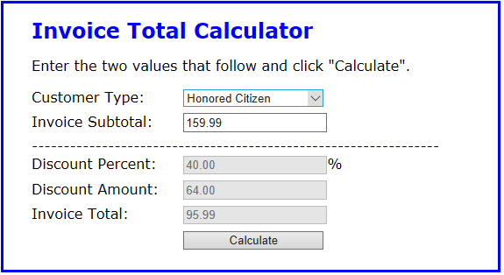

1. **Detail**

**3.0** Invoice SubTotal

**3.0.1** Case value input < 10000

amount is 0,

percent = 10%

**3.0.2** Otherwise based for the selection of **Customer Type**

**3.1 Customer Type**

**3.1.1** Include option : Lay, Honer and Orther

**3.1.2** Case user choise   
**+)** Lay :

amount is 200,

percent = 10% (if subtotal input <15000)

percent = 15% (if otherwise)

**+)** Honer :

amount is 300,

percent = 15%(subtotal input < 15000)

percent = 20%(otherwise)

**+)** Other :

percent = 15%,

Discount Amount : User can input value, value input The input value cannot be empty and < 500