

Programming HTML with JavaScript/Jquery with the following requirements:

Có sẵn acc :

User Name : admin

Pass : admin

Ngược lại 🡪 sang trang index.html

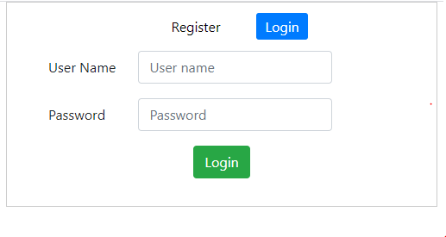

Trường hợp login thành công tới màn hình sau :

Design a web page (*manage_user.html*) which

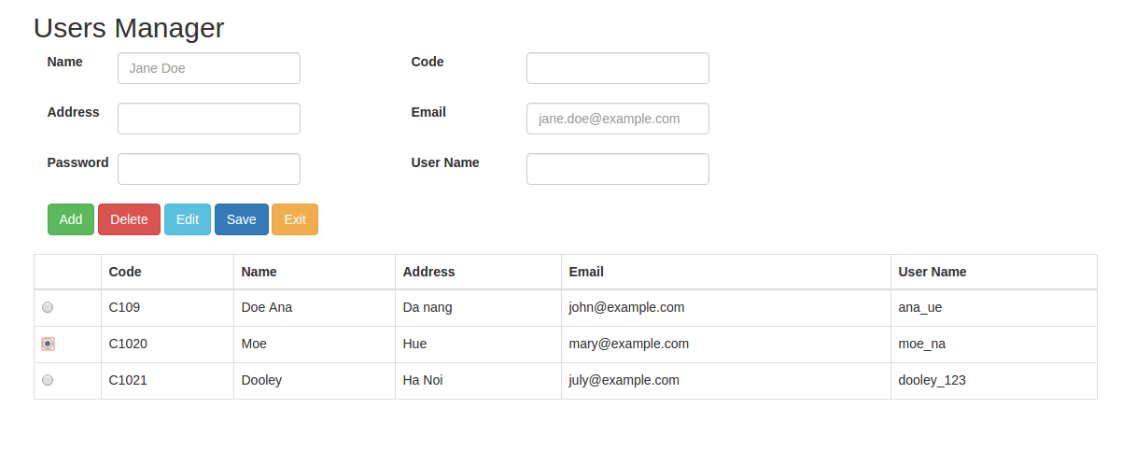

***More details:***

1. Create form and table users list.

2. Create array users ( array of object)

3. User jquery or javascript validate input:

- Name: not be empty and greater than 5 characters

- Code: not be empty and greater than 3 characters

- Email: not be empty and correct format email

4. Add new function by clicking ‘Add’ button. by that, all contents in input of the form will be deleted and focus into input name. Then enter the data and save to create new user, and show the user created in the table

5. To implement deleting function: click ‘Radio’ at corresponding user, click ‘Delete’ button to delete. If user is not selected, please notify the user before selecting

6. To implement editing function: click ‘Radio’ button at the corresponding user. Press ‘Edit’ to show the data on the form, then edit the information, and click ‘Save’ to save information