**Low-cost Swap Station**

**Overall Aim:** Identifying and tracking 3D object with an existing database.

**Structure**: The system includes an inspection area with at least one camera and a plurality of electrical connectors in order to perform a visual analysis and an electrical analysis of the mobile telephone for determination of a value of the electronic device

* We are developing systems and methods for identifying, tracking, tracing and determining the authenticity of an item. The imaging system is configured to capture an image of a unique signature associated with a item.
* The unique signature can be, for example, a random structure or pattern unique to the particular item. The imaging system is configured to process the image to identify at least one metric that distinguishes the unique signature from unique signatures of other goods.
* The database is configured to receive information related to the good and its unique signature from the imaging system, and to store the information therein.
* The authentication center is configured to analyze the field image with respect to the information stored in the database to determine whether the unique signature in the field image is a match to the captured image stored in the database.

**APPARATUS:**

**FEASIBILITY TEST:**

**3D TRIANGULATION LASER SCANNERS**: These scanners are anywhere between $15k to $60k. Laser triangulation scanners use either a laser line or single laser point to scan across an object. A sensor picks up the laser light that is reflected off the object, and using trigonometric triangulation, the system calculates the distance from the object to the scanner. The distance between the laser source and the sensor is known very precisely, as well as the angle between the laser and the sensor. As the laser light reflects off the scanned object, the system can discern what angle it is returning to the sensor at, and therefore the distance from the laser source to the object’s surface.

* **ARRAY OF LOGITECH C615 HD CAMERAS:** An array of up to 10 HD CAMERAS would be used by using a different slightly different approach. By generating a brightness histogram from imagery produced by each camera, we can look for signatures, which are similar to the 3D laser scanner. This is being coupled with a depth camera (from a kinect sensor) to get the depth impression of the device in the container. These cameras cost $56 each giving us the maximum price of $620 for the scanning system.

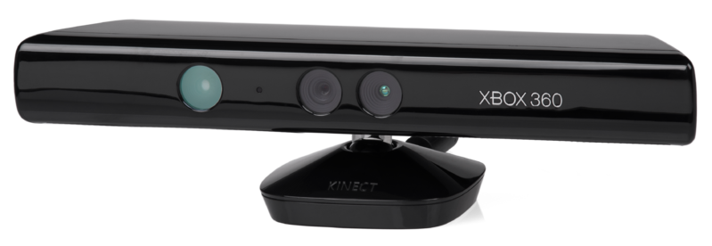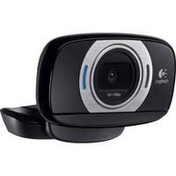

To sum up, the array of cameras is an economical replacement for the purpose of scanning small electronic devices such as phones.

**DEVICE IDENTIFICATION AND TRACKING:**

1. **Location detection from image data:**

Location detection apparatus consists of the following:

* Image capturing module
* Weight assignment module
* Processing module

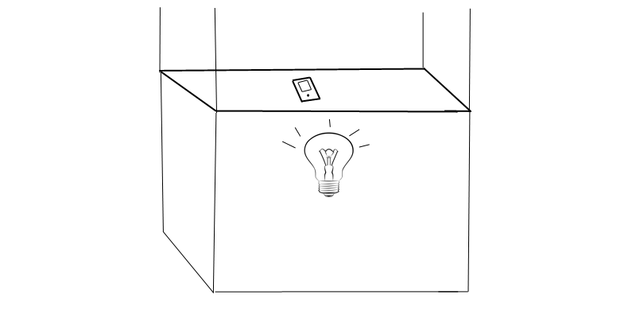

**IMAGE CAPTURING MODULE:** An Array of 10 equidistant cameras is hooked to the walls of the container box. The device is placed onto a white canvas with a light source at the back. The canvas is illuminated at the time of image detection, which creates a sharp pixel boundary, which separates the phone and its surroundings. An overhead camera captures the canvas in a single frame.

**WEIGHT ASSIGNMENT MODULE:** The weight assignment module performs the pixel weight distribution probability assignment according to image, and figures out the initial gravity center of the object according to the object location initialization.

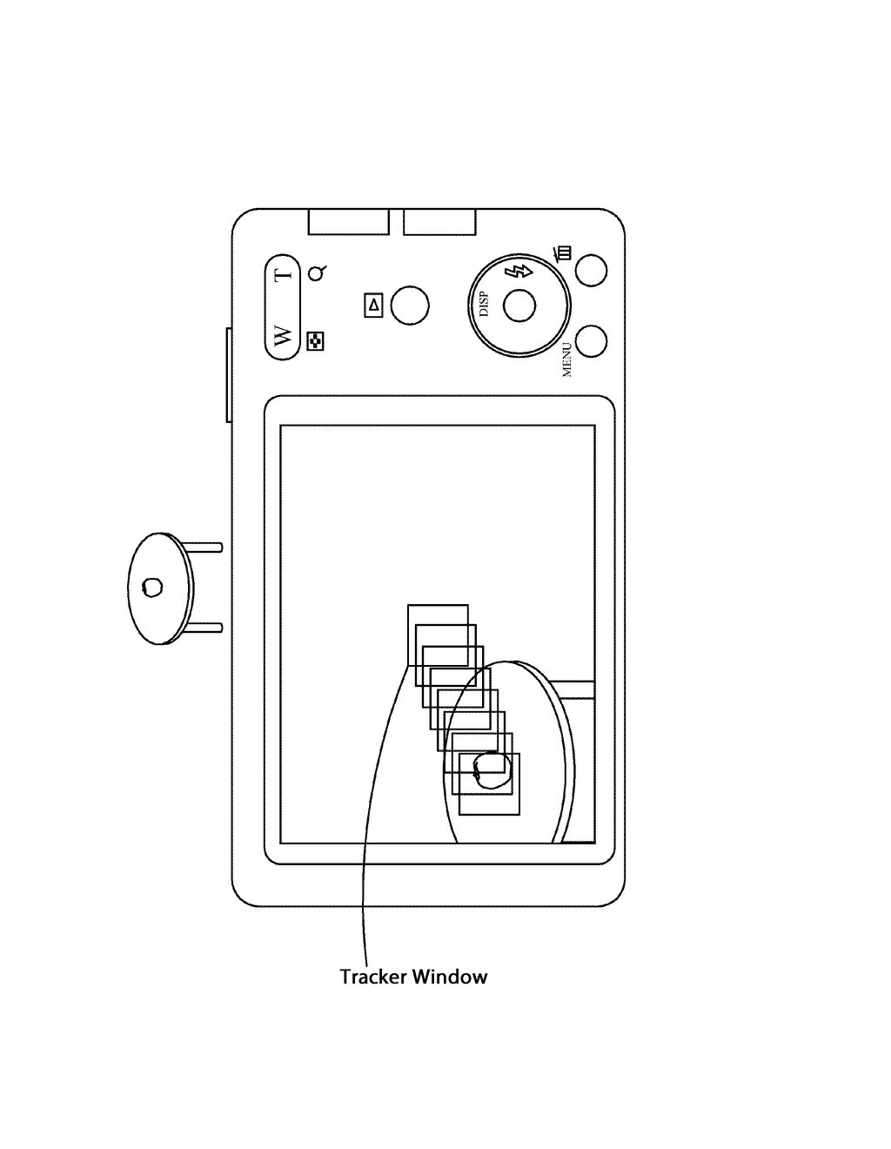

**PROCESSING MODULE:** The processing module performs the statistical analysis according to the result of the pixel weight/probability assignment and the initial gravity center of the object so as to obtain the analysis result and update the object location. The processing module determines whether or not the analysis result meets the preset value, if it does, the processing module outputs an estimated result; if it doesn't, the processing module repeats the ongoing processes.

**The image capturing module captures image data.**

**Location of the object on the canvas is determined. i.e. The center of gravity of the object to be identified is determined.**

**The weight assignment module converts the image data of detected object into a probability distribution function (weight value is assigned according to color values, edge orientation)**

**The processing module determines whether or not the possible location and the gravity center coordinate of object to be detected matches a present value.**

**Estimated result is generated!**

**II. IMAGE ANALYSIS ALGORITHM:**

Our method generates an integral image based on the input image. Then the image is split into portions. For each new portion a definite integral corresponding to the portion is computed using an integral image. Based on the definite integrals a new portion is chosen for splitting. The new portion is processed correspondingly and the processing is repeated until a termination condition is reached.

Let’s x1,y1 and x2,y2 and coordinates of the corner of a rectangular grid of pixels. Then, definite integral of this area is determined by

**ii(x2,y2)-ii(x1,y2)-ii(x2,y1- )+ii(x1,y1)**

where i1(x,y).

**COST ESTIMATES**

|  |  |  |
| --- | --- | --- |
| **Item** | **Quantity** | **Cost** |
| **Cameras** | **10** | **560** |
| **Kinect** | **1** | **70** |
| **Cage** | **1** | **450** |
| **Card Swipe Reader** | **1** | **150** |

**Total Cost = $1220**