**virsh命令详解**

编 写 人：孙自翔、赵王军

统 稿 人：

编写时间：2014-06-6

部 门 名：

审 核 人：

审核时间：

修订记录

|  |  |  |  |  |
| --- | --- | --- | --- | --- |
| 编号 | 修订内容简述 | 修订日期 | 版本 | 修订人 |
| 1 | 初稿 | 2014-06-12 | 0.1 | 孙自翔 |
| 2 | 修改 |  |  |  |
|  |  |  |  |  |

正文目录

1 文档说明 4

1.1 本文档目的 4

1.2 本文档不涉及 4

1.3 更进一步（最终目的） 4

2 libvirt 4

2.1 libvirt 4

2.2 安装包 4

2.3 virsh 4

3 virsh命令行 5

3.1 定义并启动实例 5

3.2 创建实例 5

3.3 销毁实例 6

3.4 重启实例 6

3.5 undefine实例 6

3.6 查看实例 6

3.7 查看实例xml信息 6

3.8 暂停/恢复实例 6

3.9 vncdisplay 7

3.10 挂载/卸载盘 7

3.11 卸载挂载设备 7

3.12 挂载/卸载网卡 8

3.13 调整io 8

3.14 TODO 9

4 注意事项 10

5 参考文献 10

# 文档说明

virsh是libvirt的命令行接口。

## 本文档目的

熟悉virsh命令的大部分功能,并实例演示.

## 本文档不涉及

* 文档不涉及libvirt编程接口

## 更进一步（最终目的）

* libvirt编程接口
* TODO

# libvirt

libvirt

## libvirt

libvirt is an [open source](http://en.wikipedia.org/wiki/Open_source) [API](http://en.wikipedia.org/wiki/Application_programming_interface), [daemon](http://en.wikipedia.org/wiki/Daemon_%28computer_software%29) and management tool for managing [platform virtualization](http://en.wikipedia.org/wiki/Platform_virtualization).[[1]](http://en.wikipedia.org/wiki/Libvirt#cite_note-1) It can be used to manage [KVM](http://en.wikipedia.org/wiki/Kernel-based_Virtual_Machine), [Xen](http://en.wikipedia.org/wiki/Xen), [VMware ESX](http://en.wikipedia.org/wiki/VMware_ESX), [QEMU](http://en.wikipedia.org/wiki/QEMU) and other virtualization technologies. These APIs are widely used in the orchestration layer of [hypervisors](http://en.wikipedia.org/wiki/Hypervisor) in the development of a cloud-based solution.vlan概述.

TODO

## 安装包

TODO

## virsh

virsh是什么，可以做什么?

# virsh命令行

下文中用的的xml文件为

**/home /libvirt# cat standard.xml**

**<domain type='kvm'>**

**<name>test-ubuntu-10.04</name>**

**<memory unit='KiB'>2194304</memory>**

**<currentMemory unit='KiB'>2194304</currentMemory>**

**<vcpu placement='static'>1</vcpu>**

**<os>**

**<type arch='x86_64' machine='pc-1.1'>hvm</type>**

**<boot dev='hd'/>**

**</os>**

**<features>**

**<acpi/>**

**</features>**

**<on_poweroff>destroy</on_poweroff>**

**<on_reboot>restart</on_reboot>**

**<on_crash>destroy</on_crash>**

**<devices>**

**<emulator>/usr/bin/kvm</emulator>**

**<disk type='file' device='disk'>**

**<driver name='qemu' type='qcow2' cache='none'/>**

**<source file='/data/vm/ubuntu-10.04.4-server-amd64.qcow2'/>**

**<target dev='vda' bus='virtio'/>**

**</disk>**

**<input type='tablet' bus='usb'>**

**<alias name='input0'/>**

**</input>**

**<input type='mouse' bus='ps2'/>**

**<graphics type='vnc' port='5900' autoport='yes' listen='0.0.0.0' keymap='en-us'>**

**</graphics>**

**</devices>**

**</domain>**

## 定义并启动实例

virsh help define、virsh help start

先定义再启动实例。

/home/libvirt# virsh define standard.xml #定义实例

Domain test-ubuntu-10.04 defined from standard.xml

/home//libvirt# virsh list -–all # 查看定义的实例

- test-ubuntu-10.04 shut off

/home//libvirt# virsh start test-ubuntu-10.04 # 启动实例

Domain test-ubuntu-10.04 started

这种方式启动的实例，destroy之后通过virsh list -–all仍然能够看到实例。

## 创建实例

和先定义再启动实例不同，创建实例直接定义并启动实例。但是destroy的时候，实例直接销毁。

virsh help create

/home//libvirt# # virsh create standard.xml

Domain test-ubuntu-10.04 created from standard.xml

## 销毁实例

/home//libvirt# virsh help destroy

NAME

destroy - destroy (stop) a domain

SYNOPSIS

destroy <domain> [--graceful]

DESCRIPTION

Forcefully stop a given domain, but leave its resources intact.

OPTIONS

[--domain] <string> domain name, id or uuid

--graceful terminate gracefully

/home//libvirt# virsh destroy test-ubuntu-10.04

Domain test-ubuntu-10.04 destroyed

## 重启实例

virsh help reboot

reboot。TODO：

## undefine实例

TODO

virsh help reboot

## 查看实例

TODO virst help list

## 查看实例xml信息

TODO virsh help dumpxml

## 暂停/恢复实例

TODO:解释一下暂停的概念.

virsh help susupend;virsh help resume

/home//libvirt# virsh suspend test-ubuntu-10.04

Domain test-ubuntu-10.04 suspended

/home//libvirt# virsh resume test-ubuntu-10.04

Domain test-ubuntu-10.04 resumed

## vncdisplay

打印vnc端口号

virsh help vncdisplay

/home//libvirt# virsh vncdisplay test-ubuntu-10.04

:34

## 挂载/卸载盘

virsh help attach-disk

/home//libvirt# qemu-img create -f raw /tmp/test.img 100M # 创建镜像

/home//libvirt# virsh attach-disk test-ubuntu-10.04 /tmp/test.img vdc # 挂载盘

虚拟机中看到的盘和实际的盘符可能不一致。

## 卸载挂载设备

挂载块设备。

/home//libvirt# cat attach-device.xml

<disk type='block' device='disk'>

<driver name='qemu' type='raw' cache='none'/>

<source dev='/dev/loop0'/>

<target dev='vdd' bus='virtio'/>

<address type='drive' controller='0' bus='0' target='0' unit='1'/>

</disk>

/home//libvirt#virsh attach-device test-ubuntu-10.04 attach-device.xml

Device attached successfully

然后查看虚拟机中的设备，如果看不到，需要重启

/home//libvirt# virsh detach-device test-ubuntu-10.04 attach-device.xml

Device detached successfully

挂载网卡

/home//libvirt# cat attach-net.xml

<interface type='bridge'>

<mac address='fa:16:3e:70:f0:1d'/>

<source bridge='br100'/>

<target dev='vnet50'/>

<model type='virtio'/>

</interface>

/home//libvirt# virsh attach-device test-ubuntu-10.04 attach-device.xml

Device attached successfully

然后查看虚拟机中的设备，如果看不到，需要重启

/home//libvirt# virsh detach-device test-ubuntu-10.04 attach-net.xml

Device detached successfully

## 挂载/卸载网卡

/home//libvirt# # virsh attach-interface test-ubuntu-10.04 bridge br100

Interface attached successfully

会看到一个设备,如果没有就重启

## 调整io

virsh help blkdeviotune

/home//libvirt# virsh blkdeviotune test-ubuntu-10.04 vdb --read-iops-sec 10 --write-iops-sec 15

虚拟机中看到的盘和实际的盘符可能不一致。

/home//libvirt# virsh help blkdeviotune

NAME

blkdeviotune - Set or query a block device I/O tuning parameters.

SYNOPSIS

blkdeviotune <domain> <device> [--total-bytes-sec <number>] [--read-bytes-sec <number>] [--write-bytes-sec <number>] [--total-iops-sec <number>] [--read-iops-sec <number>] [--write-iops-sec <number>] [--config] [--live] [--current]

DESCRIPTION

Set or query disk I/O parameters such as block throttling.

OPTIONS

[--domain] <string> domain name, id or uuid

[--device] <string> block device

--total-bytes-sec <number> total throughput limit in bytes per second

--read-bytes-sec <number> read throughput limit in bytes per second

--write-bytes-sec <number> write throughput limit in bytes per second

--total-iops-sec <number> total I/O operations limit per second

--read-iops-sec <number> read I/O operations limit per second

--write-iops-sec <number> write I/O operations limit per second

--config affect next boot

--live affect running domain

--current affect current domain。

## 虚拟机克隆

-o表示旧的虚拟机名称，-n表示新的虚拟机名称，-f表示新的虚拟机路径。

-o ORIGINAL_GUEST, --original=ORIGINAL_GUEST

Name of the original guest to be cloned. This guest must be shut off or paused since it is not possible to safely clone active guests at

this time.

首先暂停

root@10-120-120-15:/home/hzsunzixiang# virsh suspend test-ubuntu-10.04

Domain test-ubuntu-10.04 suspended

然后克隆

root@10-120-120-15:/home/hzsunzixiang# virt-clone --connect=qemu:///system -o test-ubuntu-10.04 -n test-ubuntu-10.04-clone -f /data/vm/ubuntu-clone

Cloning ubuntu-10.04.4-server-amd64.qcow2 | 406 MB 00:02

把克隆的虚拟机启动

Clone 'test-ubuntu-10.04-clone' created successfully.

root@10-120-120-15:/home/hzsunzixiang# virsh start test-ubuntu-10.04-clone

Domain test-ubuntu-10.04-clone started

把原来的虚拟机resume

root@10-120-120-15:/home/hzsunzixiang# virsh resume test-ubuntu-10.04

Domain test-ubuntu-10.04 resumed

root@10-120-120-15:/home/hzsunzixiang# virsh capabilities

-----------------------------------------------------------------------------------------------------------------------------------------------------------------------------

root@10-120-120-15:/home/hzsunzixiang# virsh help host

Host and Hypervisor (help keyword 'host'):

capabilities capabilities

connect (re)connect to hypervisor

freecell NUMA free memory

hostname print the hypervisor hostname

nodecpustats Prints cpu stats of the node.

nodeinfo node information

nodememstats Prints memory stats of the node.

nodesuspend suspend the host node for a given time duration

qemu-attach QEMU Attach

qemu-monitor-command QEMU Monitor Command

sysinfo print the hypervisor sysinfo

uri print the hypervisor canonical URI

version show version

root@10-120-120-15:/home/hzsunzixiang# virsh hostname

10-120-120-15

root@10-120-120-15:/home/hzsunzixiang# virsh sysinfo

root@10-120-120-15:/home/hzsunzixiang# virsh version

root@10-120-120-15:/home/hzsunzixiang# virsh uri

qemu:///system

root@10-120-120-15:/home/hzsunzixiang# virsh nodememstats

root@10-120-120-15:/home/hzsunzixiang# virsh nodeinfo

CPU model: x86_64

CPU(s): 24

CPU frequency: 1600 MHz

CPU socket(s): 1

Core(s) per socket: 6

Thread(s) per core: 2

NUMA cell(s): 2

Memory size: 66106228 KiB

root@10-120-120-15:/home/hzsunzixiang# virsh freecell

Total: 317732 KiB

-----------------------------------------------------------------------------------------------------------------------------------------------------------------------------

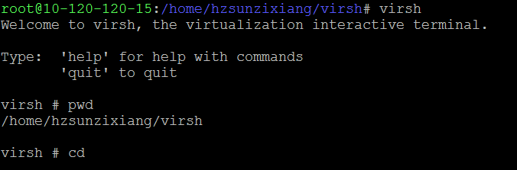

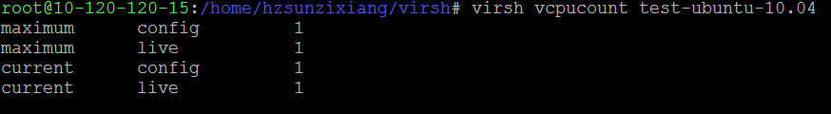

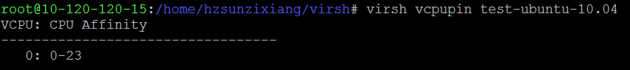





、

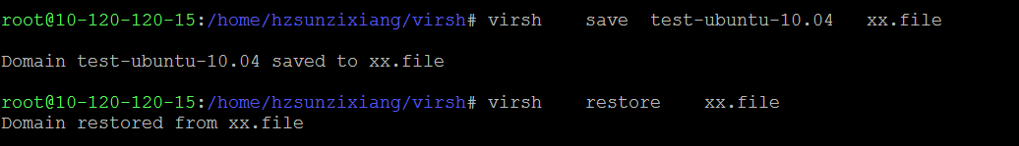

网络相关

Networking (help keyword 'network'):

net-autostart autostart a network

net-create create a network from an XML file

net-define define (but don't start) a network from an XML file

net-destroy destroy (stop) a network

net-dumpxml network information in XML

net-edit edit XML configuration for a network

net-info network information

net-list list networks

net-name convert a network UUID to network name

net-start start a (previously defined) inactive network

net-undefine undefine an inactive network

net-uuid convert a network name to network UUID

## TODO

包括但不限于下面

virsh help可以看到所有命令

dumpxml

create

start

destroy

define

virsh domid test-ubuntu-10.04domuuid

virsh dominfo test-ubuntu-10.04domname

virsh hostname

domstate

quit

reboot

restore

resume

save

shutdown

suspend

undefine

migrate

setmem

setmaxmem

setvcpus

vcpuinfo

vcpupin

domblkstat

domifstat

attach-device

attach-disk

attach-interface

detach-device

detach-disk

detach-interface

nodeinfo

# 注意事项

# 参考文献

<http://en.wikipedia.org/wiki/Libvirt>

<http://blog.sina.com.cn/s/blog_6cdb6ebc0101eacb.html>

<http://my.oschina.net/guol/blog/62253>

<http://blog.sina.com.cn/s/blog_6cdb6ebc0101eacb.html>