XIDIAN UNIVERSITY

SCHOOL OF COMPUTER SCIENCE AND TECHNOLOGY

Programming in Java

2019

Lab-1
Exercise:1: Name, Age, And Annual Income
Write a program that declares the following:
• a String variable named name
• an int variable named age
• a double variable named annualPay

Store your age, name, and desired annual income as literals in these variables. The program should display these values on the screen in a manner similar to the following:

My name is Joe Mahoney, my age is 26 and
I hope to earn $100000.0 per year.

Output
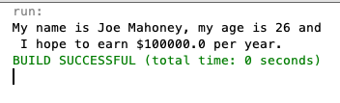

Exercise:2: Name and Initials
Write a program that has the following String variables: firstName, middleName, and lastName. Initialize these with your first, middle, and last names. The program should also have the following char variables: firstInitial, middleInitial, and lastInitial. Store your first, middle, and last initials in these variables. The program should display the contents of these variables on the screen.
[ Hint: firstInitial = firstName.charAt(0);]

Output
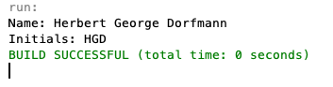

Exercise:3: Star Pattern
Write a program that displays the following pattern:
[Hint: Use Only System.out.println()]
*
***
*****
*******
*****
***
*
Exercise:4: Sales Prediction
The East Coast sales division of a company generates 62 percent of total sales. Based on that percentage, write a program that will predict how much the East Coast division will generate if the company has $4.6 million in sales this year. [Hint: Use the value 0.62 to represent 62 percent.]
Output
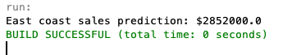
Exercise:5: Sales Tax
Write a program that will ask the user to enter the amount of a purchase. The program should then compute the state and county sales tax. Assume the state sales tax is 4 percent and the county sales tax is 2 percent. The program should display the amount of the purchase, the state sales tax, the county sales tax, the total sales tax, and the total of the sale (which is the sum of the amount of purchase plus the total sales tax). [Hint: Use the value 0.02 to represent 2 percent, and 0.04 to represent 4 percent.]
[Hint: Create a Scanner object for keyboard input.]

Output
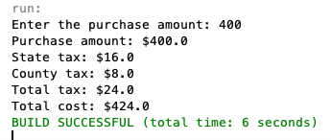

Exercise:6: String Manipulator
Write a program that asks the user to enter the name of his or her favorite city. Use a String variable to store the input. The program should display the following:
• The number of characters in the city name
• The name of the city in all uppercase letters [hint: toUpperCase()];
• The name of the city in all lowercase letters
• The first character in the name of the city

Output:
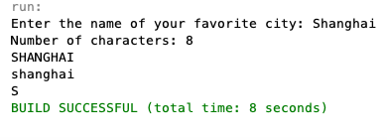

Exercise:7: Male and Female percentages
Write a program that asks the user for the number of males and the number of females regis- tered in a class. The program should display the percentage of males and females in the class.
Hint: Suppose there are 8 males and 12 females in a class. There are 20 students in the class. The percentage of males can be calculated as 8 /20 = 0.4, or 40%. The percentage of females can be calculated as 12/20 =0.6, or 60%.

Output
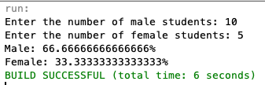

Exercise:8: Stock Transaction Program
Last month Joe purchased some stock in Acme Software, Inc. Here are the details of the purchase:
• The number of shares that Joe purchased was 1,000.
• When Joe purchased the stock, he paid $32.87 per share.
• Joe paid his stockbroker a commission that amounted to 2% of the amount he paid
for the stock.
Two weeks later Joe sold the stock. Here are the details of the sale:
- The number of shares that Joe sold was 1,000.
- He sold the stock for $33.92 per share.
- He paid his stockbroker another commission that amounted to 2% of the amount he
received for the stock.

Write a program that displays the following information:
• The amount of money Joe paid for the stock.
• The amount of commission Joe paid his broker when he bought the stock.
• The amount that Joe sold the stock for.
• The amount of commission Joe paid his broker when he sold the stock.
• Display the amount of profit that Joe made after selling his stock and paying the two
commissions to his broker. (If the amount of profit that your program displays is a negative number, then Joe lost money on the transaction.)

Output:

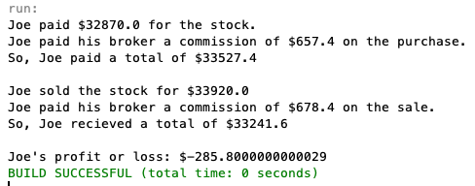

Deadline: 2019-11-05

