XIDIAN UNIVERSITY

SCHOOL OF COMPUTER SCIENCE AND TECHNOLOGY

Programming in Java
2019
Lab-1
[Student Number / Student Name(pinyin)]
Class [1/2]
Exercise:1: Name, Age, And Annual Income
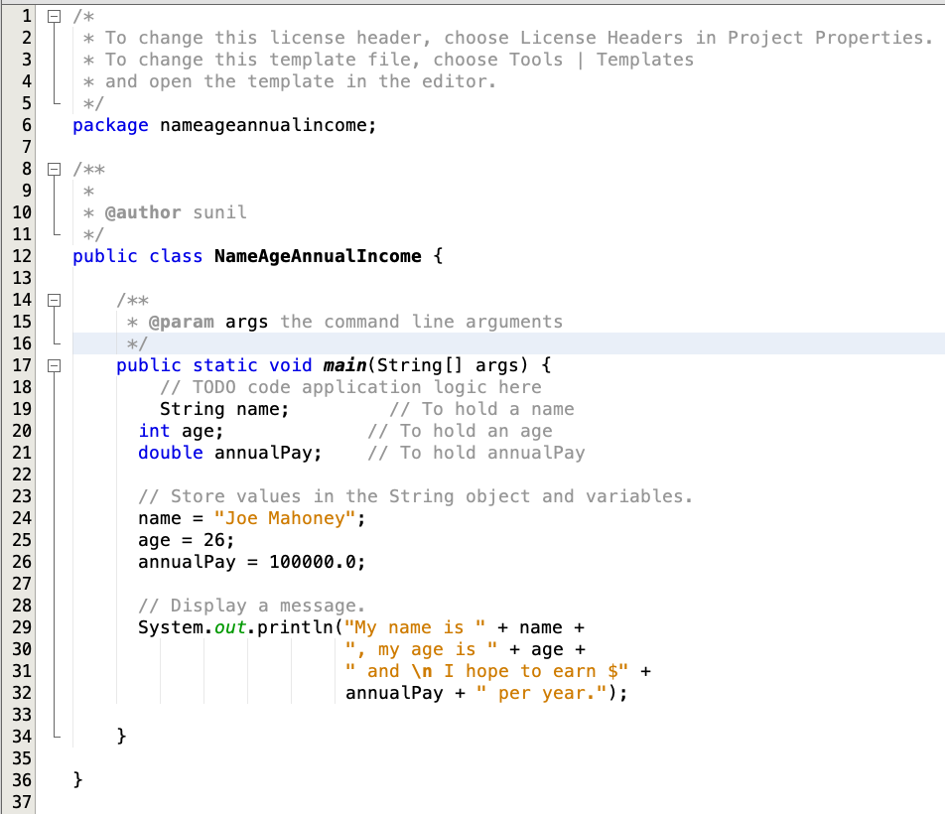
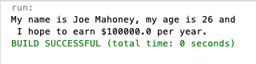

Lab1 and Lab2 Submit along with project folders
StudentID_Name(Pinyin)

