XIDIAN UNIVERSITY

SCHOOL OF COMPUTER SCIENCE AND TECHNOLOGY

Programming in Java

2019

Lab-2
Exercise:1: Roman Numerals
Write a program that prompts the user to enter a number within the range of 1 through 10. The program should display the Roman numeral version of that number. If the number is outside the range of 1 through 10, the program should display an error message.
[Hint: Use Switch Statement]

Output:
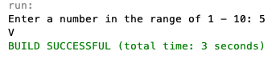

Exercise:2: Body Mass Index
Write a program that calculates and displays a person’s body mass index (BMI). The BMI is often used to determine whether a person with a sedentary lifestyle is overweight or under- weight for his or her height. A person’s BMI is calculated with the following formula:

bmi = weight * 703 / (height * height)

where weight is measured in pounds and height is measured in inches. The program should display a message indicating whether the person has optimal weight, is underweight, or is overweight. A sedentary person’s weight is considered optimal if his or her BMI is between 18.5 and 25. If the BMI is less than 18.5, the person is considered underweight. If the BMI value is greater than 25, the person is considered overweight.
[hint: if else]

Output:
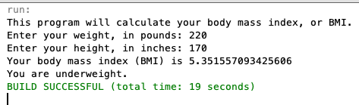

Exercise:3: Test Scores and Grade
Write a program that has variables to hold three test scores. The program should ask the user to enter three test scores and then assign the values entered to the variables. The pro- gram should display the average of the test scores and the letter grade that is assigned for the test score average. Use the grading scheme in the following table:
[Hint: Use ifelseif ]

Test Score Average | Letter Grade
90-100 | A
80-89 | B
70-79 | C
60-69 | D
Below 60 | F

Output:
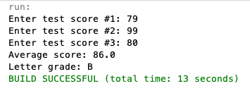
Exercise:4: Book Club Points
Serendipity Booksellers has a book club that awards points to its customers based on the number of books purchased each month. The points are awarded as follows:
• If a customer purchases 0 books, he or she earns 0 points.
• If a customer purchases 1 book, he or she earns 5 points.
• If a customer purchases 2 books, he or she earns 15 points.
• If a customer purchases 3 books, he or she earns 30 points.
• If a customer purchases 4 or more books, he or she earns 60 points.
Write a program that asks the user to enter the number of books that he or she has purchased this month and then displays the number of points awarded.

Output:
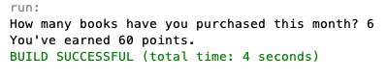

Exercise:5: Shipping Charges
The Fast Freight Shipping Company charges the following rates:

Weight of Package | Rate per 500 Miles Shipped
2 pounds or less | $ 1.10
Over 2 pounds but not more than 6 pounds | $ 2.20
Over 6 pounds but not more than 10 pounds | $ 3.70
Over 10 pounds | $ 3.80

The shipping charges per 500 miles are not prorated. For example, if a 2-pound package is shipped 550 miles, the charges would be $2.20. Write a program that asks the user to enter the weight of a package and then displays the shipping charges.
[import javax.swing.JOptionPane;]

Output:

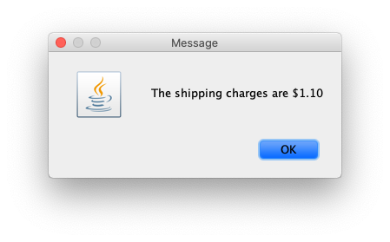

Deadline: 2019-11-05

