XIDIAN UNIVERSITY

SCHOOL OF COMPUTER SCIENCE AND TECHNOLOGY

Programming in Java
2019
Lab-7A
[Student Number / Student Name(pinyin)]
Class [1/2]
Exercise 1. Latin Translator
The Latin Translator Problem
Look at the following list of Latin words and their meanings:

Latin | English
sinister | left
dexter | Right
medium | center

Create a JavaFX application that translates the Latin words to English. The GUI should have three Buttons, one for each Latin word. When the user clicks a Button, the application should display the English translation in a Label.

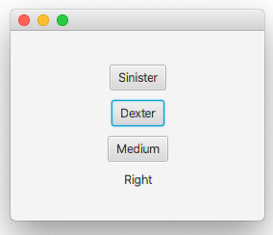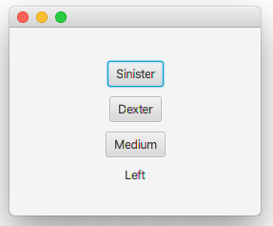
Exercise 2. Tip, Tax, and Total
Create a JavaFX application that lets the user enter the food charge for a meal at a restaurant. When a button is clicked, the application should calculate and display the amount of an 18 percent tip on the total food charge, 7 percent sales tax, and the total of all three amounts.

[Hint: final double TIP = 0.18; final double TAX = 0.07;]

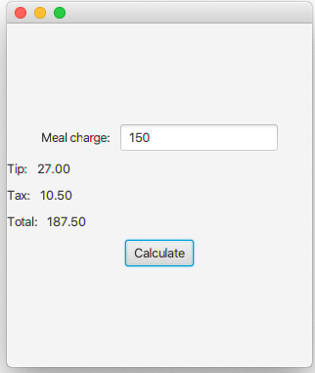

Exercise 3. Dice Simulator
Create a JavaFX application that simulates rolling a pair of dice. When the user clicks a button, the application should generate two random numbers, each in the range of 1 through 6, to represent the value of the dice. Use ImageView controls to display the dice.

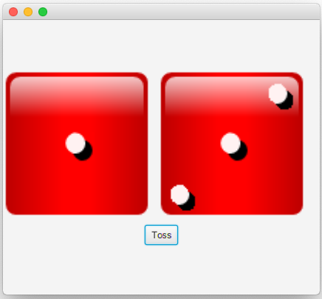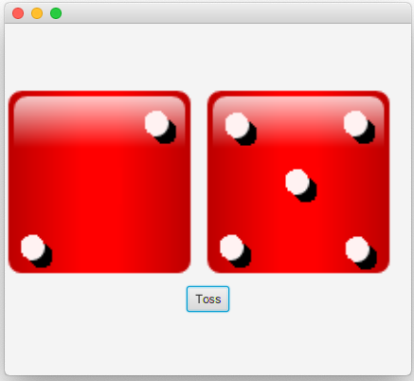

Exercise 4. Slot Machine Simulation
A slot machine is a gambling device into which the user inserts money then pulls a lever (or presses a button). The slot machine then displays a set of random images. If two or more of the images match, the user wins an amount of money that the slot machine dispenses back to the user.
Create a JavaFX application that simulates a slot machine. Below figure shows an example of how the GUI should look. The application should let the user enter into a TextField the amount of money he or she is inserting into the machine. When the user clicks the Spin button, the application should display three randomly selected symbols. (Slot machines traditionally display fruit symbols.) The program should also display the amount that the user won for the spin, and the total amount won for all spins.
The amount won for a spin is determined in the following way:
- If none of the randomly displayed images match, the user has won $0.
- If two of the images match, the user has won two times the amount entered.
- If three of the images match, the user has won three times the amount entered.

