

<Project Name>

Component Design

**Document Approval**

|  |  |  |  |
| --- | --- | --- | --- |
| **Baseline Version** | **Approved Date** | **Reviewer** | **Approver** |
| <N.N> | dd-Mmm-YY | <full name> | <Description> |

Document Revision History

|  |  |  |  |
| --- | --- | --- | --- |
| **Version** | **Date** | **Author** | **Change Description** |
| <N.N> | dd-Mmm-YY | <full name> | <Description> |

Table of Contents

I. Introduction 3

1. Purpose 3

2. Scope 3

3. Definition, Acronyms and Abbreviation 3

4. References 3

II. Common Package 3

1. Common Package 3

1.1. Package Diagram 3

1.2. Package Description 3

1.2.1 Package <ABC> 3

2. Error, Exception Handling 3

3. Log, Trace and Debug 3

III. Packages 3

1. Package Diagram 3

1.1. Package Description 3

1.1.1 Package <ABC> 3

IV. Component 3

1. Component Diagram 3

2. Components 3

2.1. <name of component> Component 3

V. Other Diagrams 3

1. Sequence Diagram ABC 3

1.1. Diagram 3

2.2. Description 3

VI. Other Consideration 3

# Introduction

## Purpose

[This section defines the purpose of the Class Design Document, in the overall project documentation, and briefly describes the structure of the document. The specific audiences for the document should be identified, with an indication of how they are expected to use the document.

*For reference:*

*This document provides a comprehensive architectural overview of the system, using a number of different architectural views to depict different aspects of the system.  It is intended to capture and convey the significant architectural decisions which have been made on the system.]*

## Scope

[A brief description of what the Class Design Document applies to; what is affected or influenced by this document.]

## Definition, Acronyms and Abbreviation

[This subsection provides the definitions of any terms, acronyms, and abbreviations required to properly interpret the Class Design document]

## References

[This subsection provides a list of the documents referenced elsewhere within Class Design Document]

# Common Package

## Common Package

[Give description of common package]

### Package Diagram

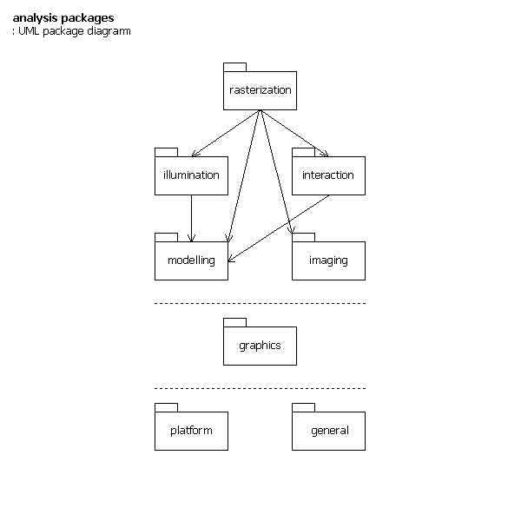

|  |  |  |
| --- | --- | --- |
| **No.** | **Name** | **Description** |
| 01 | <package name> | <brief description about package to describe what package is for, what does it represent> |
|  |  |  |
|  |  |  |

### Package Description

### Package <ABC>

[Attach package design, package view, package description…]

## Error, Exception Handling

[Describe components for handling error, exception]

## Log, Trace and Debug

[Describe components for handling log, trace]

# Packages

## Package Diagram



[List out all of packages and describe their characteristics]

|  |  |  |  |
| --- | --- | --- | --- |
| **No.** | **Name** | **Type** | **Description** |
| 01 | <package name> | Java, .Net | <brief description of the package, to depict what package does> |
|  |  |  |  |

### Package Description

### Package <ABC>

[Attach package design, package view, package description…]

# Component

## Component Diagram

[Describe component diagram and list out all of component present in the diagram]

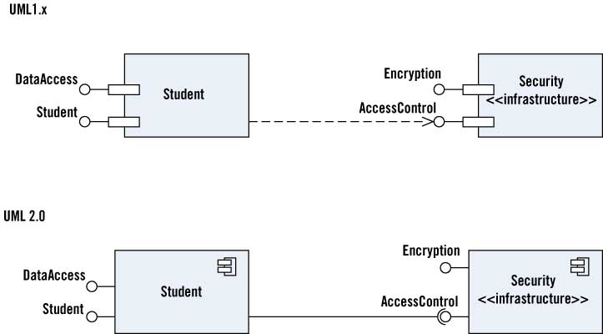

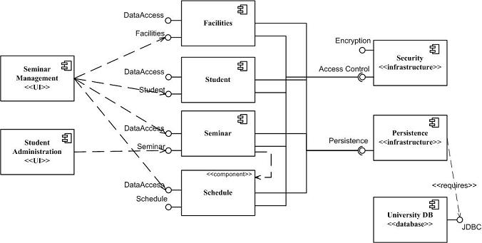

|  |  |  |
| --- | --- | --- |
| **No.** | **Name** | **Description** |
| *1* | *Seminar* | *Allow to register seminar, manage seminar.* |
| *2* | *Schedule* | *Create schedule, manage schedule* |

## Components

### <name of component> Component

[Attach component design, component view,…]

# Other Diagrams

[Describe all diagrams that is consisted in the system such as sequence diagram, state diagram and for some functionalities of the system]

## Sequence Diagram ABC

### Diagram

[Describe Sequence Diagram and description of specific sequence diagram]

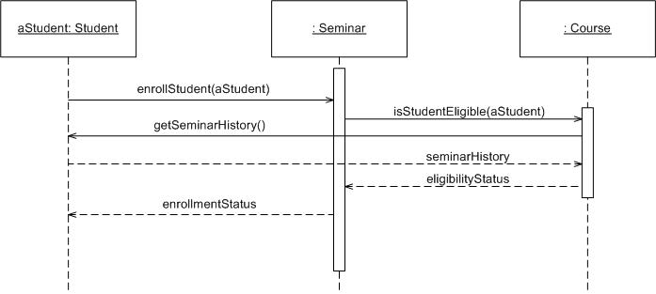

### Description

# Other Consideration

*--- End of the document ---*