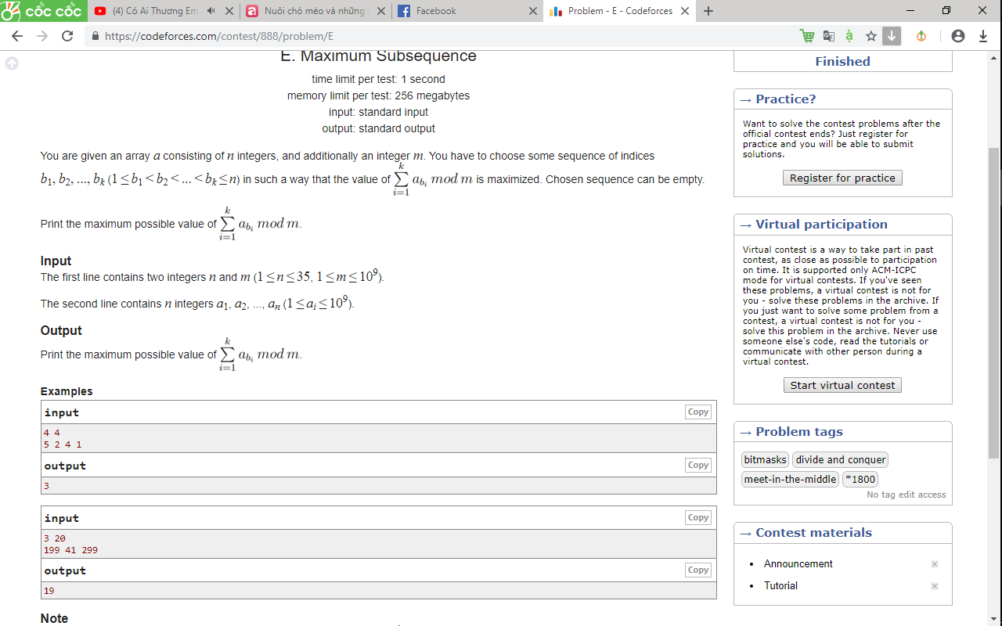

https://codeforces.com/contest/888/problem/E