-- san pham ban chay nhat
SELECT SP.TenSP, SUM(CT.SoLuong) AS TongSoLuongBanDuoc
FROM ChiTietHoaDon AS CT
JOIN SanPham AS SP ON CT.MaSP = SP.MaSP
GROUP BY SP.MaSP, SP.TenSP
ORDER BY TongSoLuongBanDuoc DESC
LIMIT 7;

Basas Day Slide - Slip On | 70
Basas Simple Life NE - Low Top | 61
Basas Evergreen - Low Top | 43
Basas Bumper Gum EXT NE - Low Top | 30
Vintas Denim - Low Top | 30
Basas Mono Black NE - Low Top | 27
Urbas SC - Low Top | 23
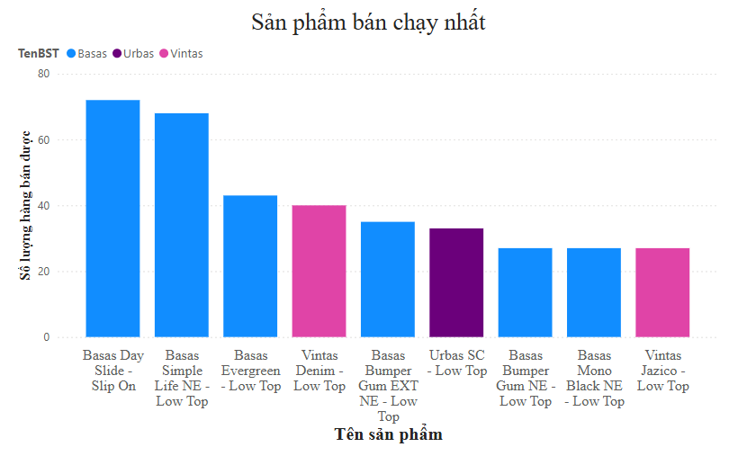

Khach hang mua nhieu nhat
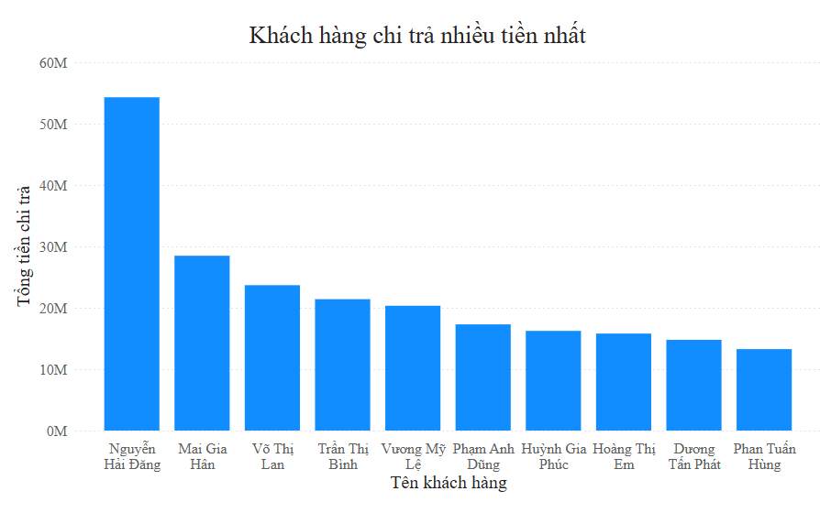
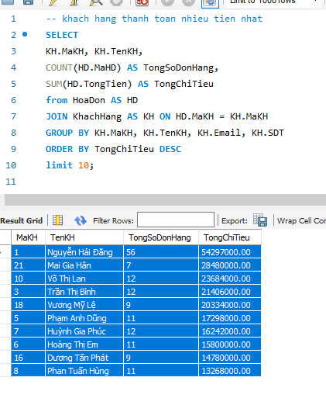
Doanh thu theo tháng max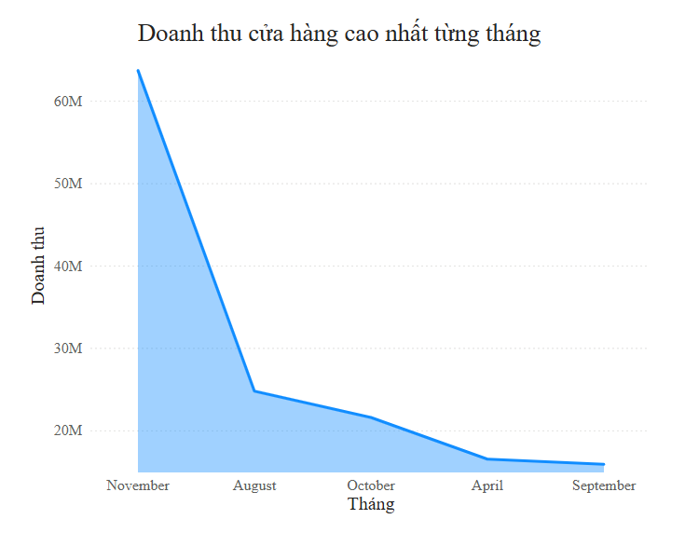
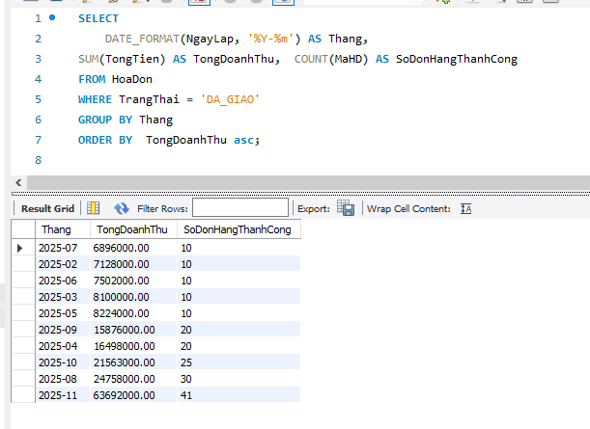

— bst (tạo 1 measure mới trong PBI)
TongDoanThu_ChuaGiam = SUMX('myananas chitiethoadon', [SoLuong] * [DonGia])
