An Internship Report
Of
DATA ANALYTICS
VirtualWorks Lab Internship
Submitted
To
School of Computer Science and Engineering
IILM University, Greater Noida, U.P.
In partial fulfillment of the requirement of degree of
B-Tech (CSE)

By
Roll Number of Student:- 25SCS1003004846
Name of Student: HAIDAR RAJ ALI
Batch: 2026-27

CANDIDATE'S DECLARATION
I, HAIDAR RAJ ALI, do hereby declare that the internship report titled “Data Analytics” has been completed by me as part of the Bachelor of Technology in Computer Science and Engineering programme. This report presents the work and learning associated with my VirtualWorks Lab internship from 08 August 2026 to 07 September 2026. The internship was completed in the domain of Data Analytics, and the project/task record and performance details included in this report are based on the internship completion and performance evaluation documents issued by VirtualWorks Lab by Noivrn.
I further declare that the report has been prepared for academic submission and that the supporting internship credentials included in the report have been reproduced for verification purposes. I shall be responsible for the authenticity of the information submitted by me.
Signature:-
Student Name:- HAIDAR RAJ ALI
Roll No. :- 25SCS1003004846

ACKNOWLEDGEMENT
I would like to express my sincere gratitude to everyone who supported me during the completion of my internship and the preparation of this report. The internship provided an opportunity to work with practical Data Analytics assignments and to understand how analytical tasks can be structured, documented, and evaluated.
I am thankful to VirtualWorks Lab, an educational initiative by Noivrn, for providing the internship opportunity and for evaluating my work across technical competence, task completion, problem solving, communication and documentation, and consistency and effort. The internship was completed for a total of 155 hours, with an overall score of 92/100 and Grade A (Excellent).
I also express my gratitude to IILM University, Greater Noida, and the faculty of the School of Computer Science and Engineering for their academic guidance and encouragement. Finally, I am grateful to my parents and everyone who encouraged me throughout this learning experience.
Signature:
Student Name: HAIDAR RAJ ALI
Roll No.: 25SCS1003004846

TABLE OF CONTENTS
1. Candidate's Declaration........................................................i
2. Acknowledgement................................................................ii
3. Internship Completion Certificate.............................................-
4. Performance Evaluation Report..................................................-
5. Project Description....................................................................1
5.1 Introduction............................................................................1
5.2 Organization Profile................................................................2
5.3 Problem Statement..................................................................3
5.4 Project Objectives...................................................................3
5.5 Scope of the Project.................................................................4
5.6 Technologies and Tools Used...................................................4
5.7 System Architecture.................................................................5
5.8 Methodology.............................................................................6
5.9 Projects / Task Record..............................................................7
5.10 Expected Outcomes & Verification.............................................8
6. Bibliography/References..............................................................9

3. INTERNSHIP COMPLETION CERTIFICATE
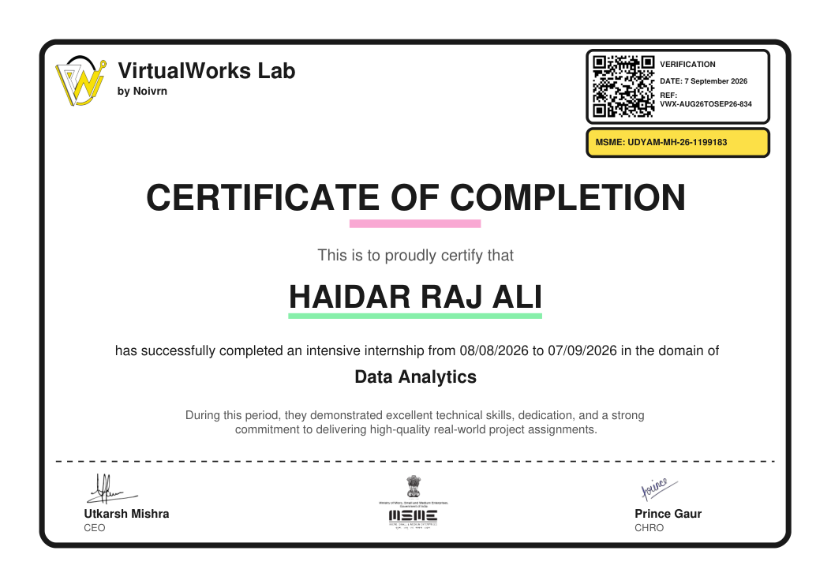

4. PERFORMANCE EVALUATION REPORT
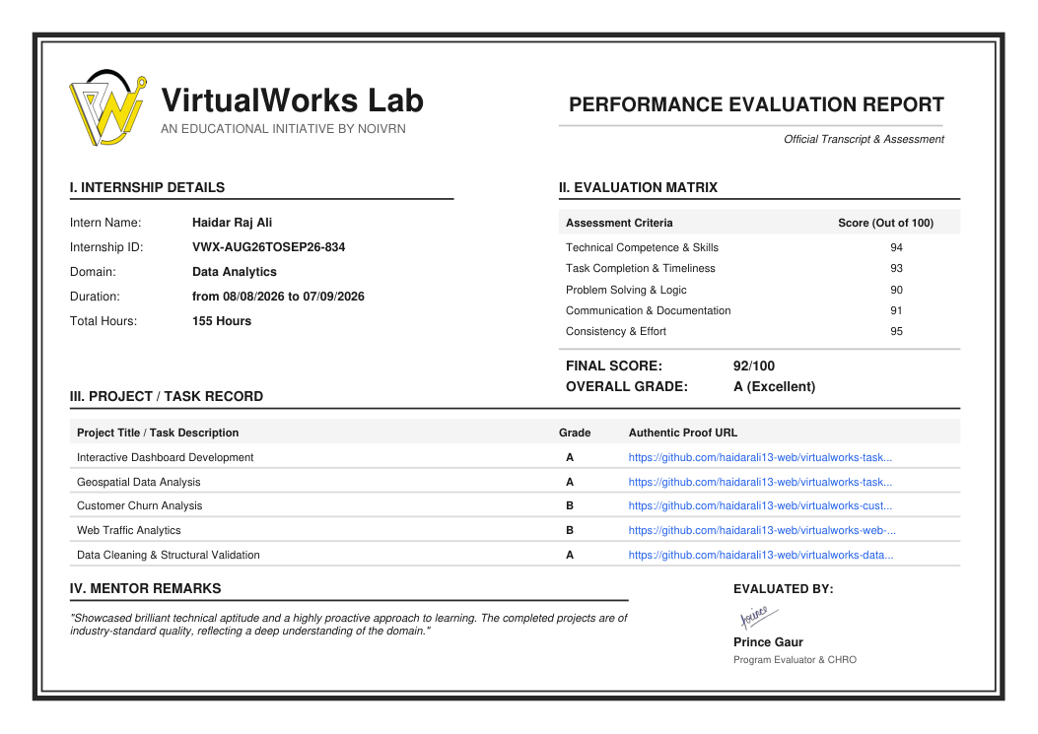

5. PROJECT DESCRIPTION
5.1 Introduction
This report presents a detailed account of the Data Analytics internship completed at VirtualWorks Lab from 08 August 2026 to 07 September 2026. The internship certificate records a total engagement of 155 hours and confirms successful completion in the domain of Data Analytics. The recorded internship work consisted of five project/task areas: Interactive Dashboard Development, Geospatial Data Analysis, Customer Churn Analysis, Web Traffic Analytics, and Data Cleaning & Structural Validation.
The internship was designed around practical project assignments rather than a single theoretical topic. Across the recorded tasks, the work covered data preparation, analysis, visualization, and interpretation-oriented activities. This report organizes those activities into a coherent academic account while keeping the task names and credential details consistent with the official performance evaluation record.

5.2 Organization Profile
VirtualWorks Lab is identified on the internship certificate as an educational initiative by Noivrn. The completion certificate verifies the internship domain as Data Analytics and records the internship period from 08 August 2026 to 07 September 2026. The accompanying Performance Evaluation Report provides the internship ID, total hours, assessment matrix, project/task record, and evaluator remarks.
The official evaluation describes the completed projects as being of industry-standard quality and notes a proactive approach to learning. For academic purposes, the internship can therefore be viewed as a practical exposure to structured analytics assignments, task delivery, problem solving, and documentation.
Internship Snapshot
Intern Name | Haidar Raj Ali
Organization | VirtualWorks Lab by Noivrn
Domain | Data Analytics
Duration | 08/08/2026 – 07/09/2026
Total Hours | 155 Hours
Internship ID | VWX-AUG26TOSEP26-834

5.3 Problem Statement
The internship task record shows a set of practical analytics problems involving dashboards, geospatial analysis, customer churn, web traffic, and data cleaning with structural validation. Taken together, these assignments address a common Data Analytics challenge: converting raw or structured datasets into reliable, interpretable outputs that can support understanding and decision-making.
A major part of this challenge is ensuring that data is sufficiently clean and structurally valid before analysis. Once prepared, analytical techniques and visual representations can be used to examine patterns such as geographic distribution, customer behaviour, and web activity. The internship therefore provided a practical setting for connecting data preparation with analysis and presentation.
5.4 Project Objectives
• Develop practical exposure to Data Analytics through real-world project assignments.
• Understand the role of data cleaning and structural validation in producing reliable analytical results.
• Work with interactive dashboard-oriented analysis and communicate findings through visual outputs.
• Explore geospatial data analysis as a way of examining location-based patterns.
• Study customer churn data to identify analytical patterns relevant to customer behaviour.
• Analyse web traffic data to understand activity and performance-oriented patterns.
• Strengthen problem solving, documentation, task completion, and analytical communication skills.
• Complete and document the assigned internship work for academic evaluation.

5.5 Scope of the Project
The scope of the internship is defined by the five project/task areas recorded in the official Performance Evaluation Report. It includes interactive dashboard development, geospatial data analysis, customer churn analysis, web traffic analytics, and data cleaning with structural validation. The work therefore covers both data preparation and analytical presentation, with the specific depth determined by each assigned project.
5.6 Technologies and Tools Used
NOTE FOR FINAL EDITING: Add the exact tools/software used in your VirtualWorks tasks here.
• Tools / Software: ________________________________________________
• Programming / Query Language: ____________________________________
• Visualization Platform: __________________________________________
• Libraries / Frameworks: __________________________________________
• Other Tools: _____________________________________________________

5.7 System Architecture
The following conceptual workflow represents the relationship among the internship's recorded task categories. It is intended as an academic representation of the analytics process; the official certificate does not specify a single technical architecture or software stack.
DATA INPUT | Datasets / source records
CLEANING & VALIDATION | Data Cleaning & Structural Validation
ANALYSIS | Geospatial • Churn • Web Traffic
VISUALIZATION | Interactive Dashboard Development
INSIGHTS | Interpretation & documented findings
The workflow emphasizes a basic analytical principle: data should be prepared and validated before analysis, and analytical results should be presented in a form that is understandable and useful.

5.8 Methodology
Because the supplied internship credential does not provide a week-wise syllabus, the methodology below is organized around the recorded project/task sequence rather than inventing a weekly curriculum.
Phase | Project / Task | Methodological Focus
Phase 1 | Data Cleaning & Structural Validation | Prepare and validate the data structure before analytical use.
Phase 2 | Interactive Dashboard Development | Organize analytical outputs into an interactive dashboard-oriented presentation.
Phase 3 | Geospatial Data Analysis | Analyse location-related data and represent geographic patterns.
Phase 4 | Customer Churn Analysis | Examine customer churn data for meaningful analytical patterns.
Phase 5 | Web Traffic Analytics | Analyse web traffic data and document relevant observations.

5.9 Projects / Task Record
The following project titles and grades are reproduced from the official Performance Evaluation Report supplied with the internship certificate.
Project / Task | Grade | Academic Description
Interactive Dashboard Development | A | Dashboard-oriented analytical presentation.
Geospatial Data Analysis | A | Location-based data analysis.
Customer Churn Analysis | B | Analysis of customer churn patterns.
Web Traffic Analytics | B | Analysis of web traffic activity.
Data Cleaning & Structural Validation | A | Data preparation and structural validation.
Key Demonstrated Skills
• Practical data preparation and structural validation.
• Analytical thinking across multiple data-focused project categories.
• Dashboard-oriented data presentation and communication.
• Application of analytical reasoning to geographic, customer, and web activity data.
• Task completion, documentation, consistency, and problem solving.

5.10 Expected Outcomes & Verification
The internship was successfully completed for 155 hours. The Performance Evaluation Report records a final score of 92/100 and an overall Grade A (Excellent), with individual assessment scores of 94 for Technical Competence & Skills, 93 for Task Completion & Timeliness, 90 for Problem Solving & Logic, 91 for Communication & Documentation, and 95 for Consistency & Effort.
• Improved practical understanding of data preparation, analysis, and visualization-oriented workflows.
• Greater familiarity with working on varied analytics problem statements.
• Stronger analytical reasoning and structured problem-solving practice.
• Improved documentation and communication of project work.
• Evidence of consistent task delivery through the internship evaluation record.
Mentor / Evaluator Remark
The official evaluation remarks that the intern demonstrated strong technical aptitude and a proactive approach to learning, and that the completed projects reflected a strong understanding of the domain.
Internship ID: VWX-AUG26TOSEP26-834 | Final Score: 92/100 | Grade: A (Excellent)

6. BIBLIOGRAPHY/REFERENCES
1. VirtualWorks Lab by Noivrn, “Certificate of Completion – Data Analytics,” Ref: VWX-AUG26TOSEP26-834, dated 07 September 2026.
2. VirtualWorks Lab by Noivrn, “Performance Evaluation Report – Official Transcript & Assessment,” Internship ID: VWX-AUG26TOSEP26-834.
3. VirtualWorks Lab by Noivrn, Project / Task Record included in the supplied Performance Evaluation Report.
4. IILM University, School of Computer Science and Engineering, academic internship submission requirements.
— End of Report —

