**My Guitar Shop Database – Portfolio Project**

D. Haiden

May 14, 2023

**Figure 1.**

*First query: Obtain certain fields from the Products table*

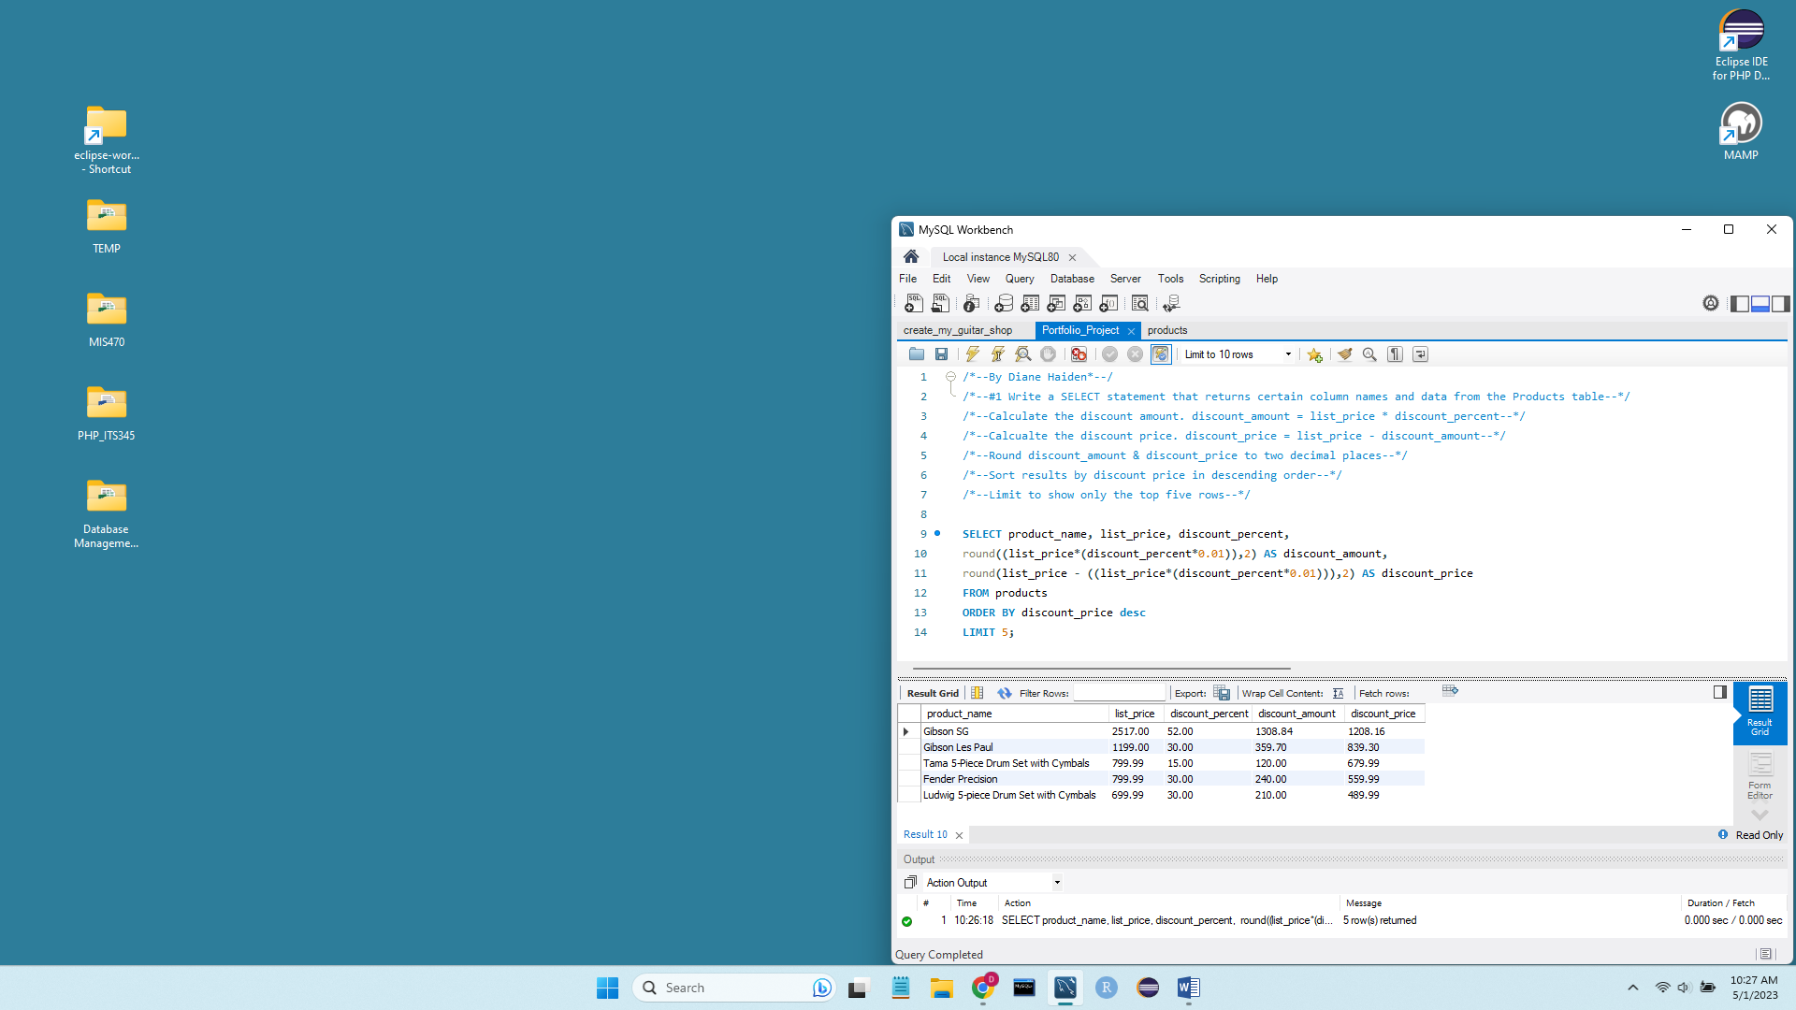

**Figure 2.**

*Second query: Obtain certain fields from the Order_Items table*

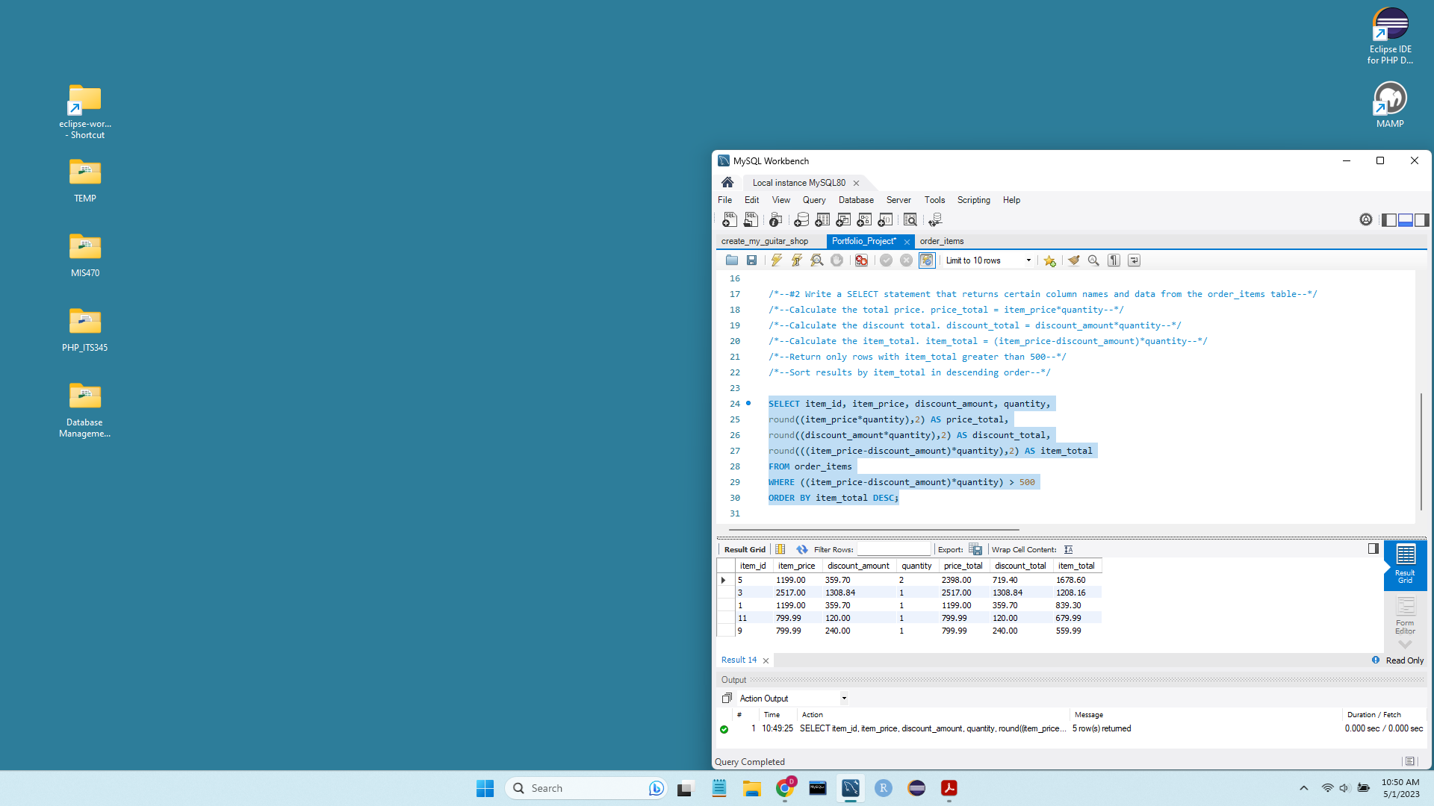

**Figure 3.**

*Third query: Obtain the product_name and list_price of the Products table*

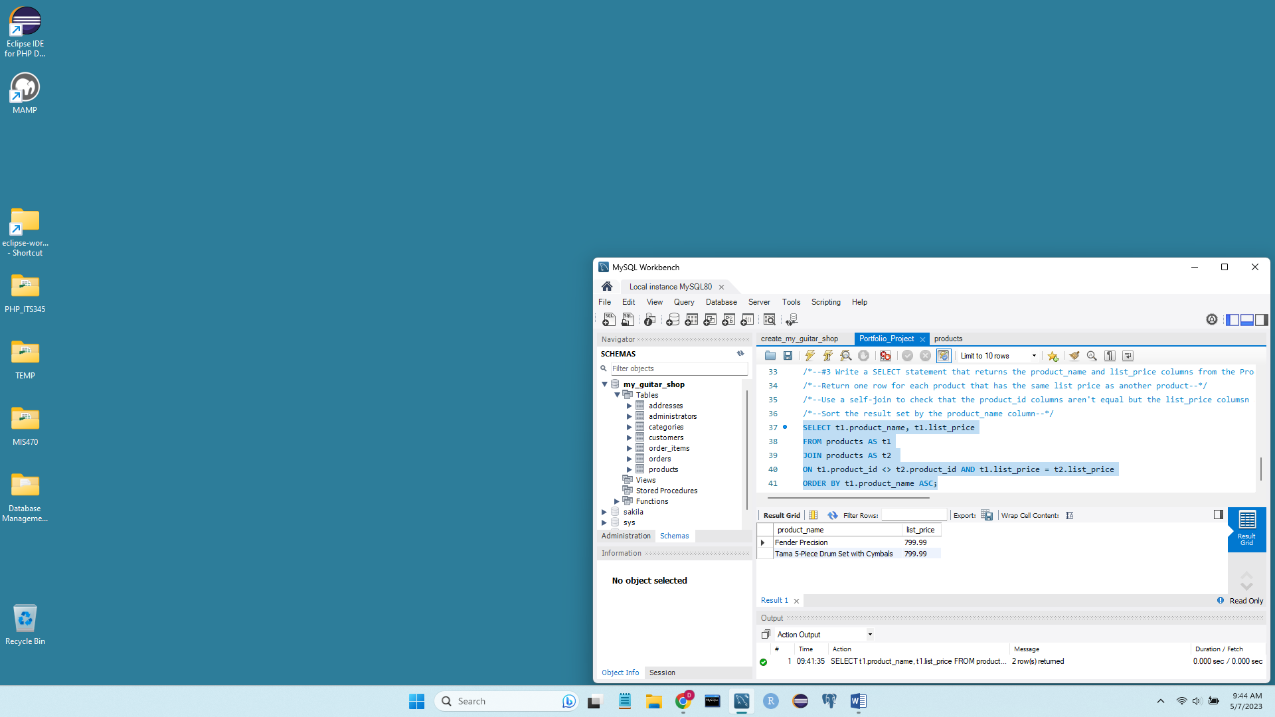

**Figure 4.**

*Fourth query: Obtain the category_name and product_id where product_id is null*

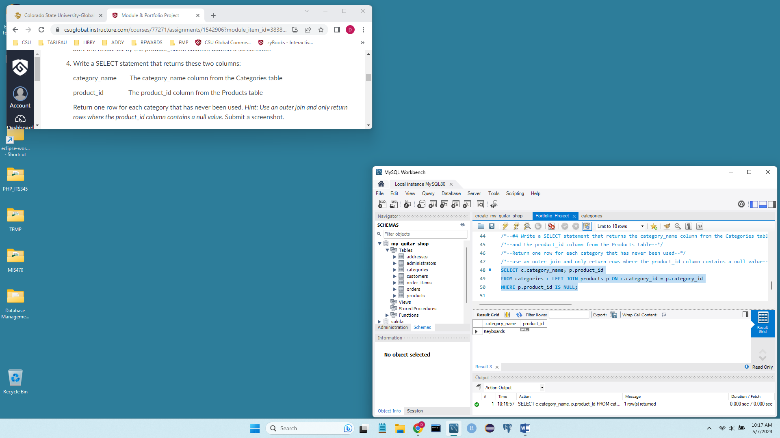

**Figure 5a.**

*Fifth query: Original Customer table before INSERT statement was executed*

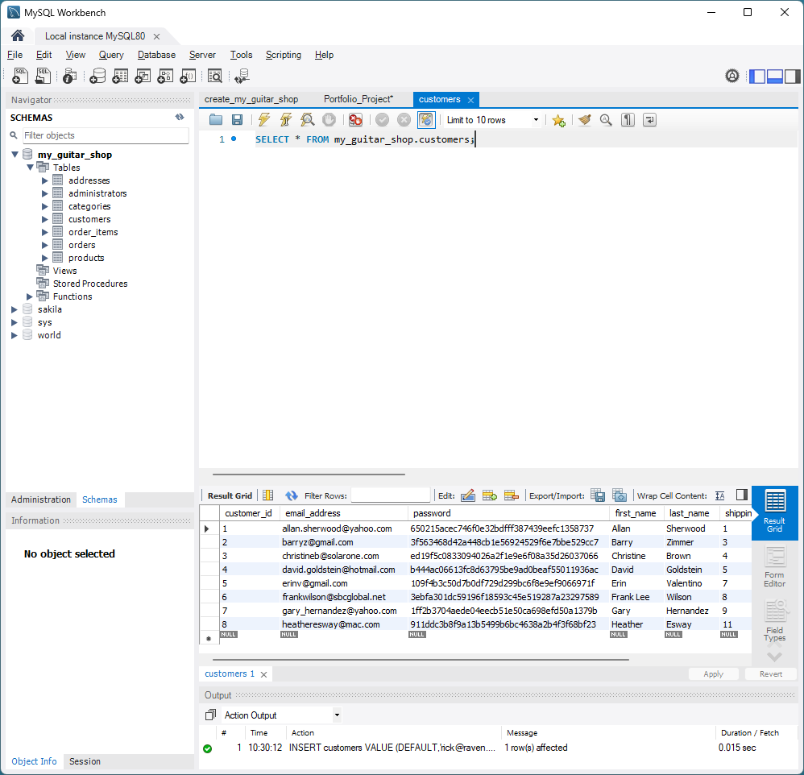

**Figure 5b.**

*Fifth query: Original Customer table before INSERT statement was executed*

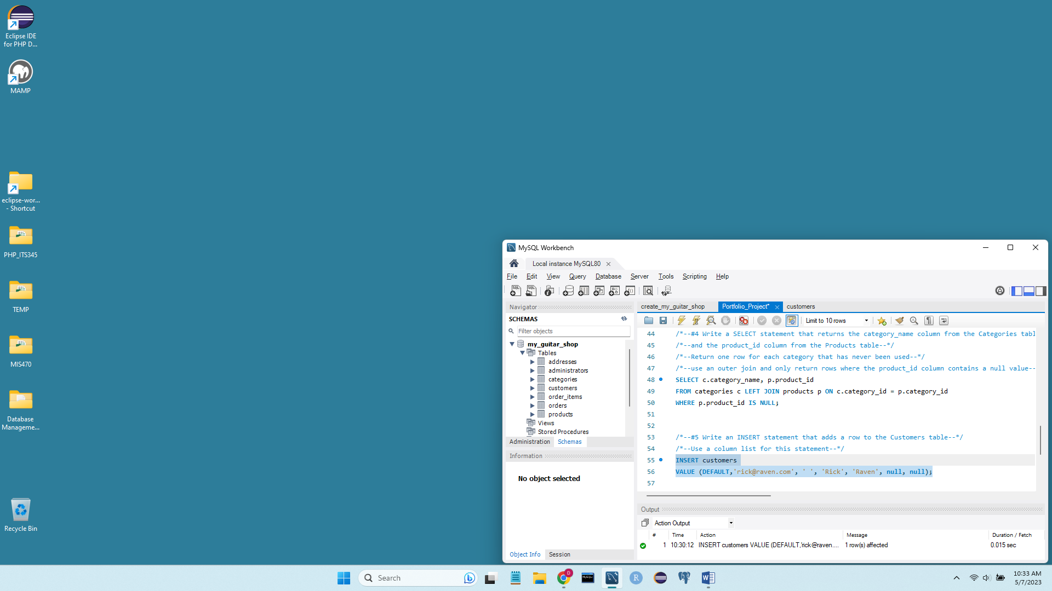

**Figure 5c.**

*Fifth query: New Customer table after INSERT statement was executed*

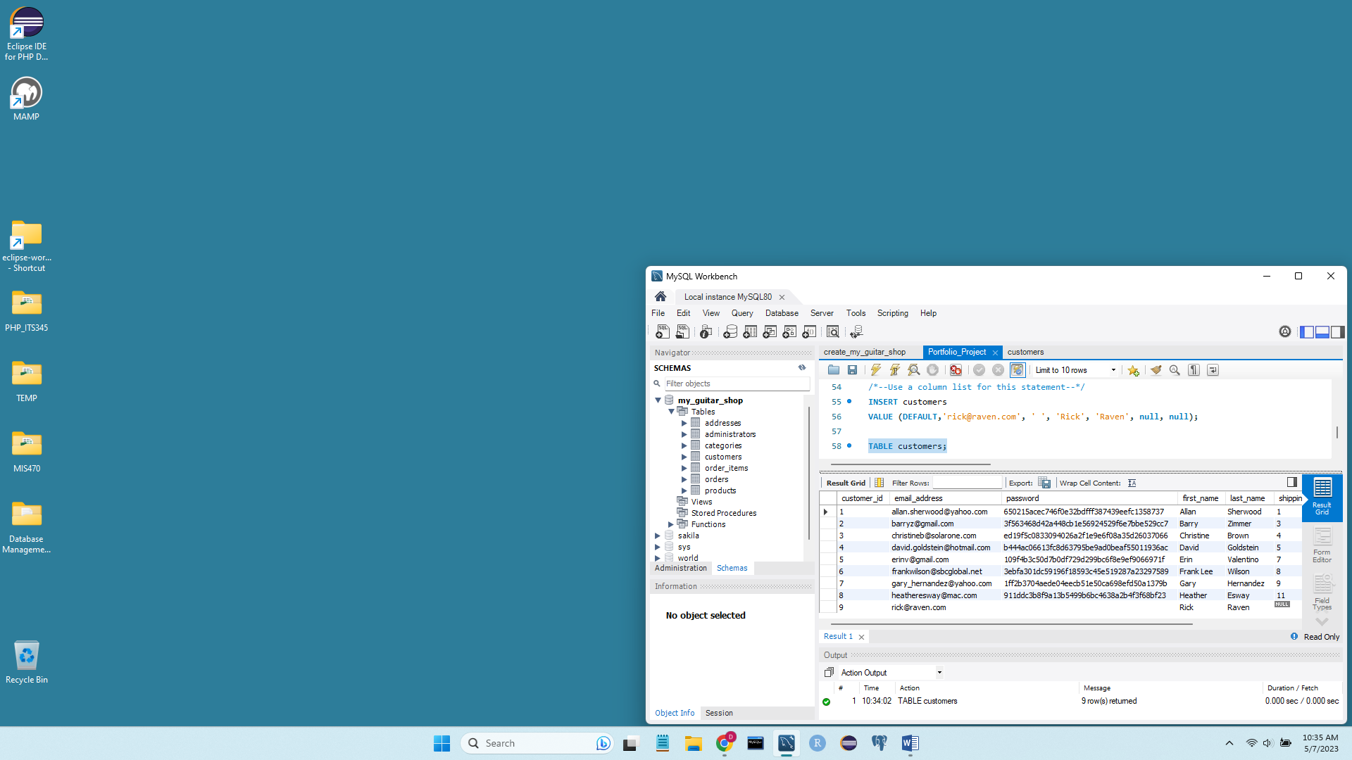

**Figure 6.**

*Sixth query: Determining which customers have ordered more than one product*

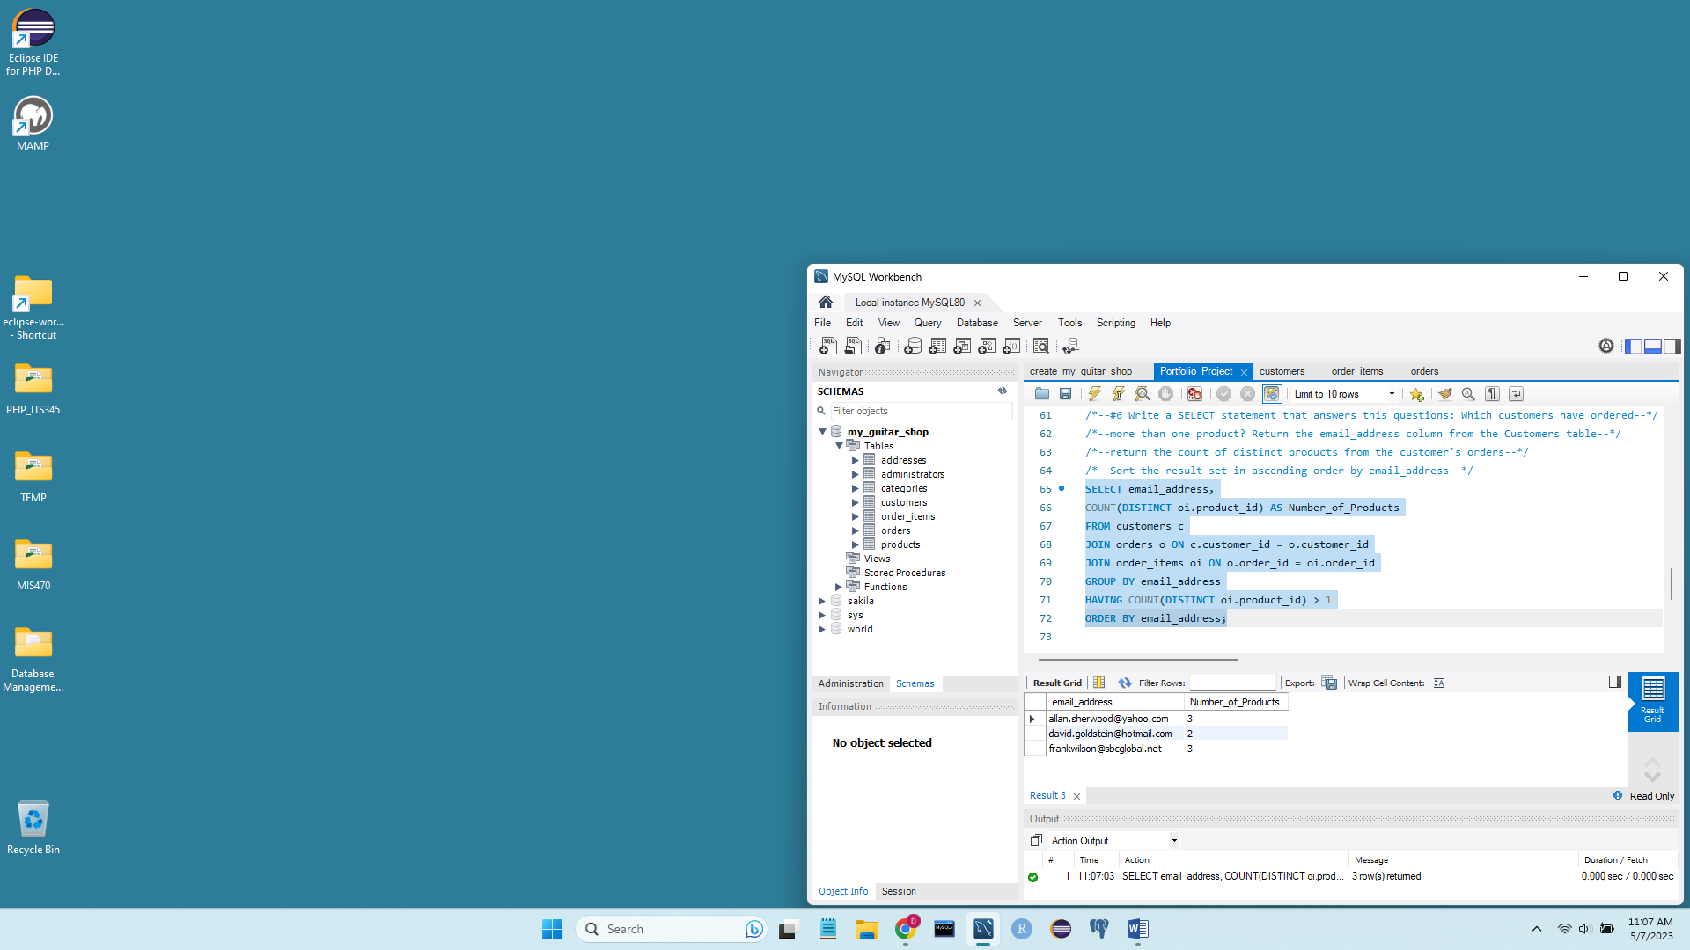

**Figure 7.**

*Determining the total quantity purchased for each product within each category*

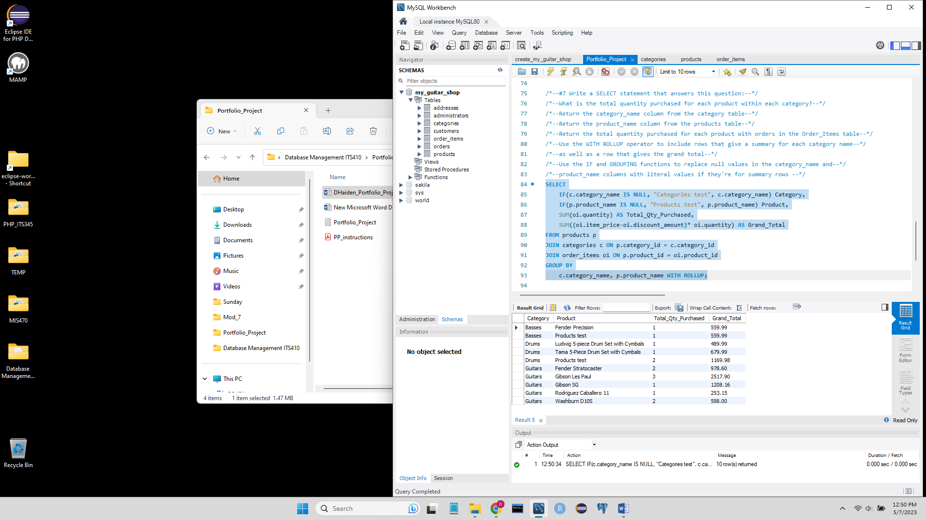

**The last query was omitted from this screen capture for data privacy