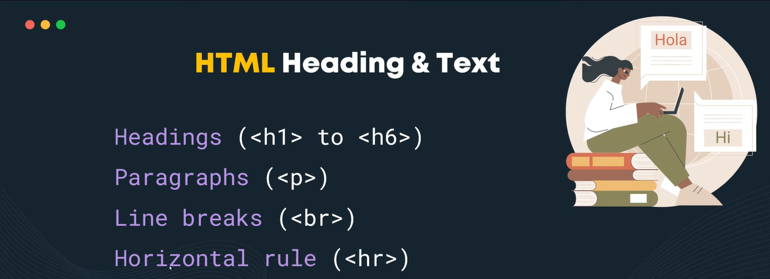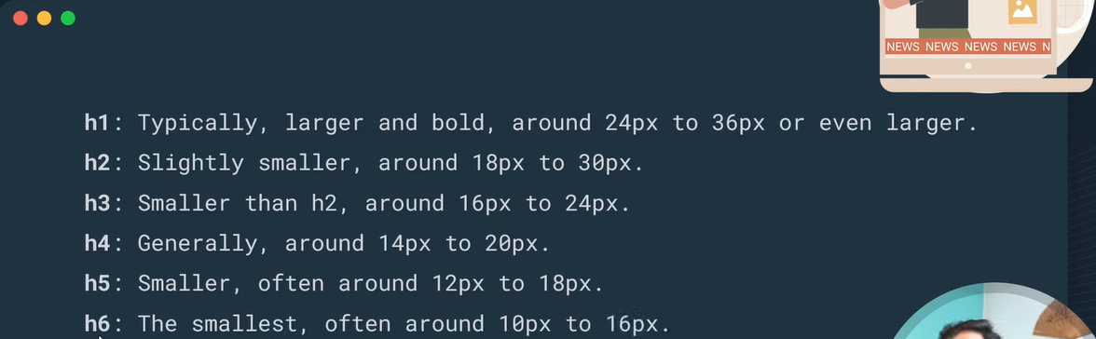

**Note ↓**

*The tag's element name is case-insensitive, e.i., we can use <H1></H1>*

*A single H1 is typically used per page*

*Follow the hierarchy from H1 to H6 consistently*

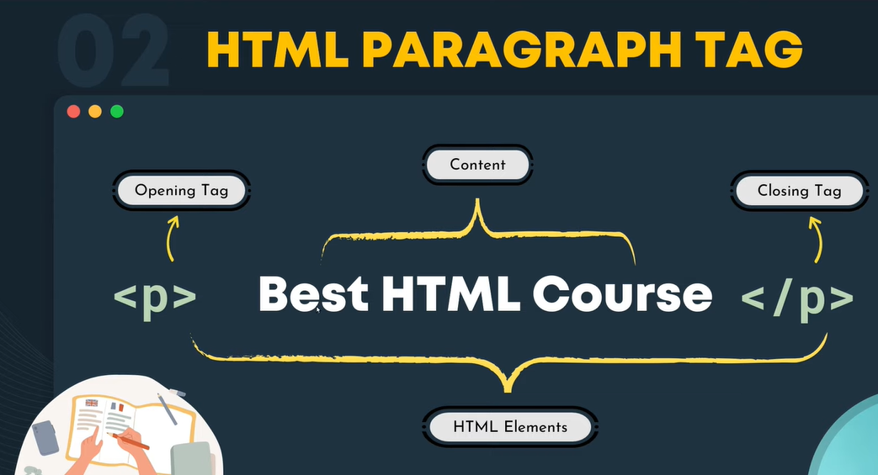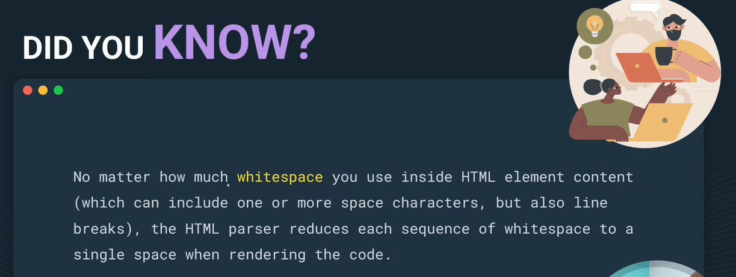

**For example ↓**

