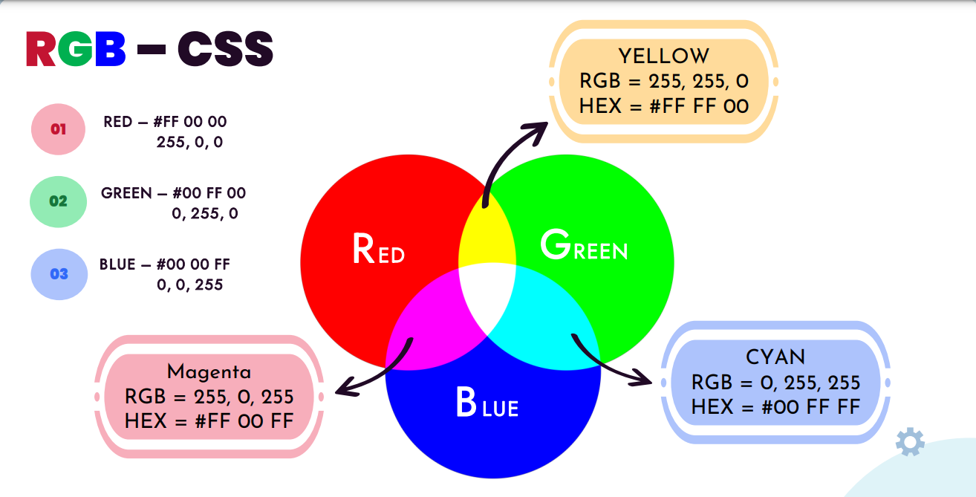

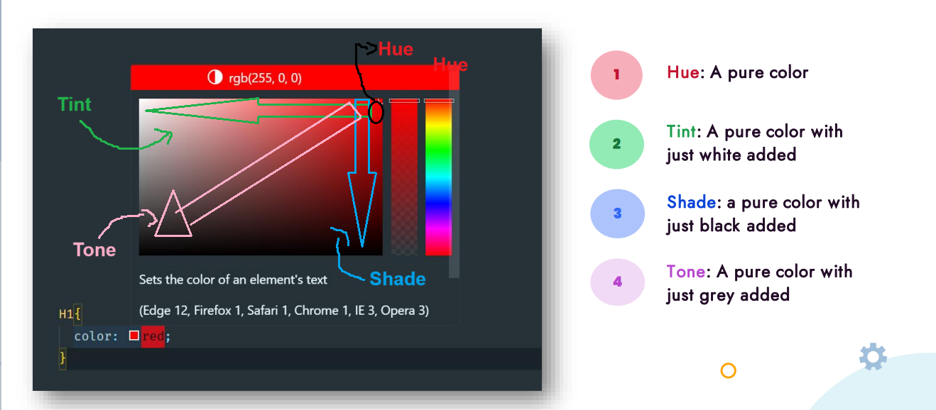

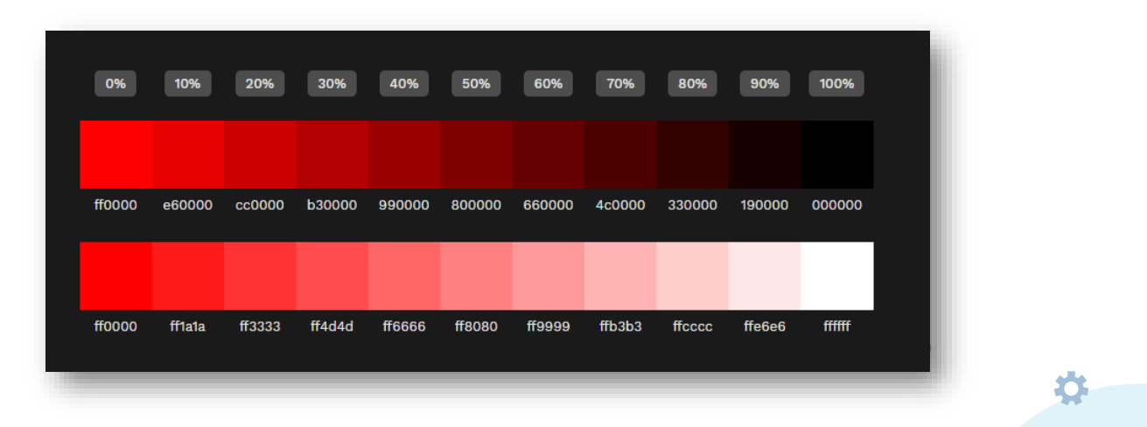



**”#000” creates black colour & “#fff” creates white colour, all other hexadecimal no. of three same digits create shades of gray colour.**