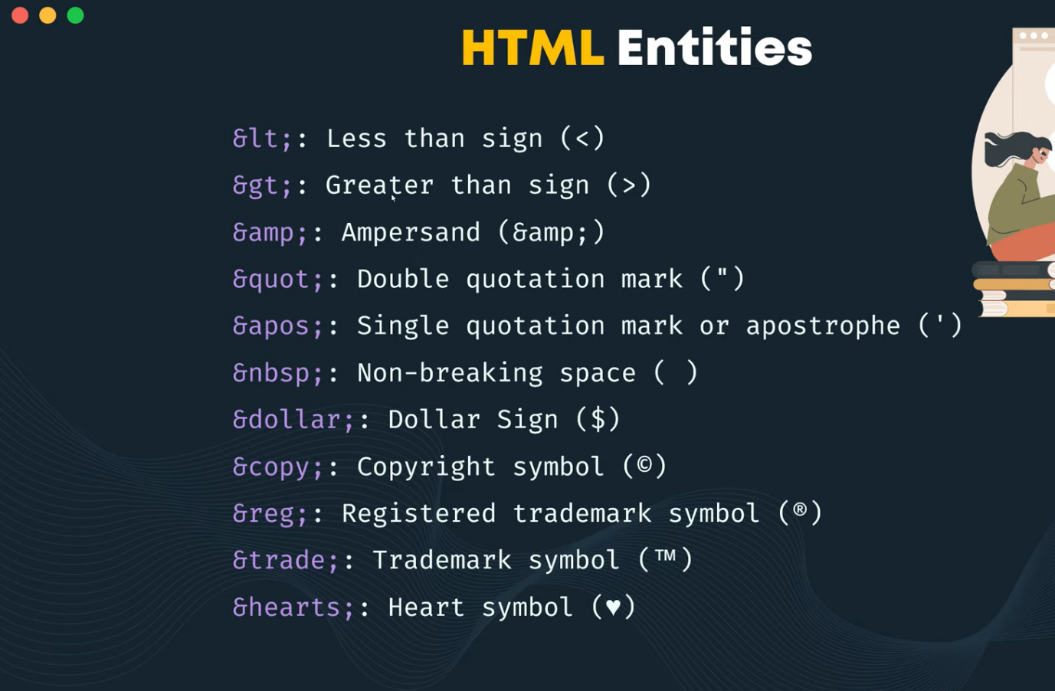

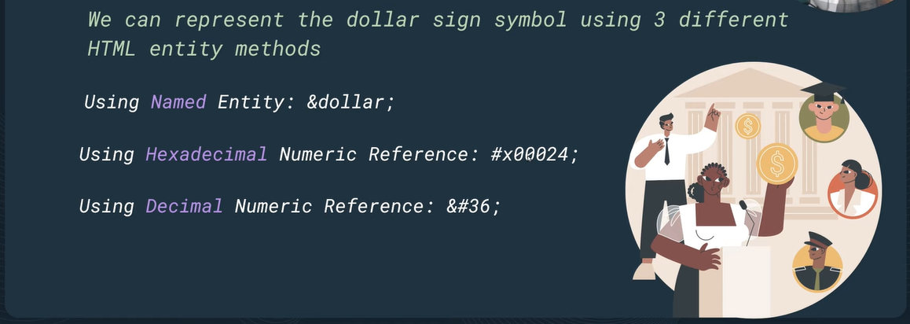

*for more* [*https://www.htmlquick.com/reference/character-entity-reference.html*](https://www.htmlquick.com/reference/character-entity-reference.html)