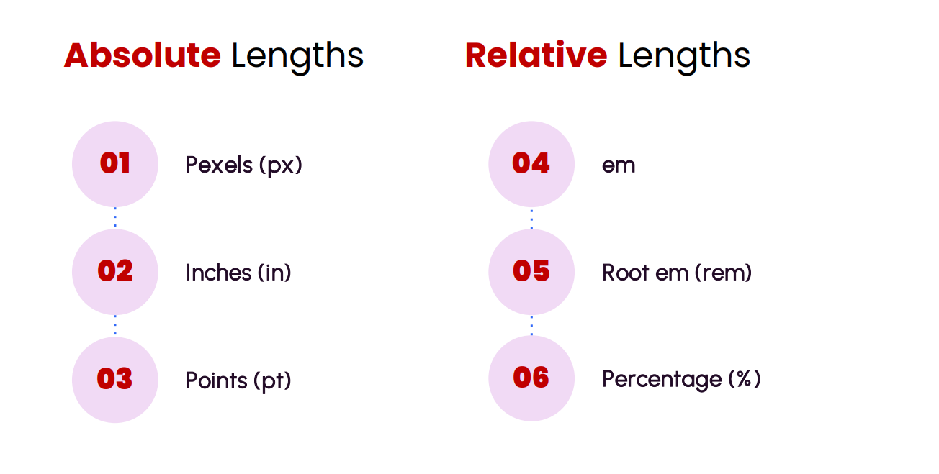

* Absolute Units: These units are fixed and do not change with the size of the parent element or the window. They are consistent across all devices, whether it’s a phone or a large monitor. Common absolute units include pixels (px), centimeters (cm), millimeters (mm), and inches (in).
* Relative Units: These units are based on another element’s size, either the parent element or the window itself. They are useful for creating responsive designs because they scale proportionally to the parent or window size. Common relative units include percentages (%), em, rem, viewport width (vw), viewport height (vh), and others.

*/\*? for Percentages  100% = 16px  \*/*

*/\* 1px = 6.25% \*/*

*/\*? for 1 em  = 16px \*/*

*/\*? for 1 rem = we can specify the font size of our will \*/*

*/\* we need 1rem = 10px, it makes our life easy  \*/*