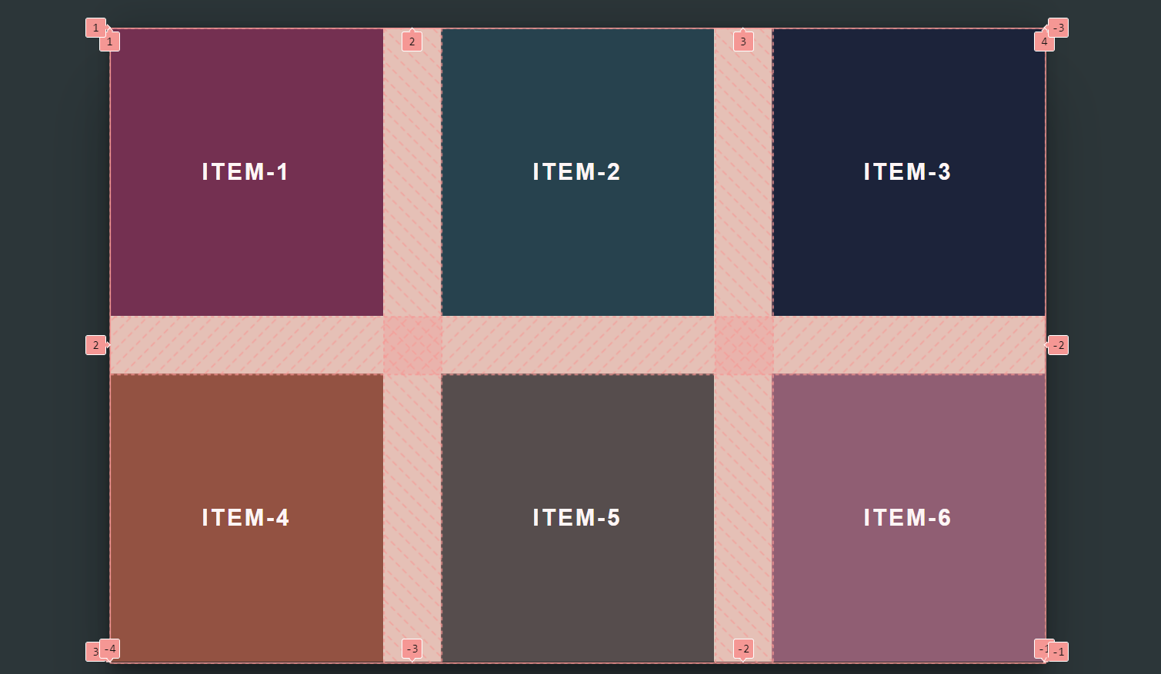

In this grid, there are 3 rows and 4 columns.

*/\*\* item-1 starts from row-1 and ends at row-2 we can change its position \*/*

  grid-row-start: 2;

  grid-row-end: 3;

*/\*\* shorthand  \*/*

  grid-row: 2 / 3;

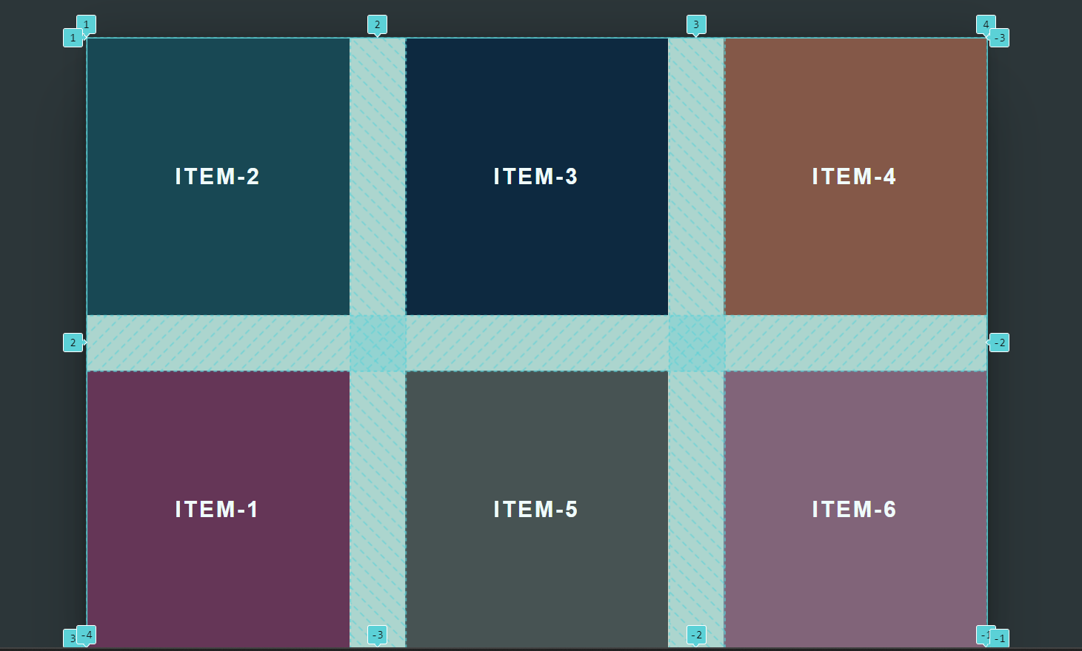

*/\*\* item-1 starts from column-1 and ends at column-2 we can change its position \*/*

  grid-column-start: 3;

  grid-column-end: 4;

*/\*\* shorthand  \*/*

  grid-column: 3 / 4;

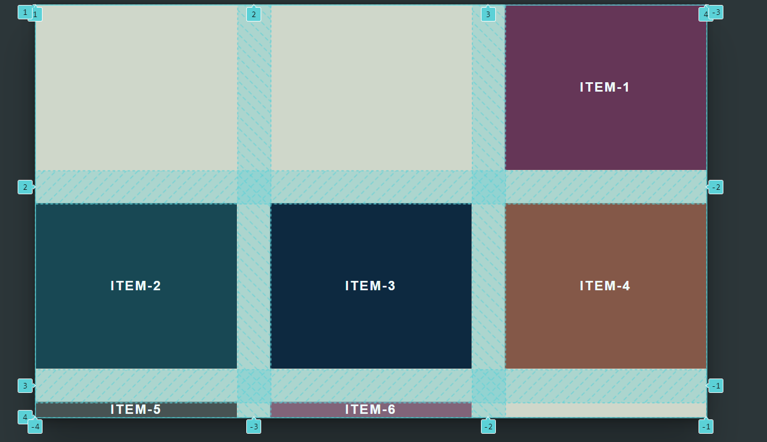

*/\*\* we can use this  \*/*

*/\*\* grid-area: grid-row-start / grid-column-start / grid-row-end / grid-column-end;  \*/*

  grid-area: 1 / 2 / 2 / 3;

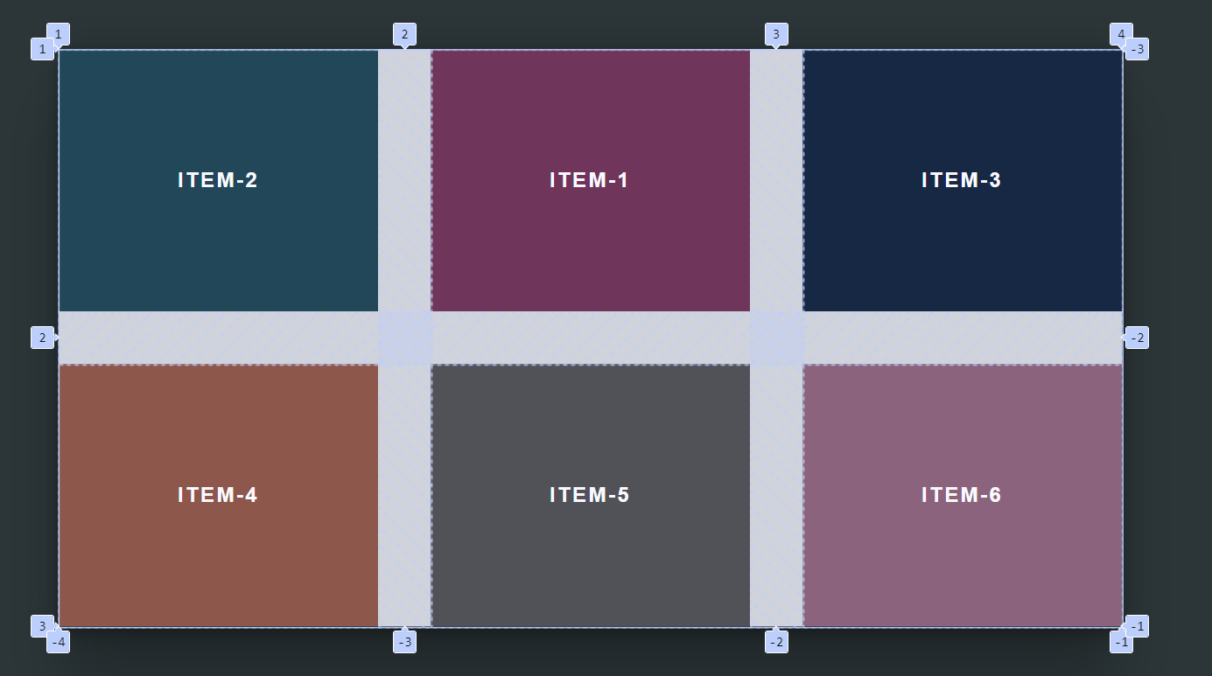

On doing this ↓

.item-3 {

  background-color: #041630;

  grid-area: 1 / 2 / 2 / 3;

  grid-row: 1/2;

  grid-column: 2/4;

}

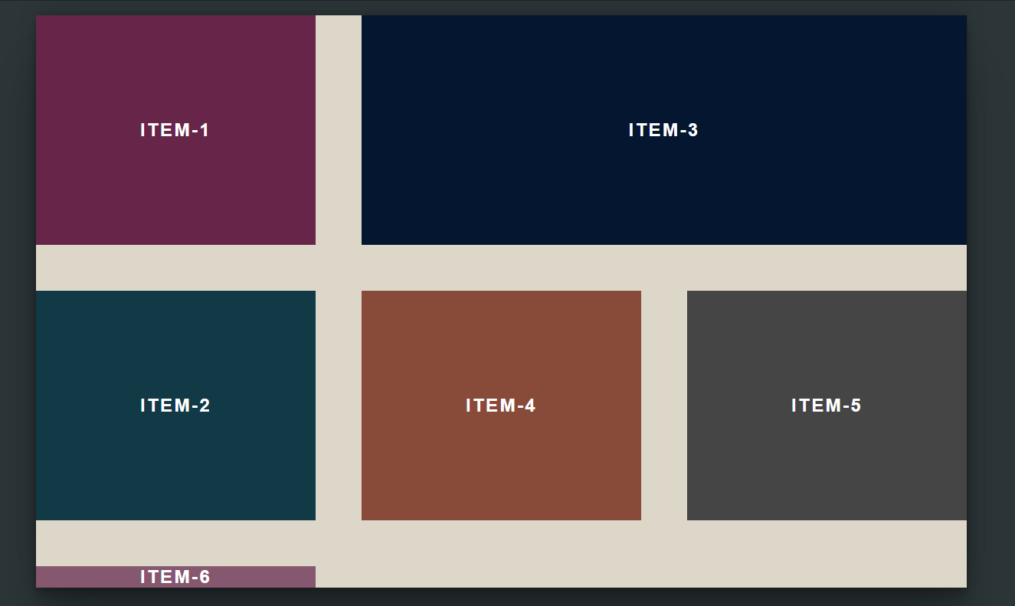a new row is created, this is called ‘implicit grid’. To give it those properties which other items have we use ‘grid-auto-rows’ in ‘grid-container’

*/\*\* grid-auto-rows property  \*/*

  grid-auto-rows: 250px;

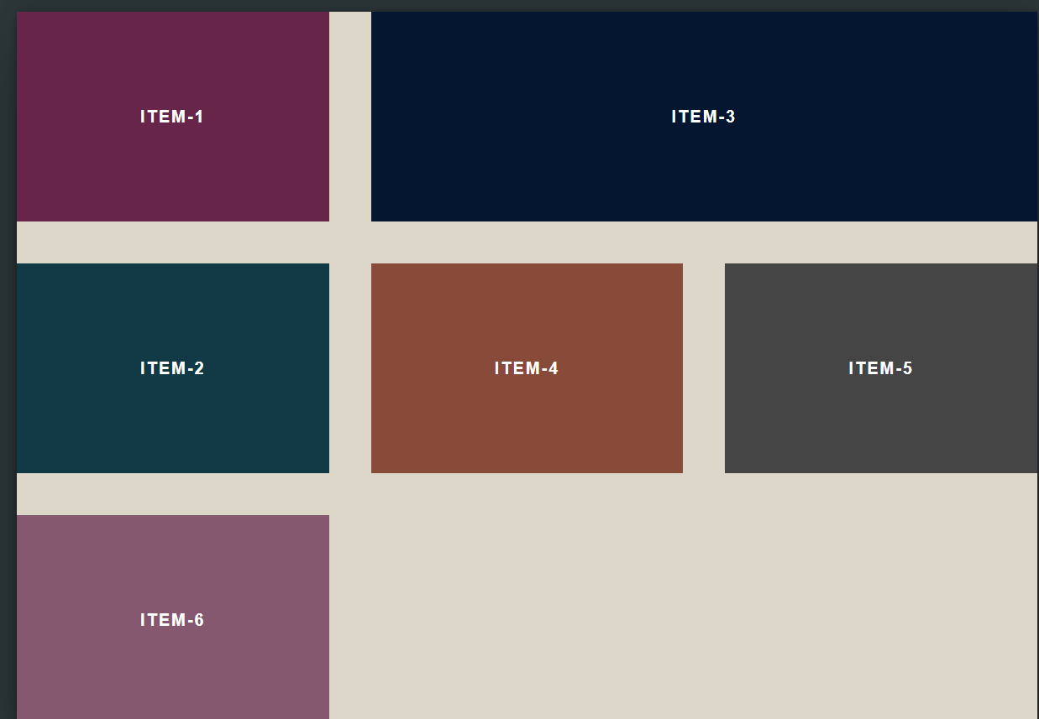

*/\*? it will give the width to column-2 in which its greatest word takes place  \*/*

  grid-template-columns: 1fr min-content repeat(1, 1fr);

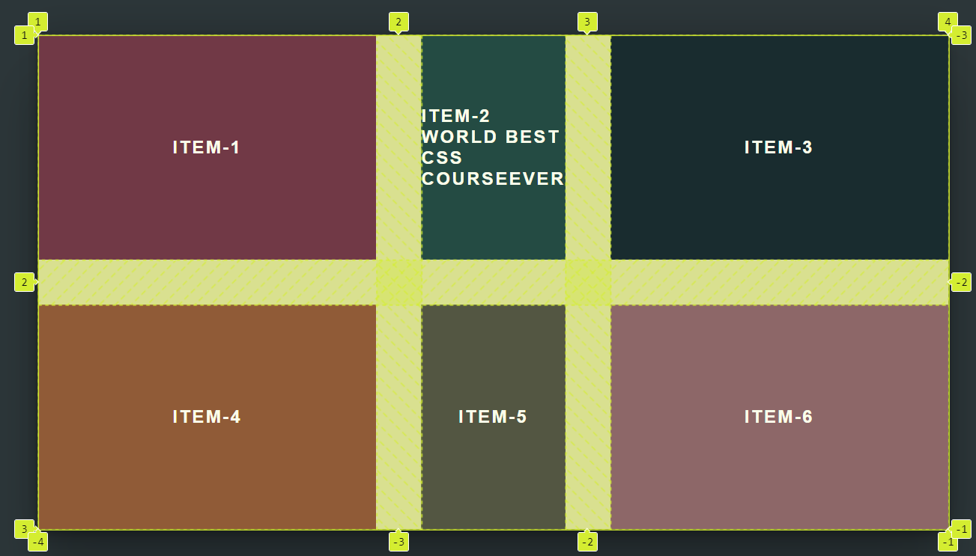

*/\*? it will give the width to column-2 in which its whole sentence takes place  \*/*

grid-template-columns: 1fr max-content repeat(1, 1fr);

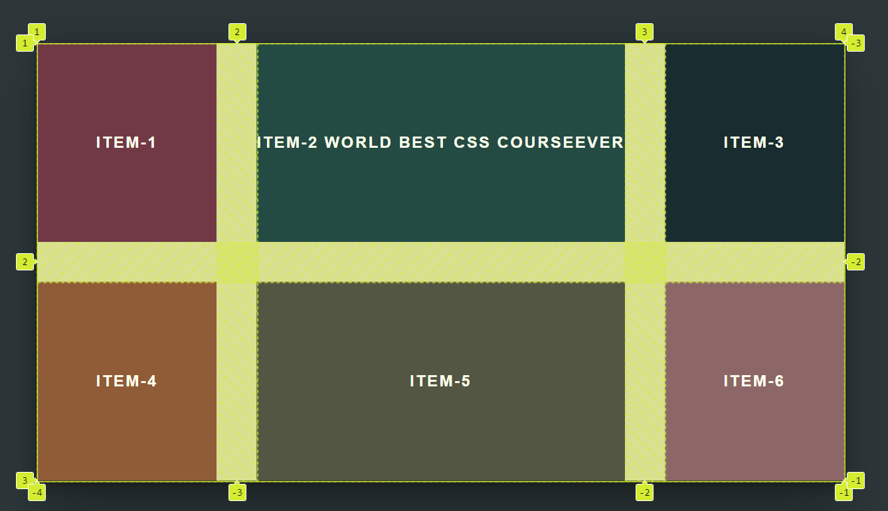

*/\*? it will set min. and max. width of column-2  \*/*

grid-template-columns: 1fr minmax(250px, 1fr) repeat(1, 1fr);

