Go to <https://www.mongodb.com/try/download/community> and download mongodb according to your system

Go to <https://www.mongodb.com/try/download/shell> and download mongodb shell according to your system

Go to <https://www.mongodb.com/try/download/database-tools> and download mongodb database tools according to your system

Note 🡪 download msi file not zip file

To check the installation is completed, enter in cmd 🡪 mongod –version

If the following result is not shown ↓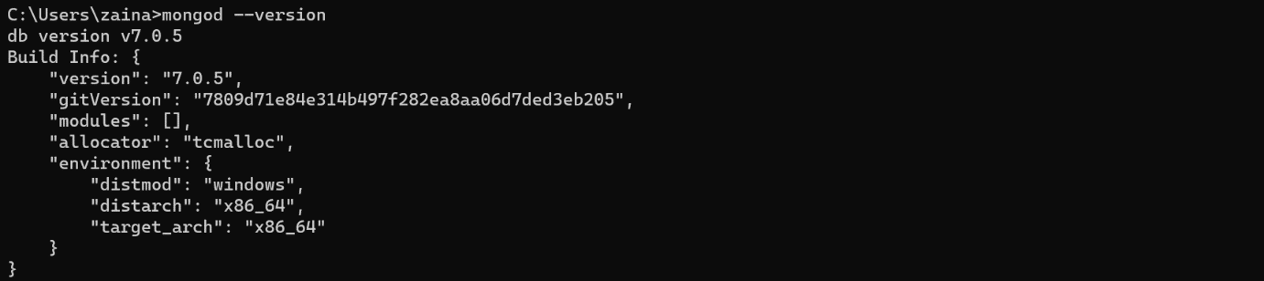then download zip file of mongodb shell and extract that folder then

Go to “C:\Users\user\Desktop\my_files\mongosh-2.1.3-win32-x64\mongosh-2.1.3-win32-x64\bin” and copy “mongosh” application and past it into “C:\Program Files\MongoDB\Server\7.0\bin” then copy this path and past it into “edit system environment ” application.