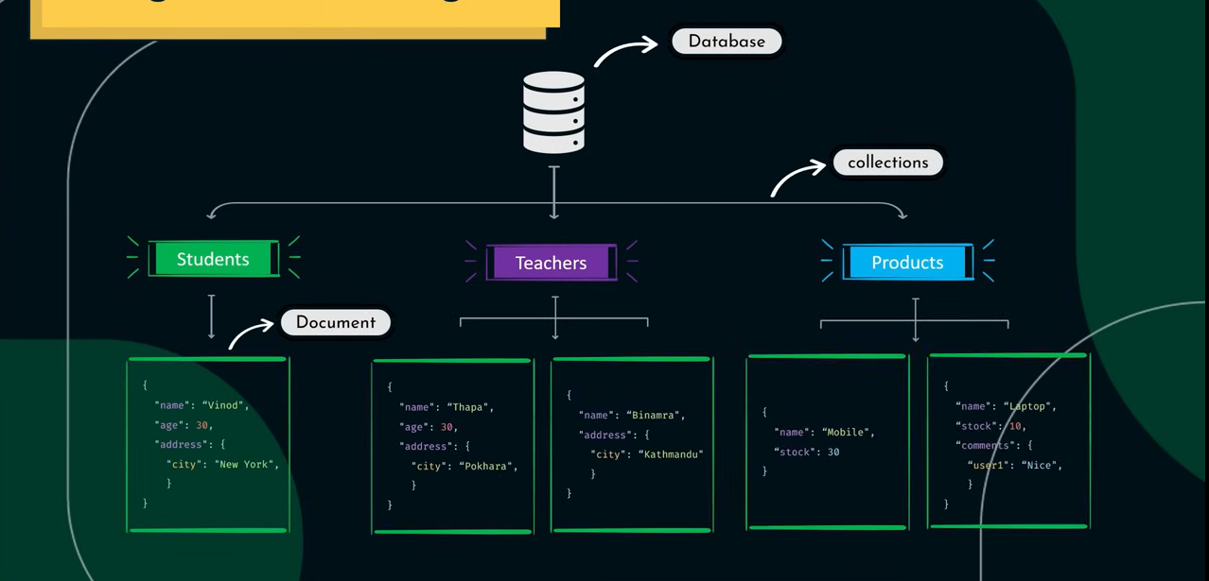

To show database 🡪 show dbs; or show databases

To use or create database 🡪 use database_name;

To delete database 🡪 db.dropDatabase();

To show colloction 🡪 show collections;

To create collection 🡪 db.createCollection(‘collection_name’);

To delete collection 🡪 db. collection_name.drop();

It does not show a database which has no collection.

Go to cmd and enter “mongosh” & use mongodb commands.