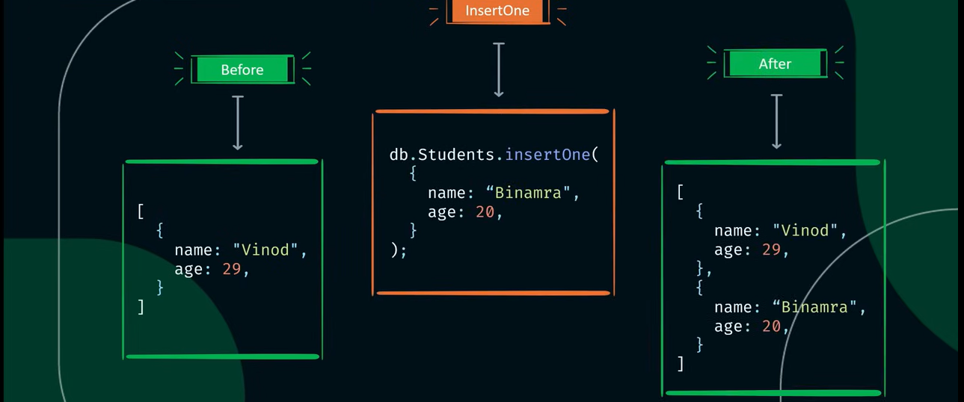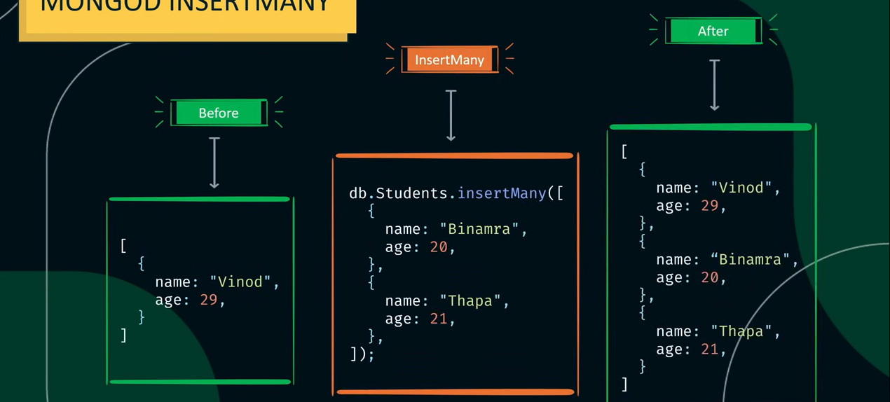

To see the documents 🡪 db.collection_name.find()

Using quotes is necessary when

1. Field name contains special characters, spaces or starts with a digit
2. Field name is the name of a reserved keyword in mongodb