



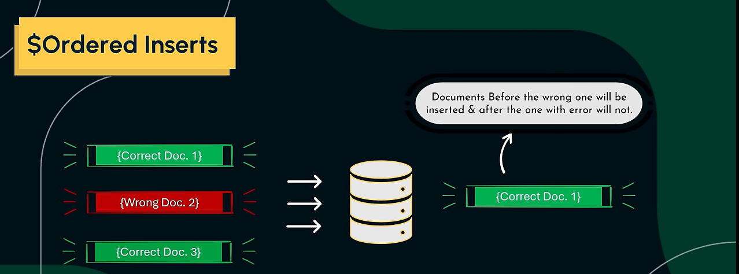

We have entered duplicate object-id '65ba379634e5bfd5817cfd37' in 3rd document at 2nd index. In ordered insertion, it will insert 1st & 2nd documents but will not insert 3rd and 4th documents due to error of insertion duplicate object-id ↓

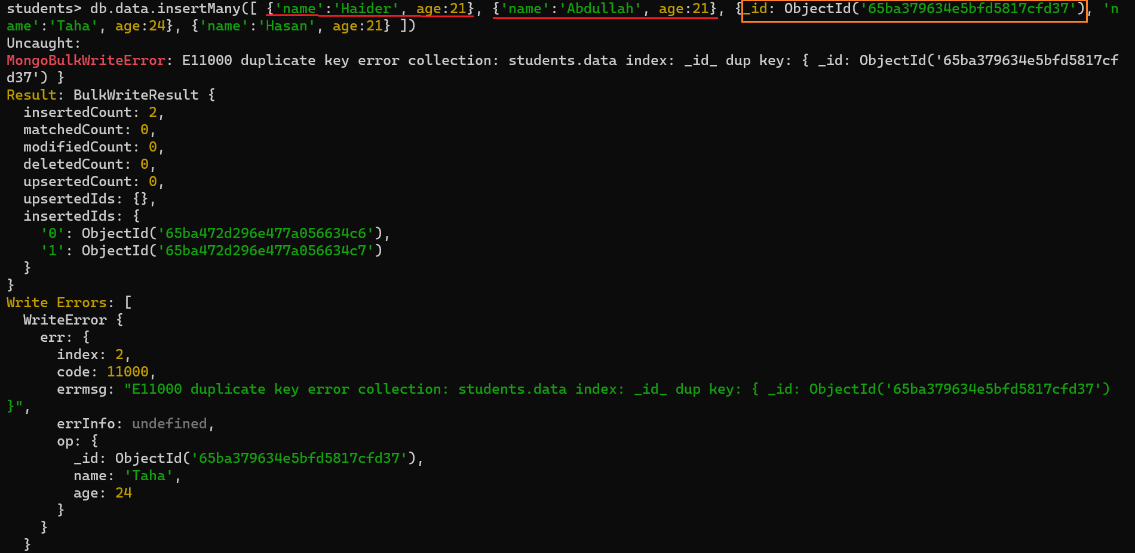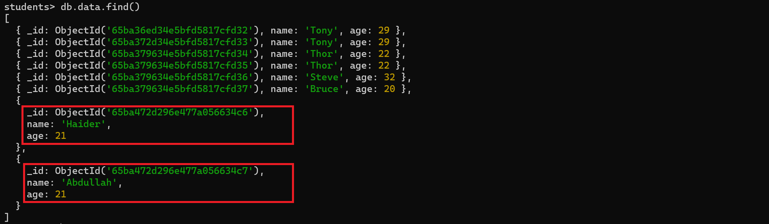



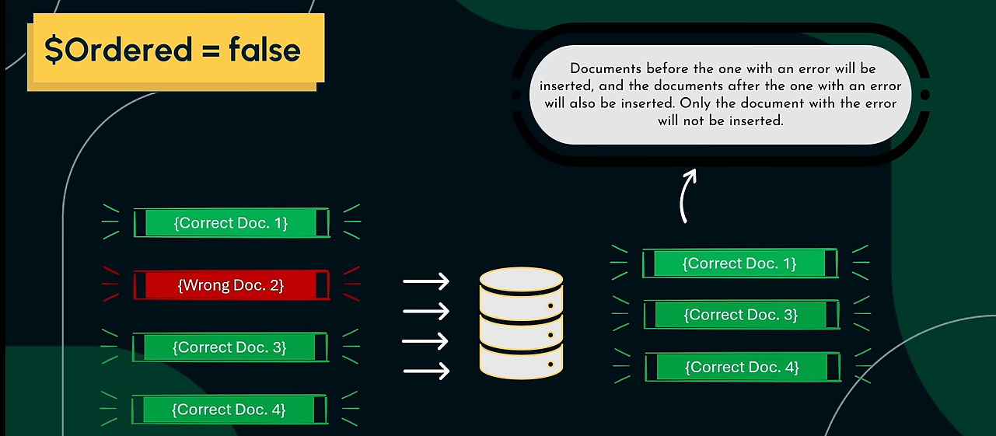

We have entered duplicate object-id '65ba379634e5bfd5817cfd37' in 3rd document at 2nd index. In unordered insertion, it will insert 1st, 2nd & 4th documents but will not insert 3rd document due to error of insertion duplicate object-id ↓

