To find whole document 🡪 db.collection_name.find() ↓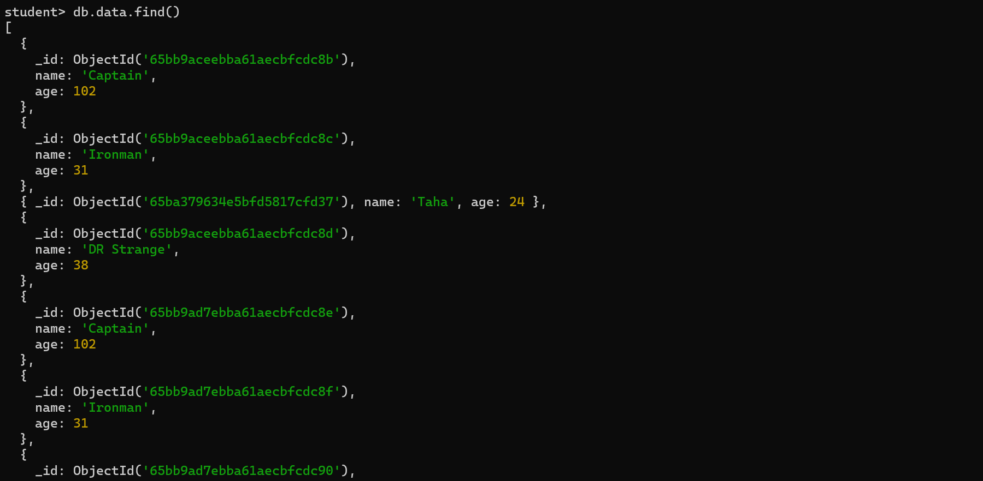

To find specific documents 🡪 db.collection_name.find({ key:value }) ↓

To find one document 🡪 db.collection_name.findOne({ key:value }) ↓