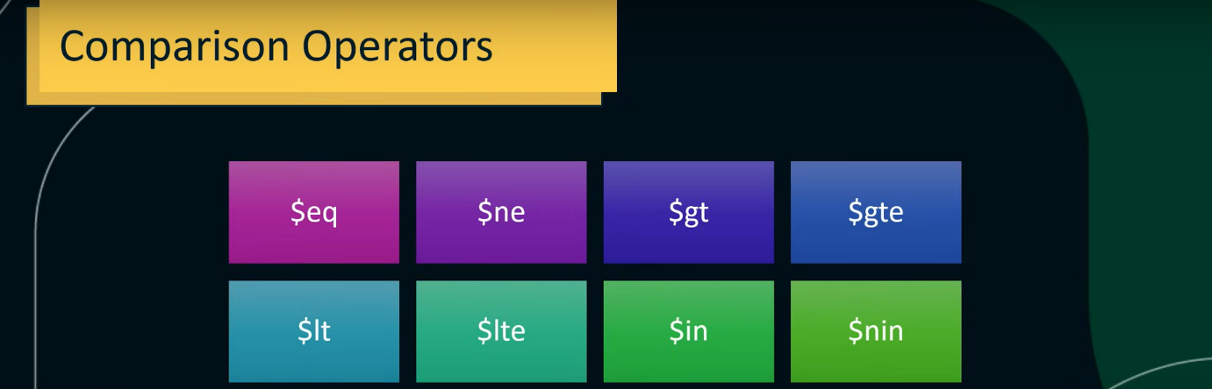

$eq = equal to

$ne = not equal to

$gt = greater than

$lt = less than

$gte = greater than or equal to

$lte = less than or equal to

$in = for in a list

$nin = for not in a list

Syntax 🡪 db.collection_name.find({ ‘field_name’ : { operator : value } })

To get no. of documents in the result, use 🡪 count()

For example ↓

