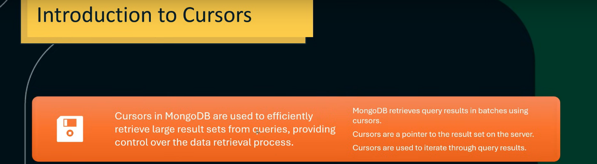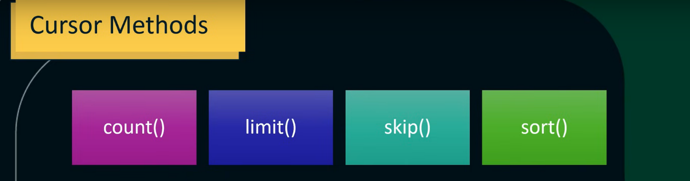

count() 🡪 to count no. of documents ↓

limit() 🡪 to set limit of documents ↓ 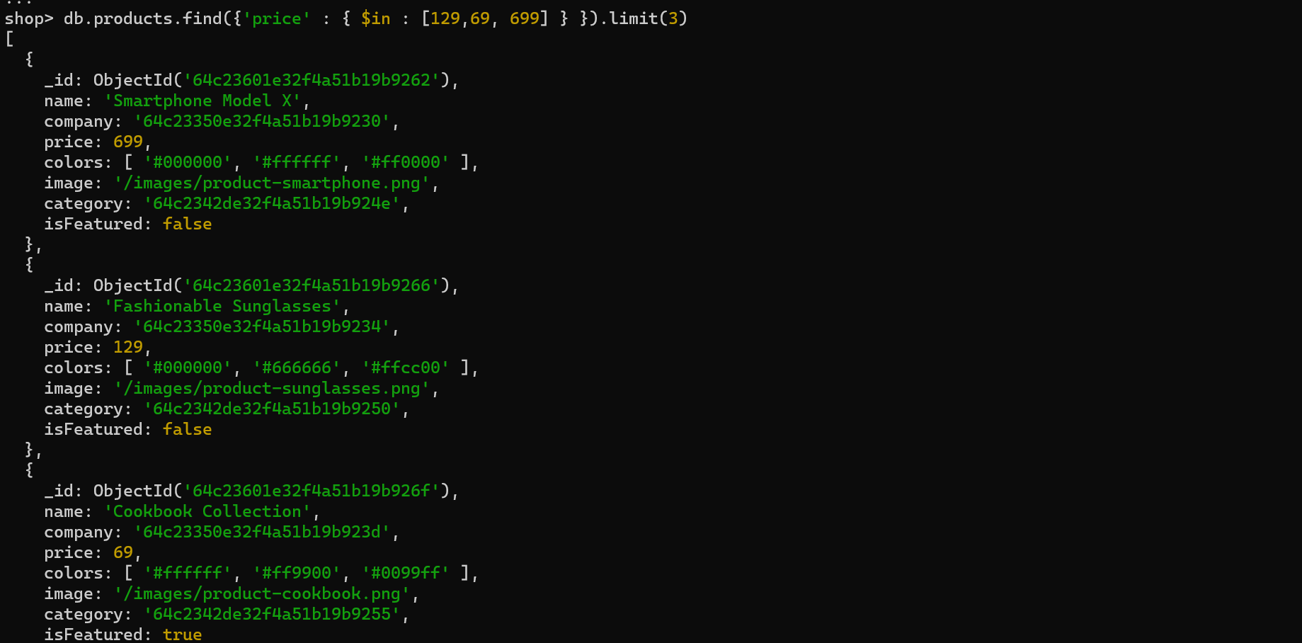

skip () 🡪 to skip specified no. of documents ↓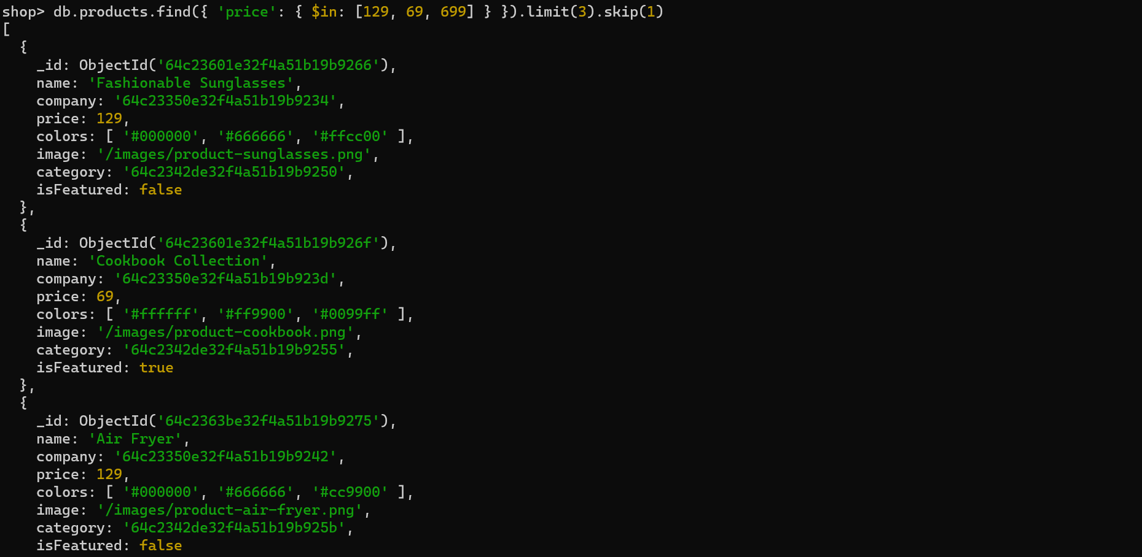using skip(), 1st document has been skipped.

sort() 🡪 to sort, use 1 for increasing order and use -1 for decreasing order ↓