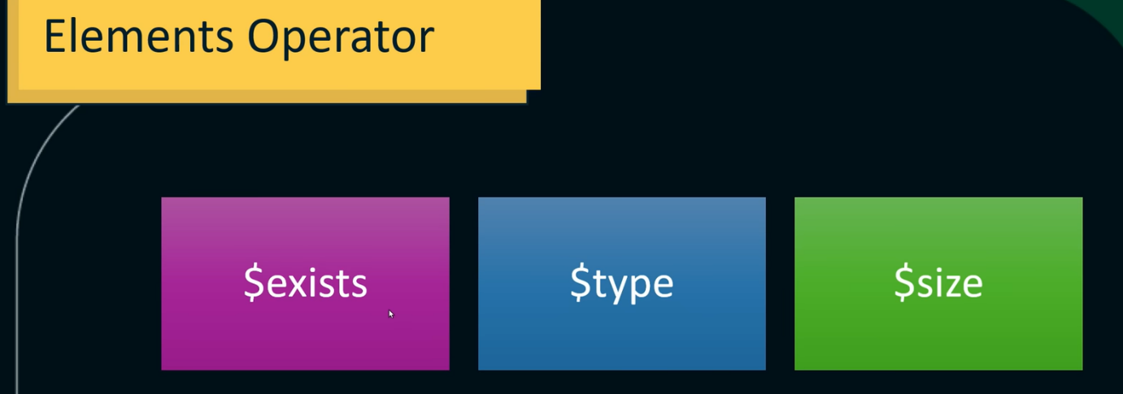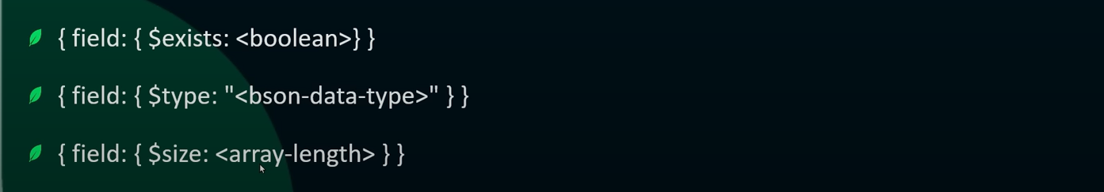

For example ↓







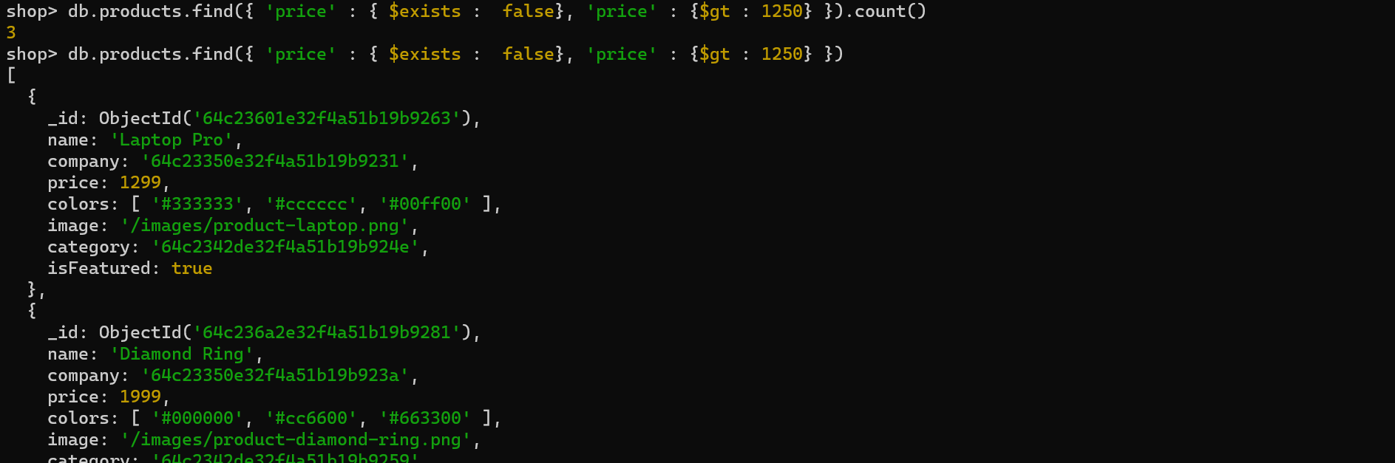

The $type operator filters documents based on the BSON data type of a field.

Using this, we can check which field has string datatype or any other, e.g., ↓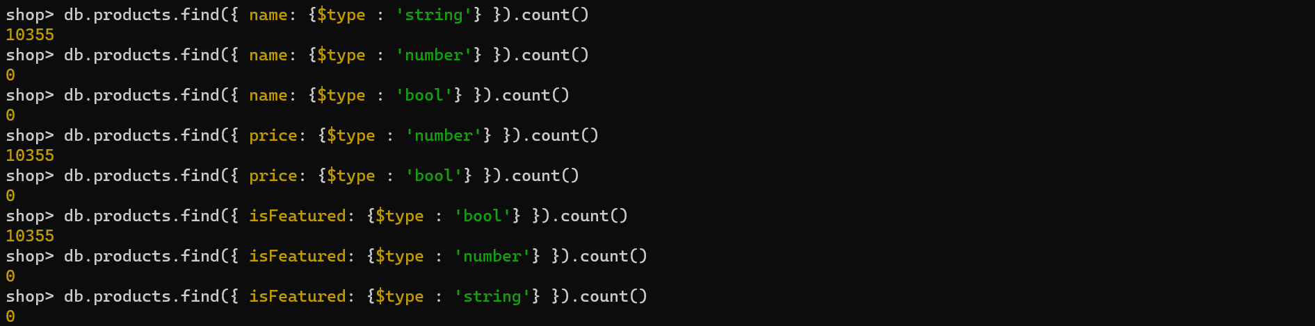

We can use the following numbers for their datatypes ↓*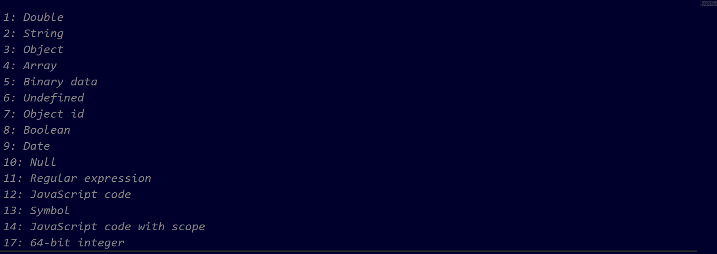*

For example ↓*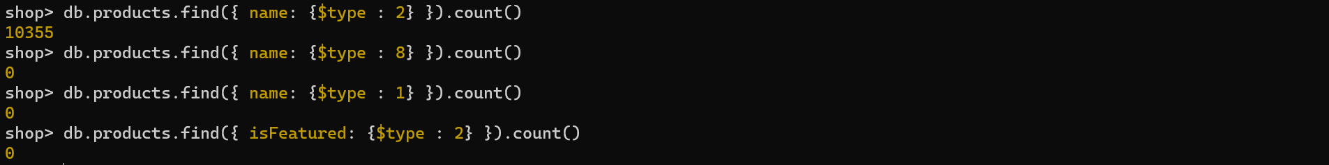*

If a document has a key which value is an array then we can find out the documents having same size of the array using $size operator, e.g., ↓*