We use this method, when we want to find out objects of elements as you can see in ‘comments’ field.



For example ↓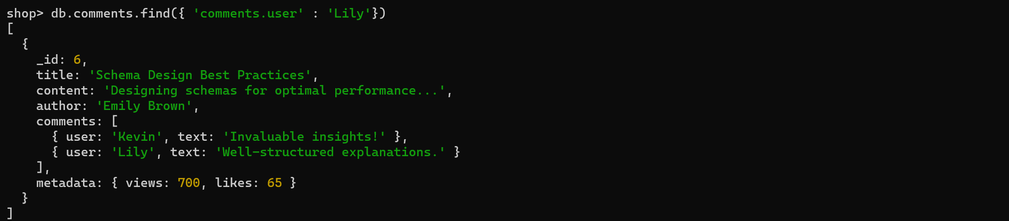

Find out the documents in which views is grater than or equal to 1200 ↓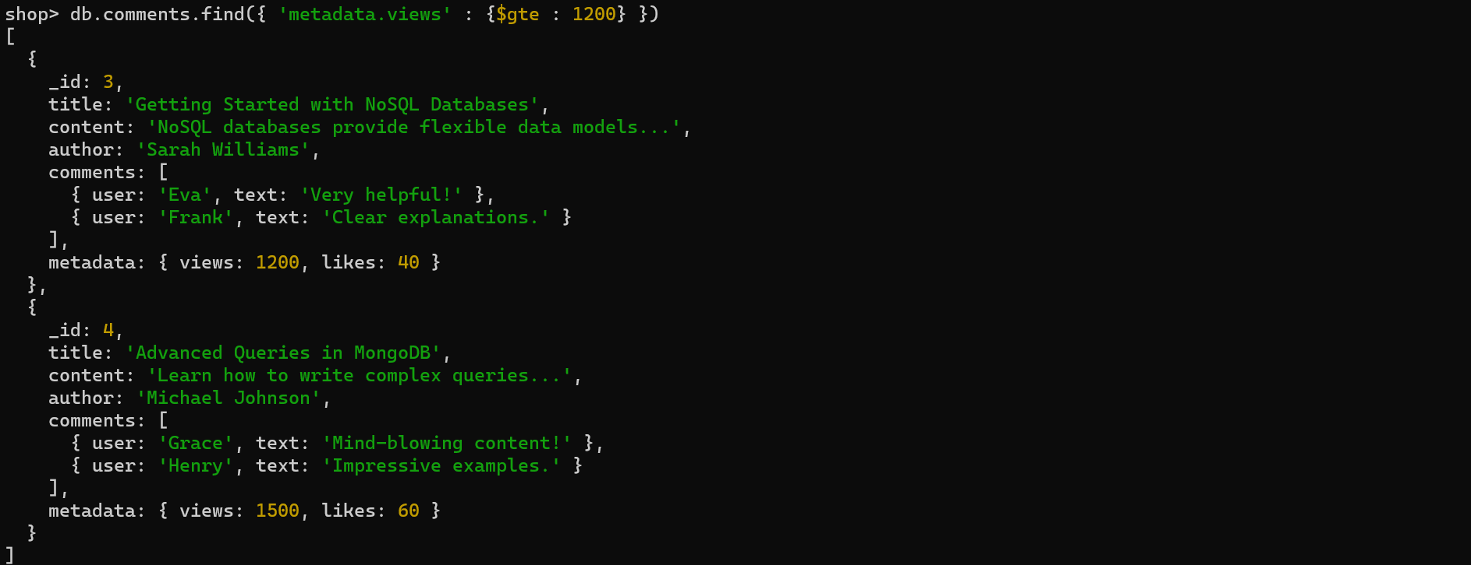

Find out the documents in which user is ‘Henry’ and likes > 50 ↓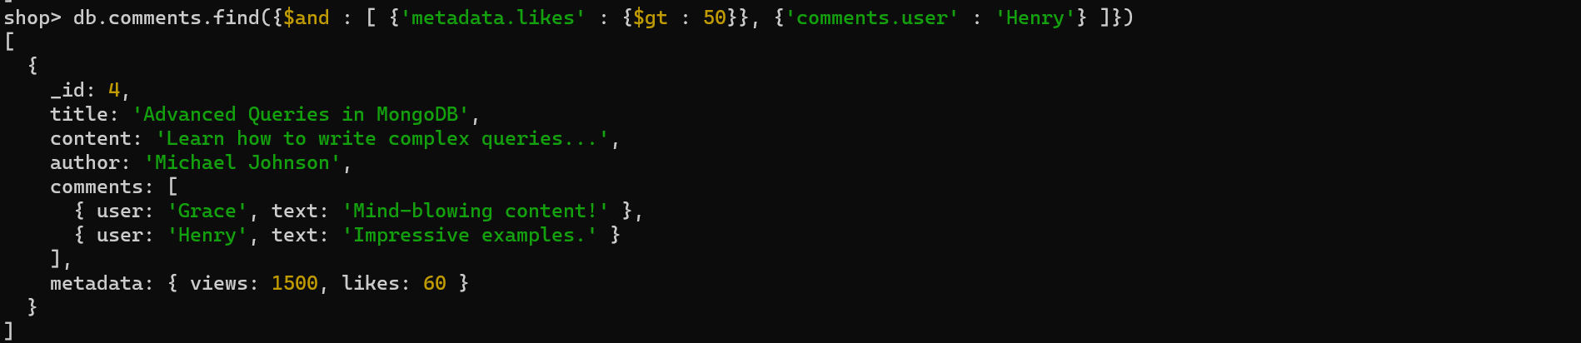or ↓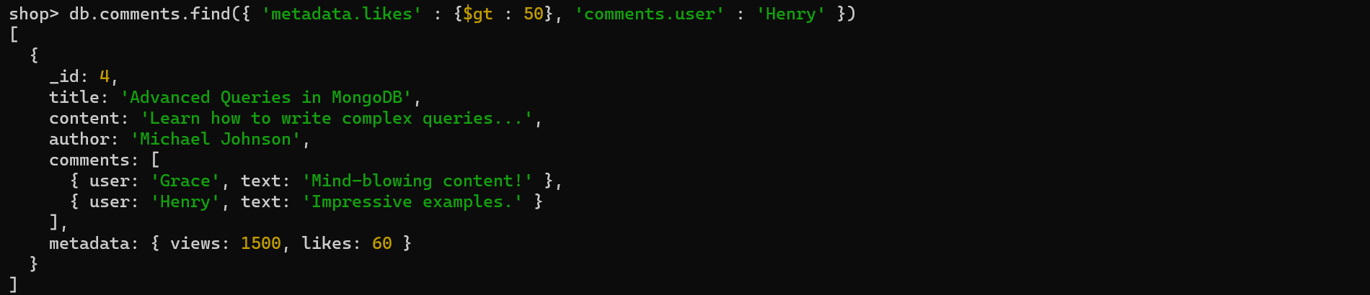

Find out the documents in which users Alice and Vinod only commented ↓