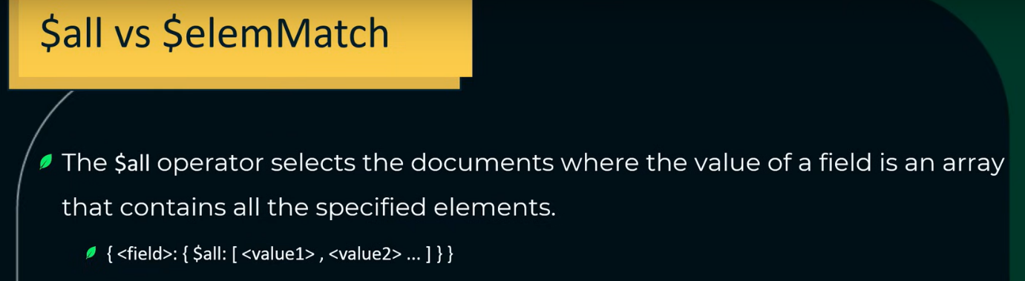

For example ↓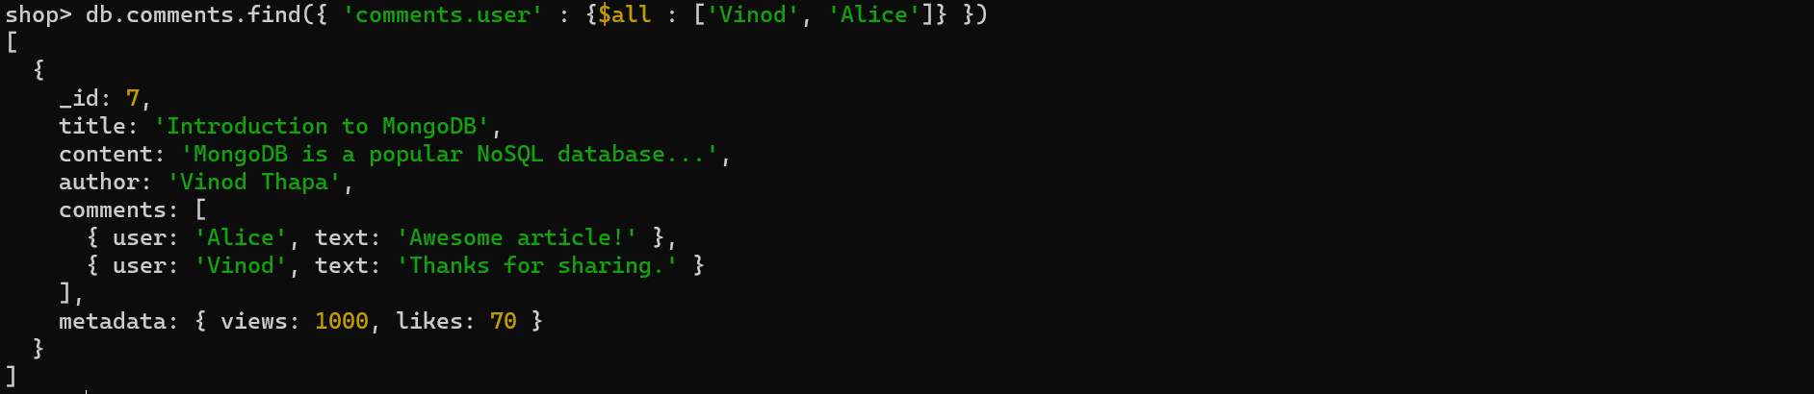

We have to find out the documents in which user is ‘Vinod’ and his comment is ‘Thanks for sharing.’ . In this case, both fields are different so we can not use ‘all’ operator therefore we use ‘elemMatch’ operator ↓For example ↓