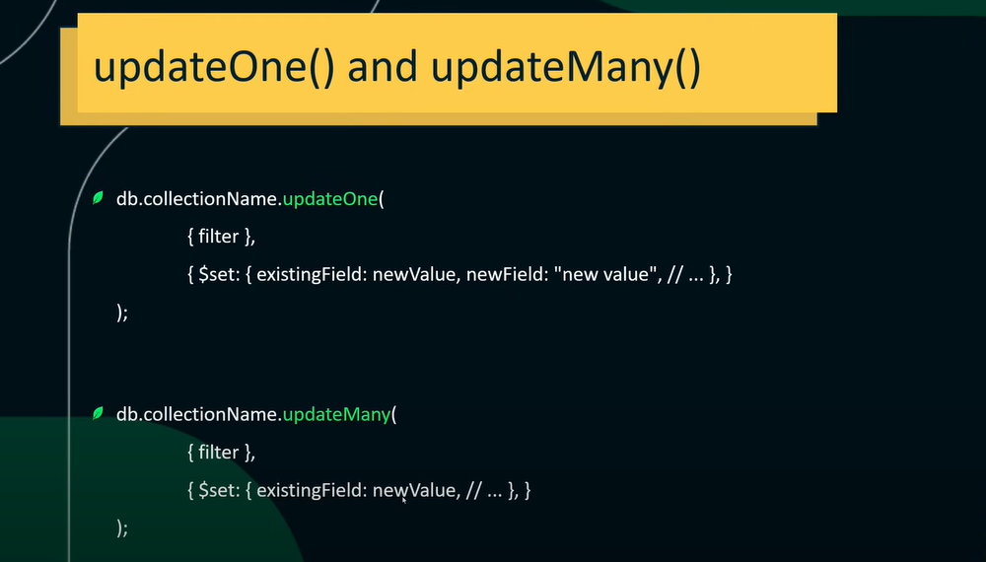

Before updating ↓ 

updating ↓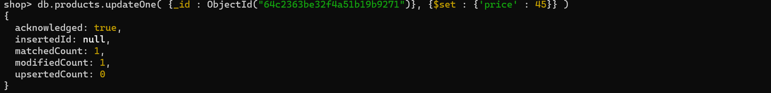

after updating ↓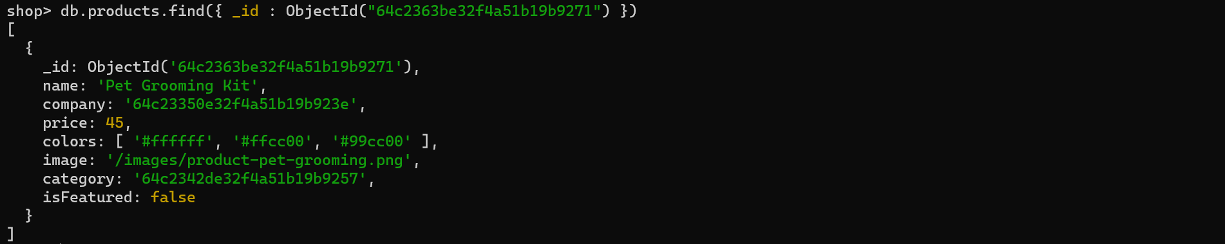

Update isFeatured from ‘true’ to ‘false’ ↓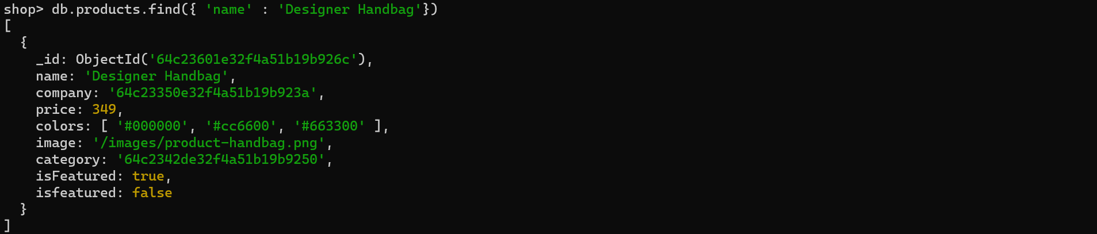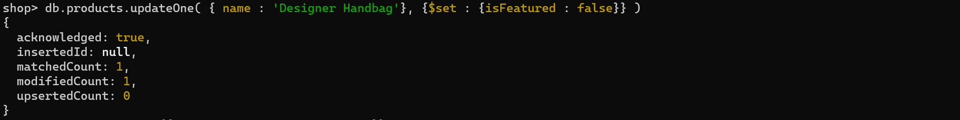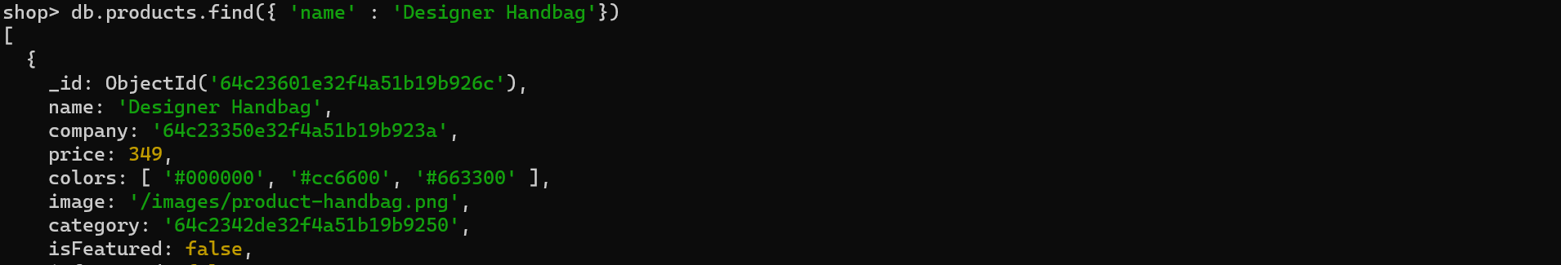

Update all isFeatured value to true where the price is 120 ↓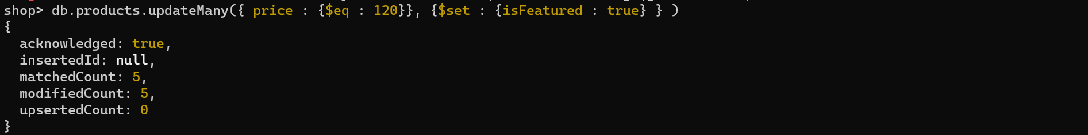

If we use updateOne then only one document will be updated.

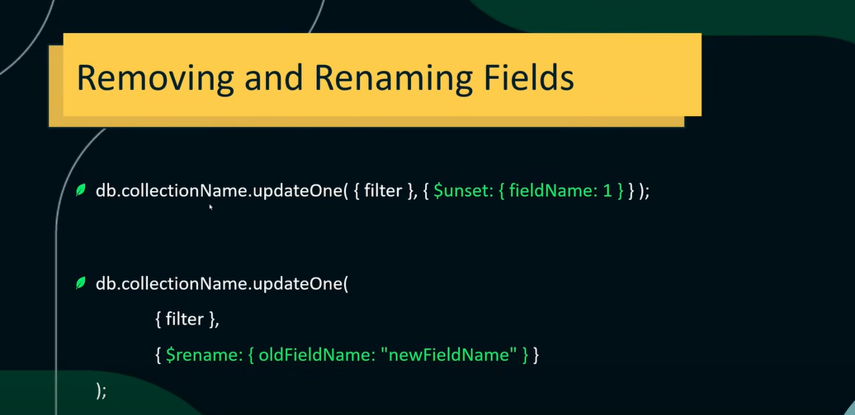

Rename the isFeatured field to isFeature where price = 123 ↓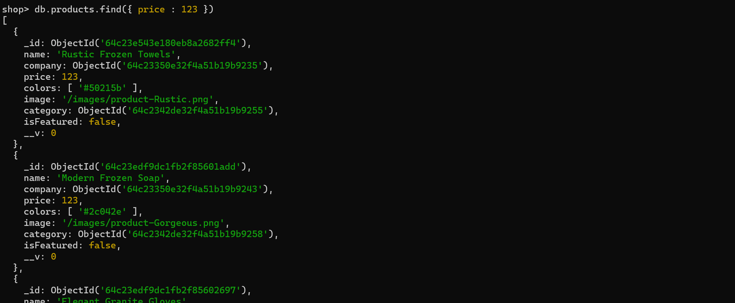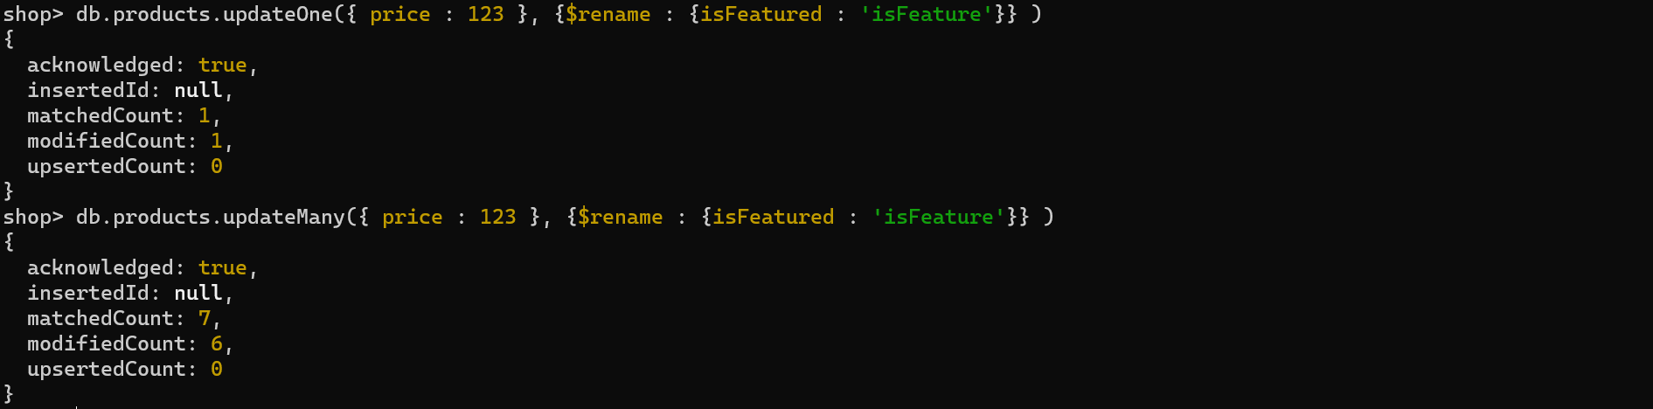

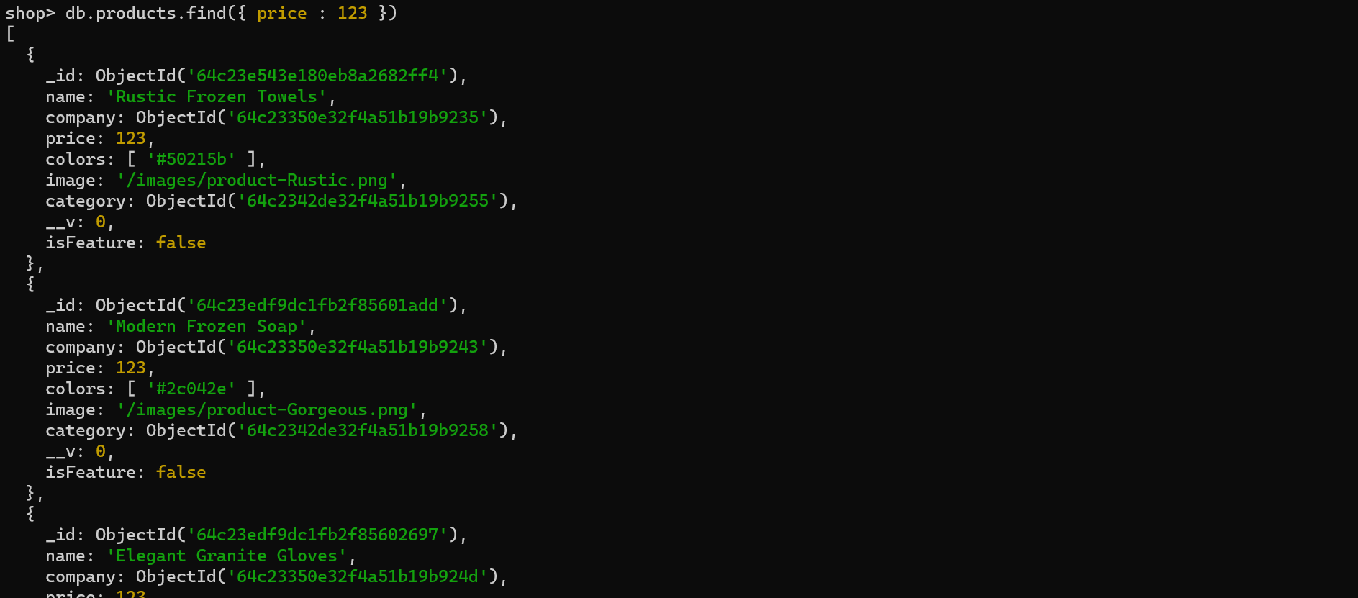

We can add new fields using updateOne and updateMany ↓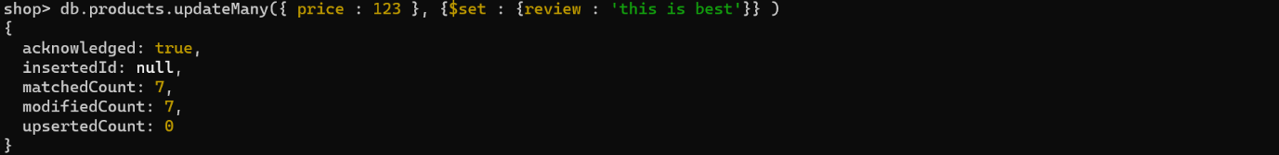



Add a comment in comments field where id = 5 ↓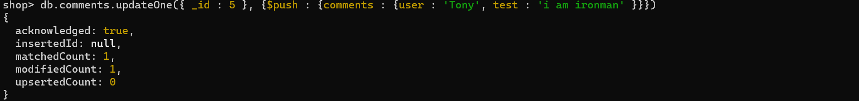

Update the comment where id is 7 and user is Vinod ↓





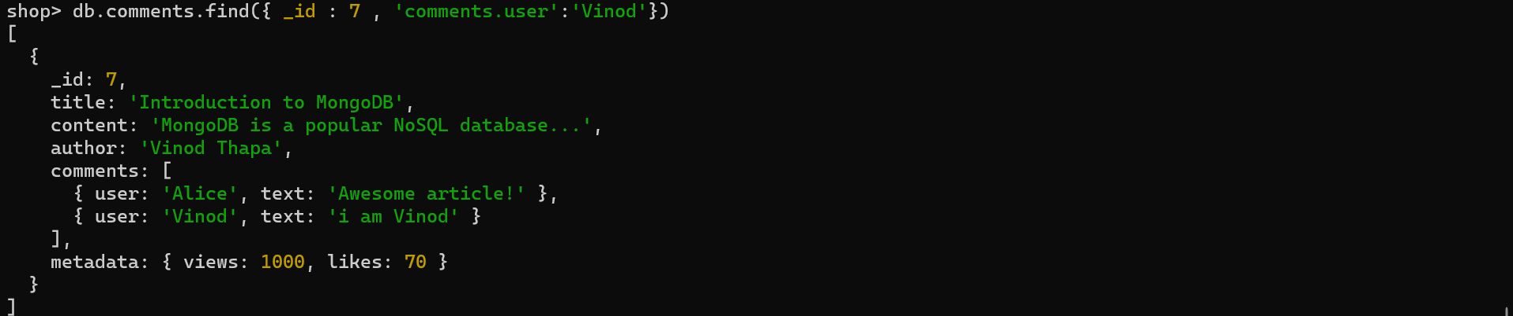

Similarly we can change user name ↓