Example of $match operator ↓

And ↓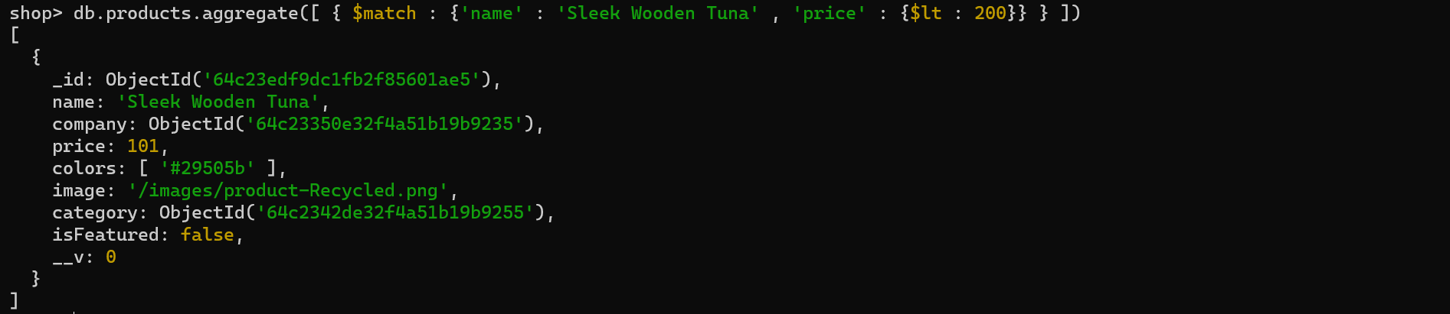

Example of $group operator ↓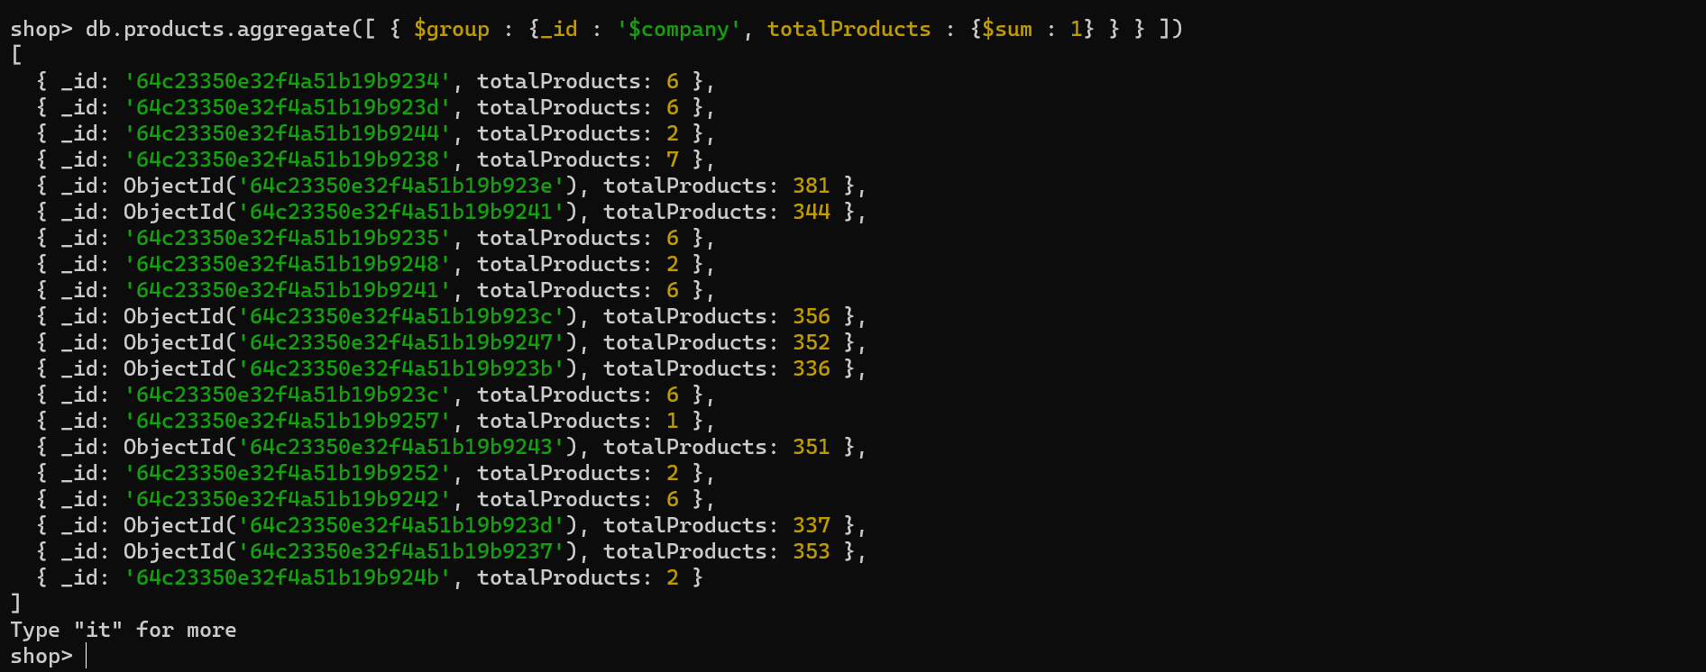

And ↓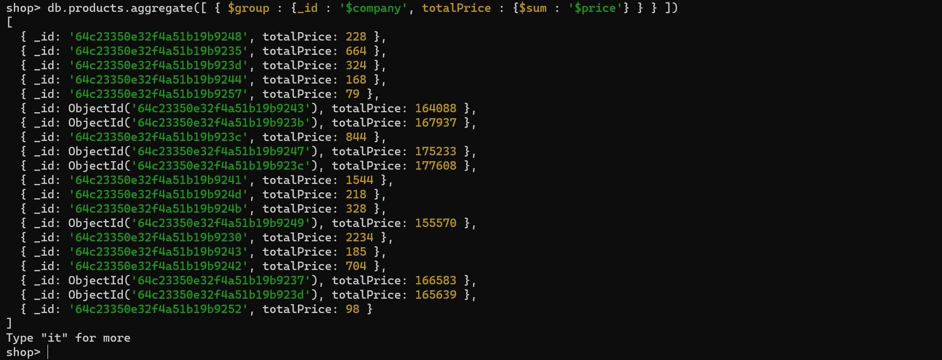

We can use them together ↓ 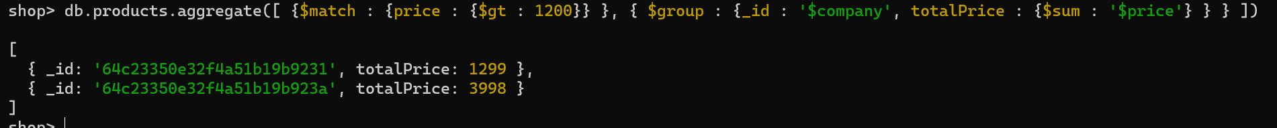

And ↓

And 