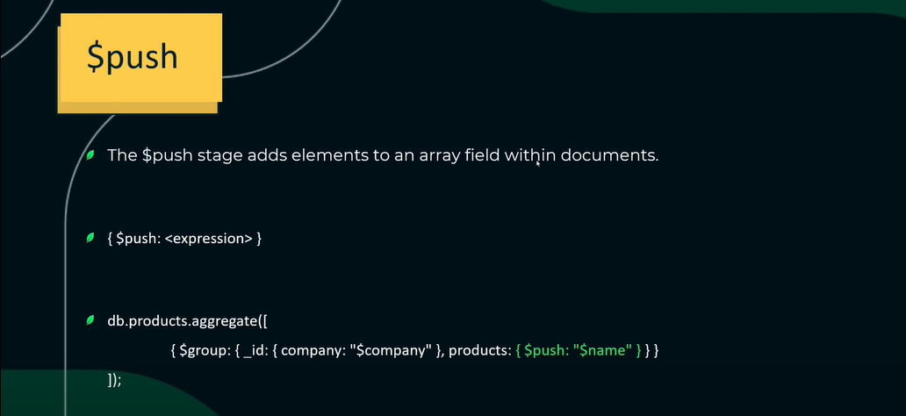

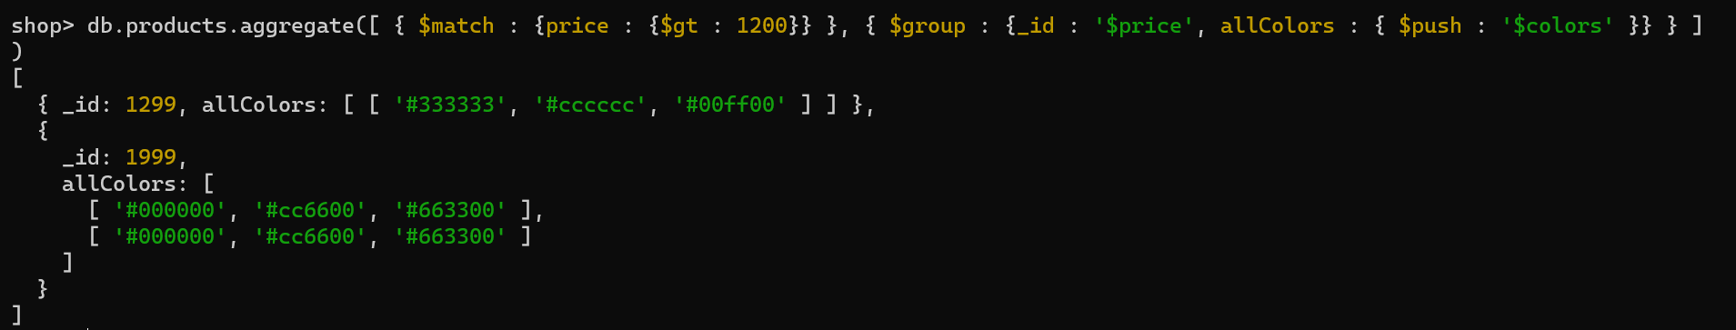in this array of arrays has been created and duplicates are also present.

To get all value in one array, we don’t want array of arrays is created. Therefore, we use $unwind operator ↓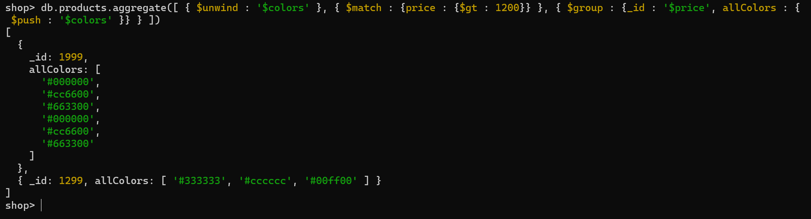

To remove duplicate values, we use $addToSet operator in place of $push ↓