Example of $size operator ↓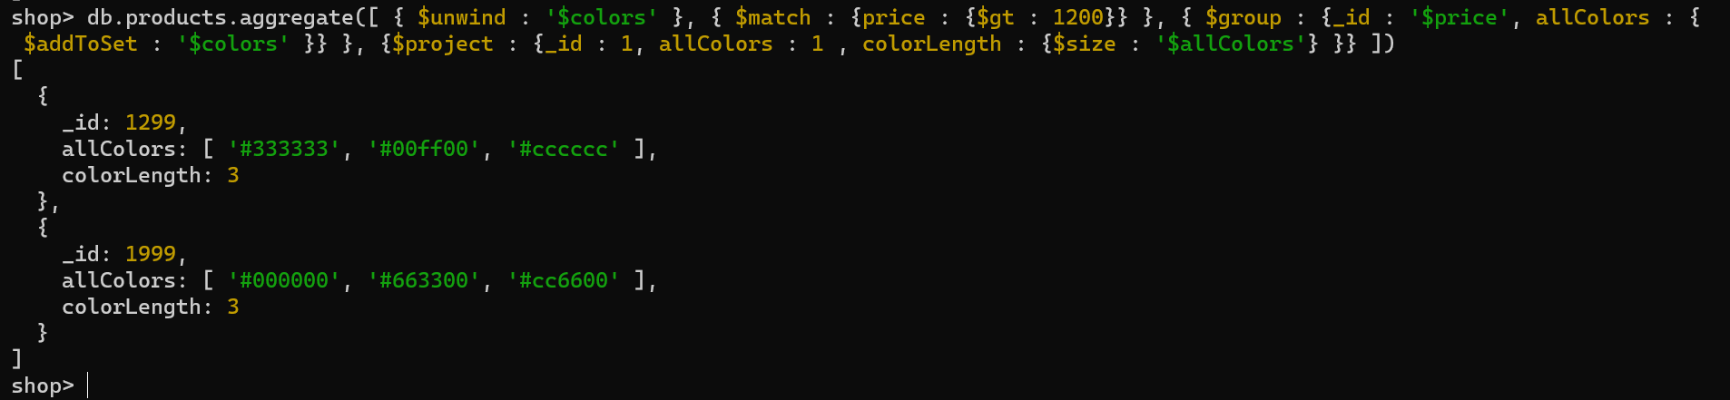

Example of $limit operator ↓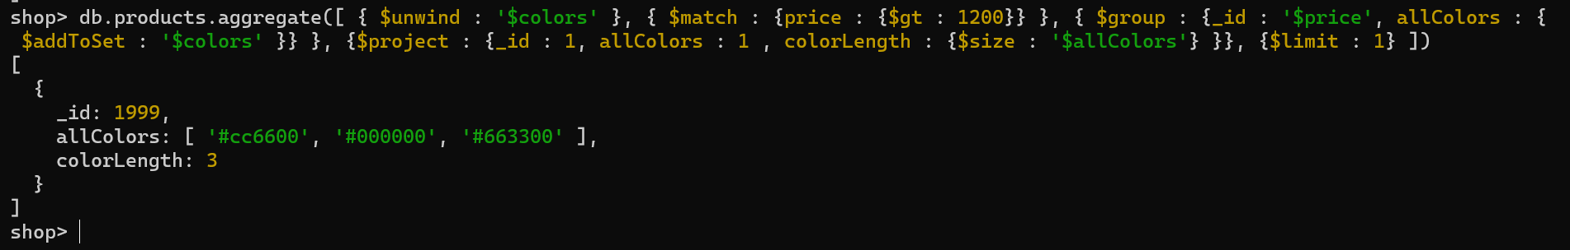

Example of $skip operator ↓