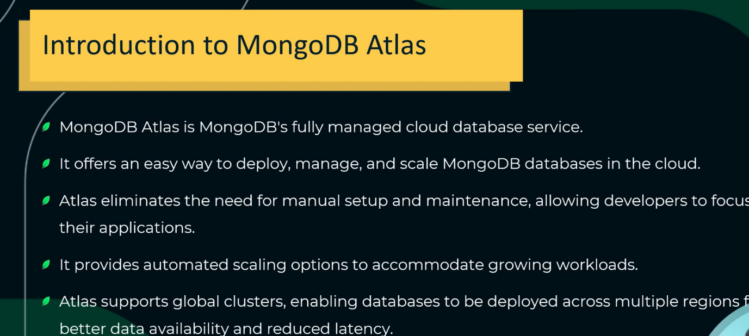



go to ‘https://www.mongodb.com/atlas/database’ and click on ‘try free’ option and do sign up.