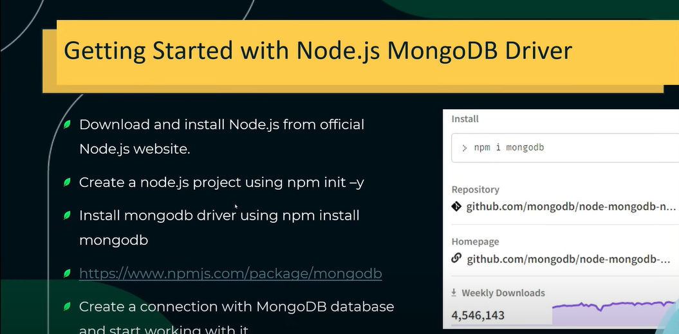

Run the command 🡪 npm init -y

Run the command 🡪 npm i mongodb

Go to cmd and enter ‘mongosh’ then copy IP address through which we will connect ↓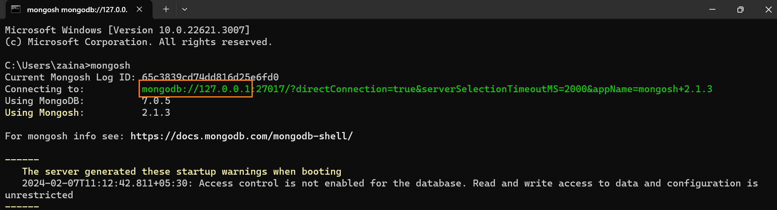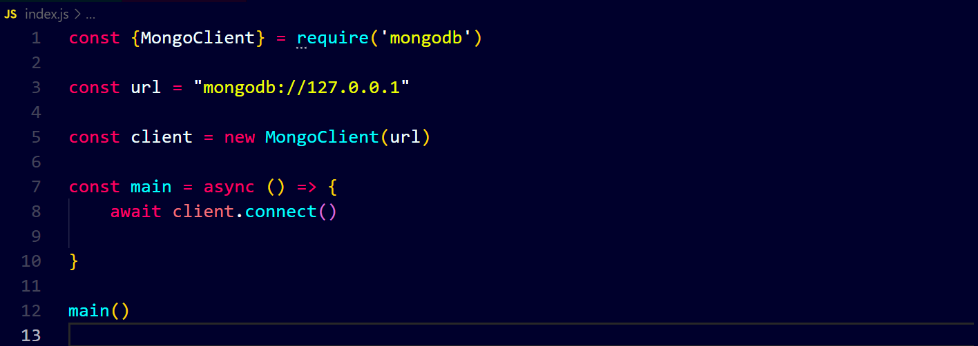

Code ↓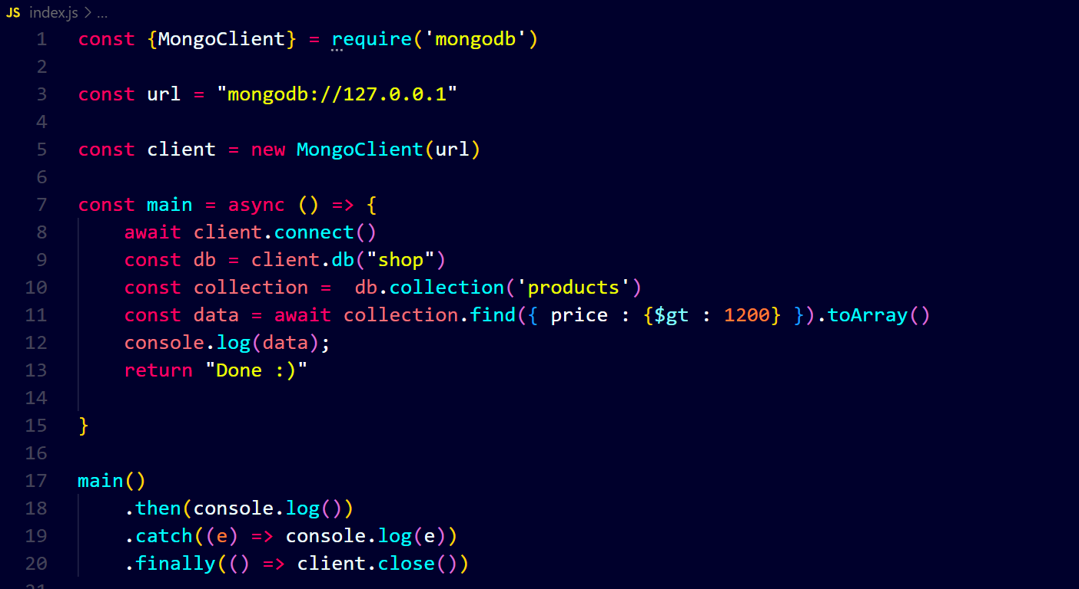

Output ↓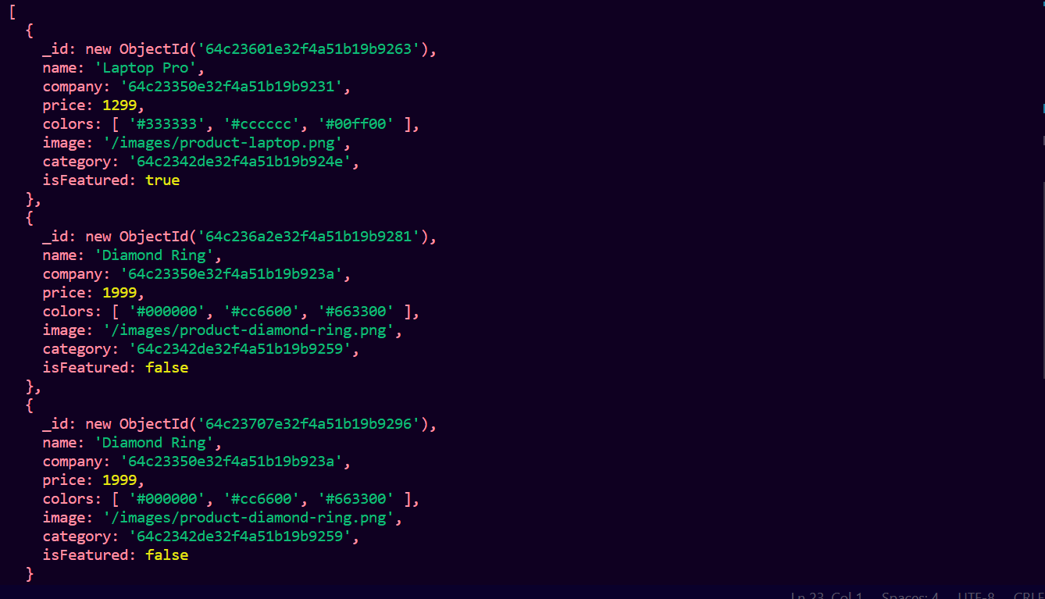

Now we will insert data ↓



Output ↓