Run the command 🡪 npm init -y Run the command 🡪 npm i mongoose In mongoose, we have to create schema Now we will make connection and write code to get data from collection ‘product’

Code for connection and schema ↓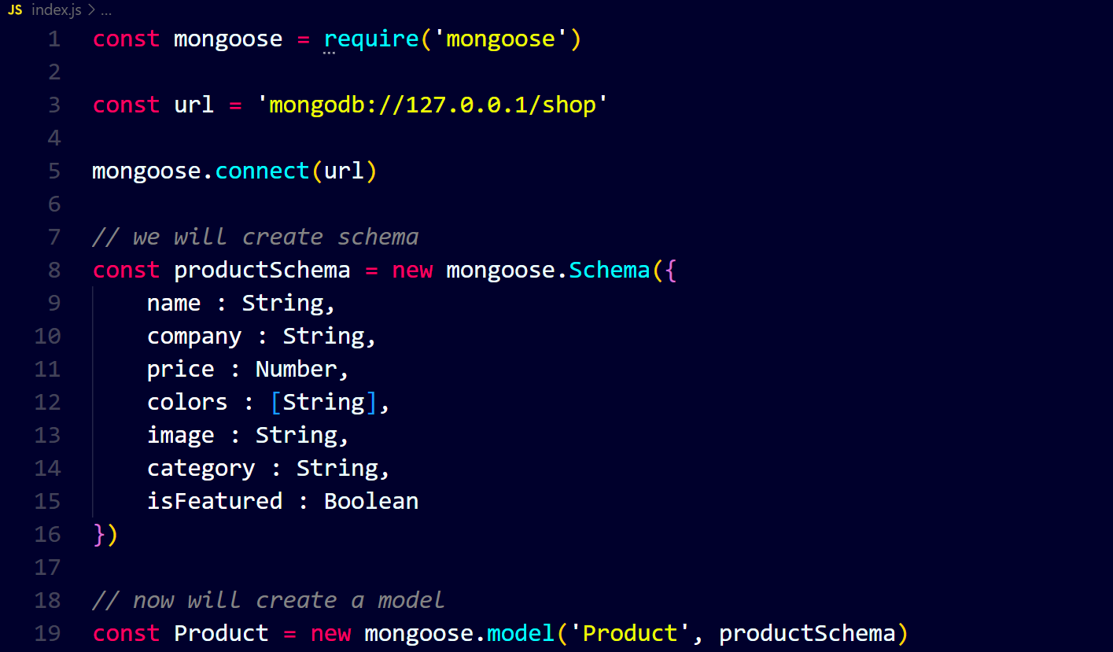Code for get data ↓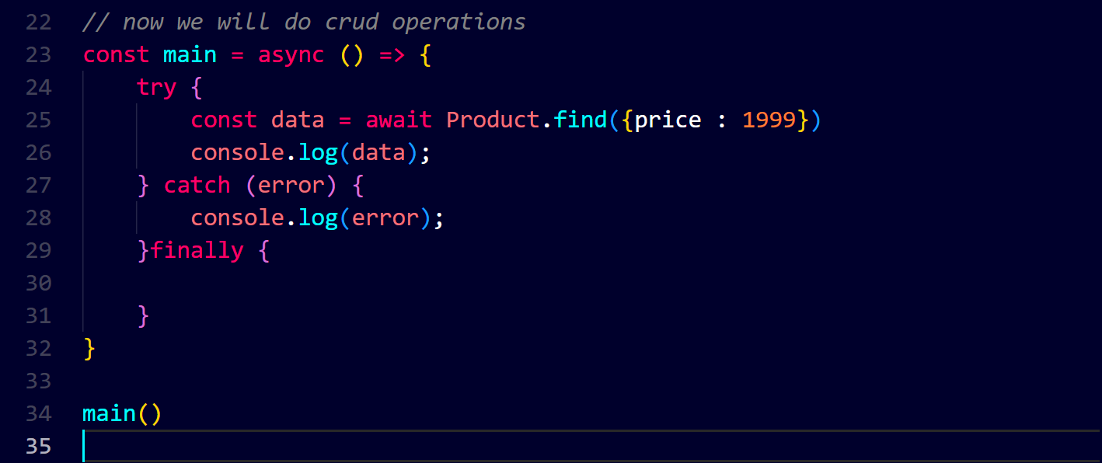Output ↓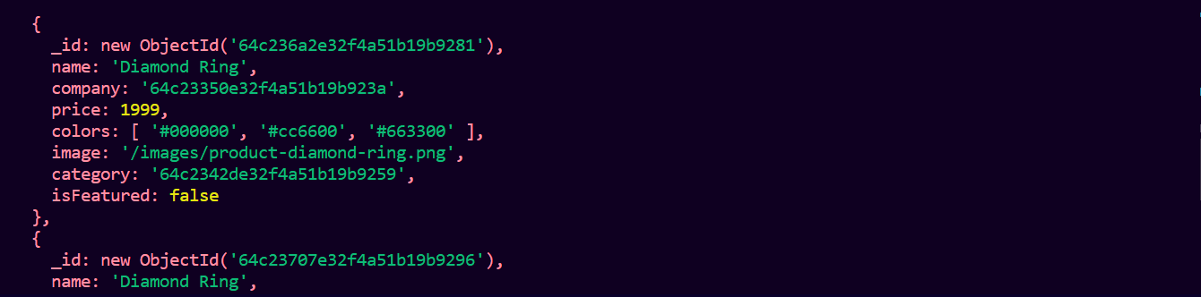

Code for inserting data and the data ↓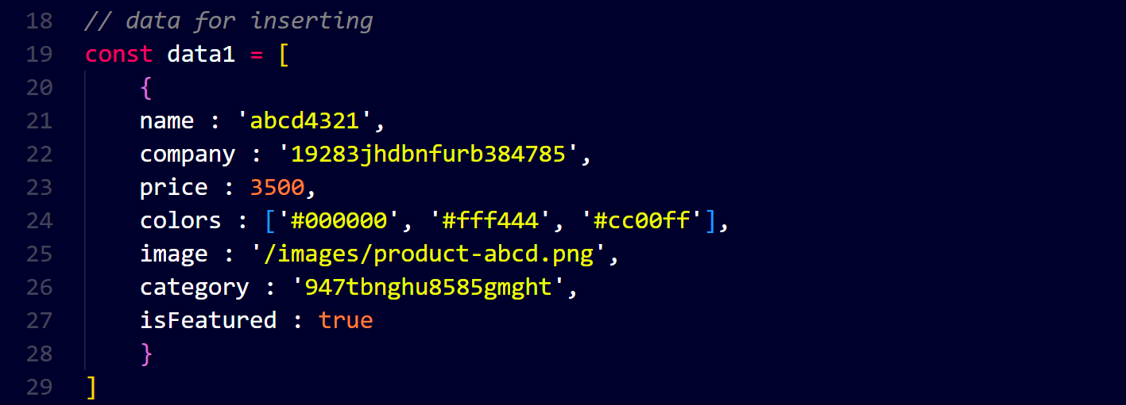Output in mongodb compass ↓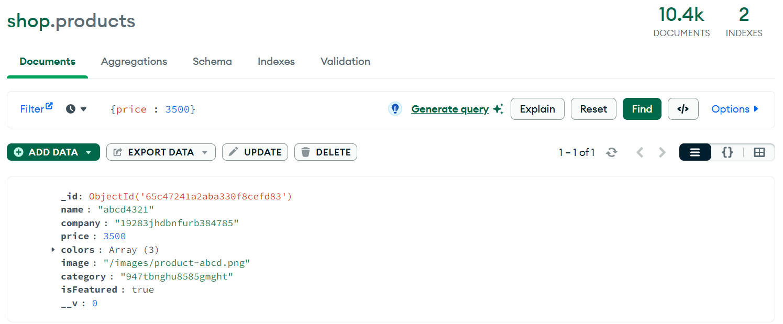

Remember these changes take place on local server not on original server.

Now we will make changes on origina server using Atlas. You can see at atlas there is no data with price 3500 ↓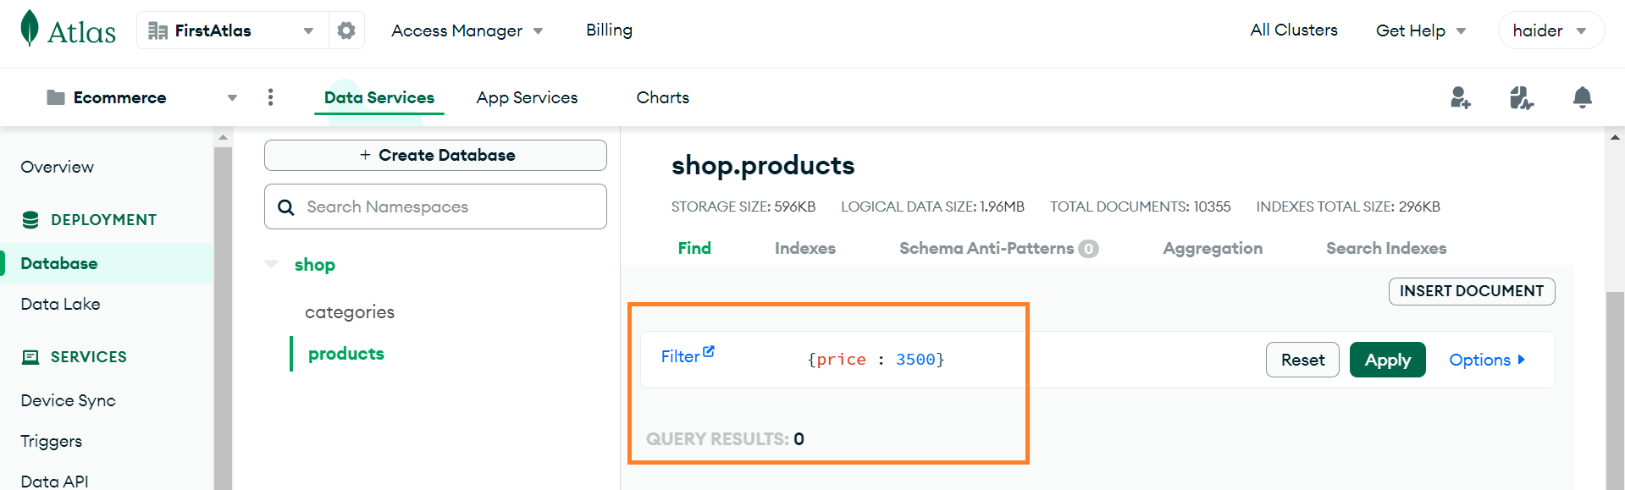

Now we will connect mongodb with mongo driver i.e., nodejs, etc. ↓

Step-1 🡪 go to overview option and, after clicking on connect, select ‘Drivers’ ↓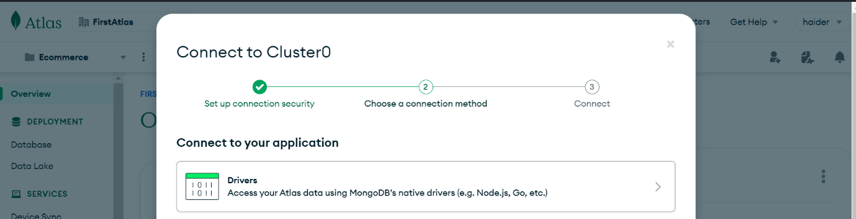

Step-2 🡪 copy the connection string and paste it in ‘url’ in your code and enter password ↓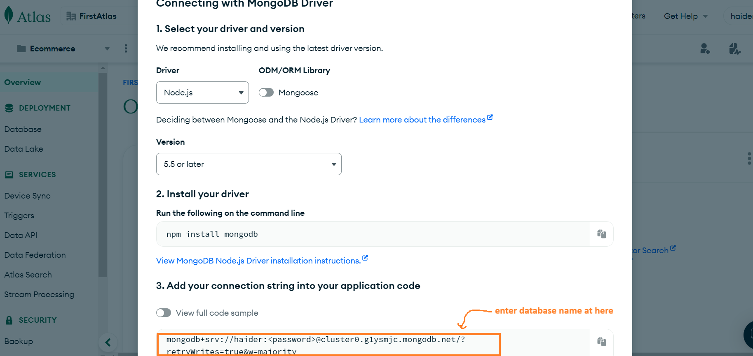

After running the file, we can see the data has been inserted n original database at atlas ↓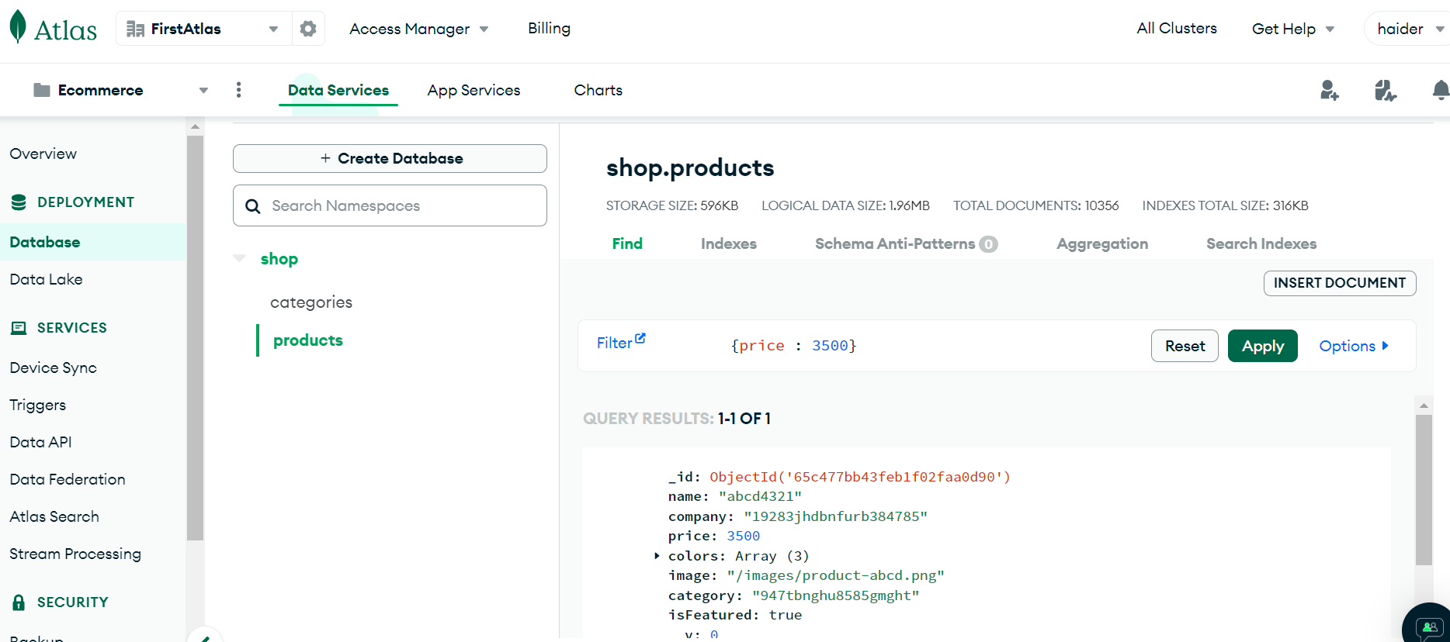

Code for updating data ↓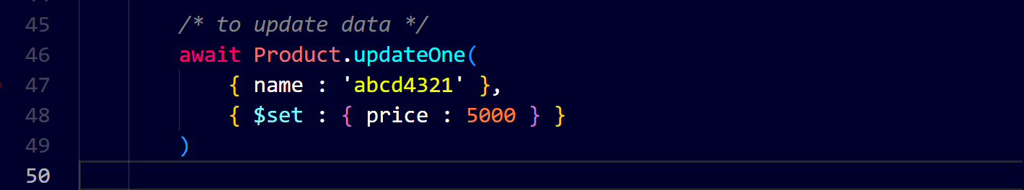we can see there is no data with price 3500 ↓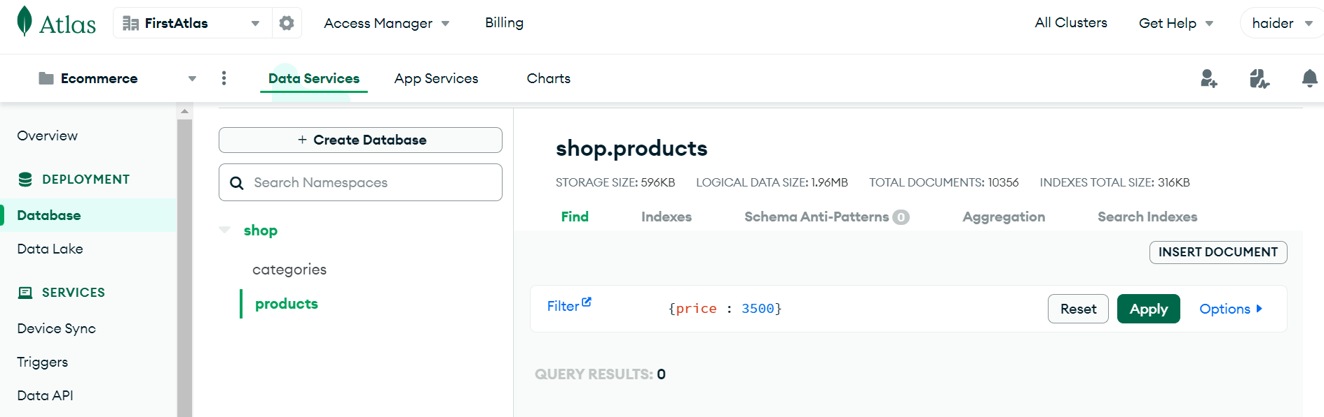

That data has been updated to this with price 5000 ↓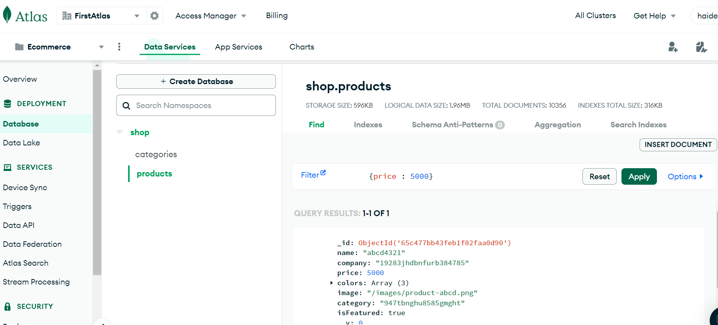

Code for delete data ↓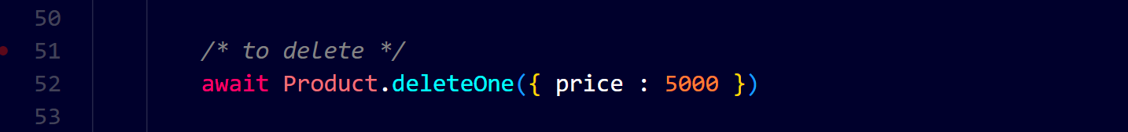

There is no data exists on atlas with price 5000 ↓