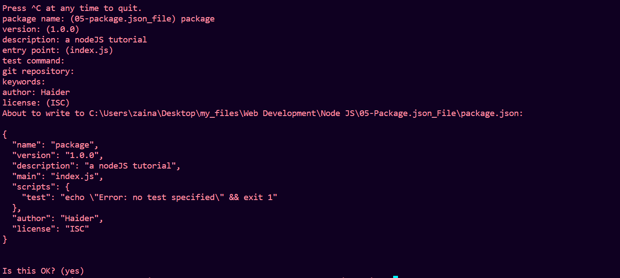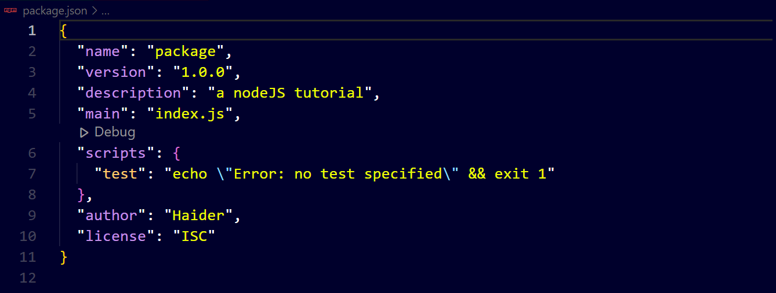

After installing a package “colors” ↓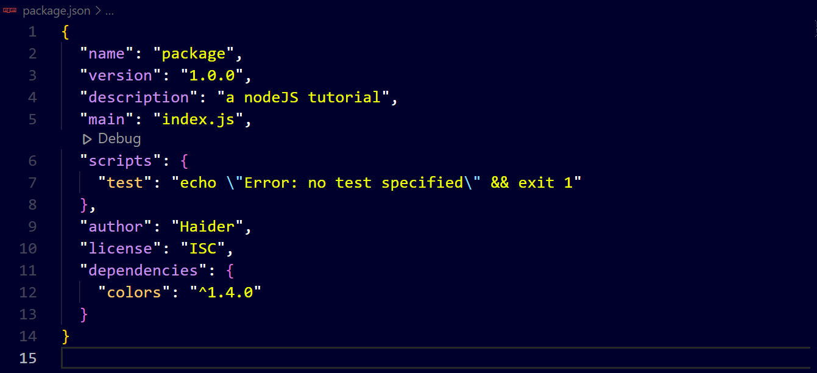

you can see an object named “dependencies” has been created that contains that package and its version

Similarly, after installing “simple-node-logger” package ↓

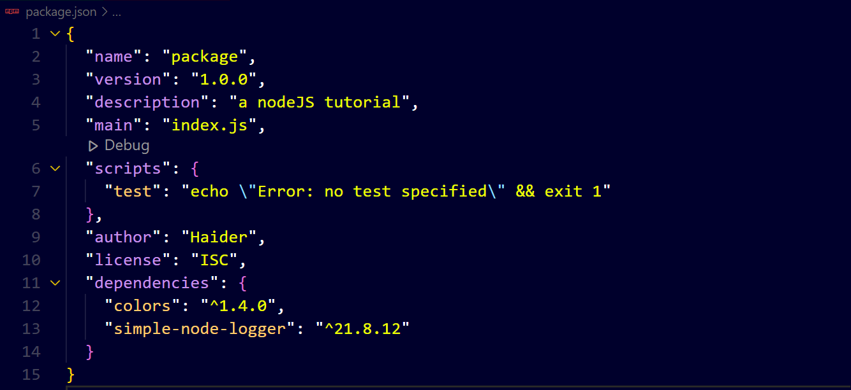

“node_modules” folder contains those packages ↓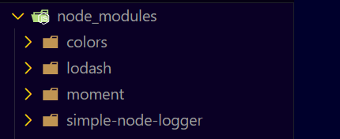

You can delete “node_modules” and run “npm i ” to get again. All packages mentioned in “dependencies” in “package.json” file are installed.