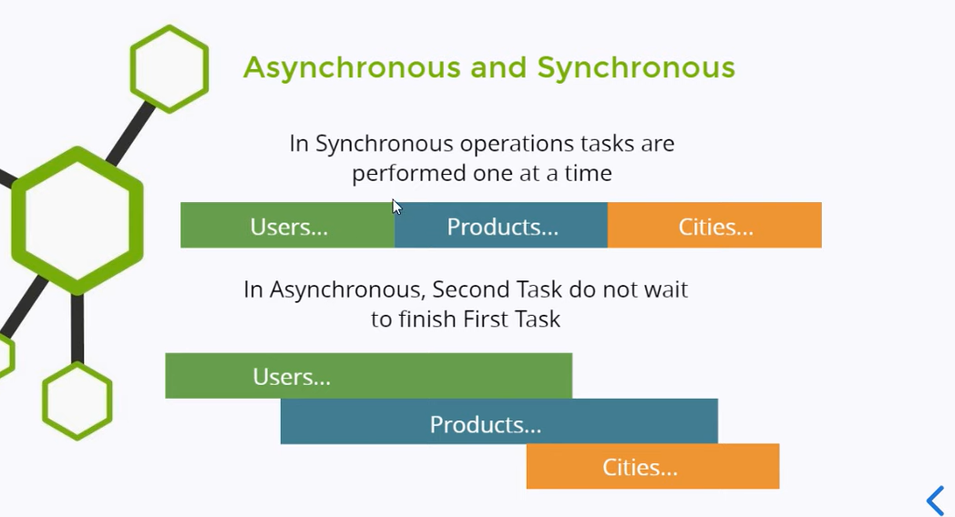

in this example, you can see that code has been executed line by line ↓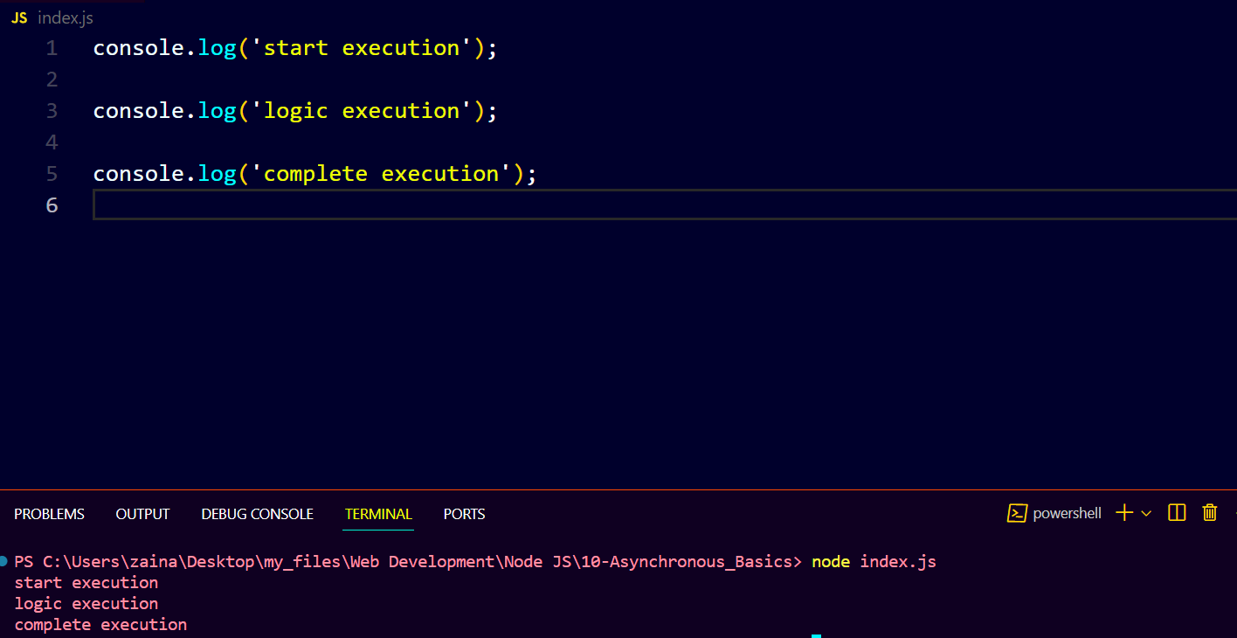

if 2nd line of code takes some time to execute then 3rd line will not wait it will be executed before execution of 2nd line and this is called “asynchronous behaviour”

For example ↓

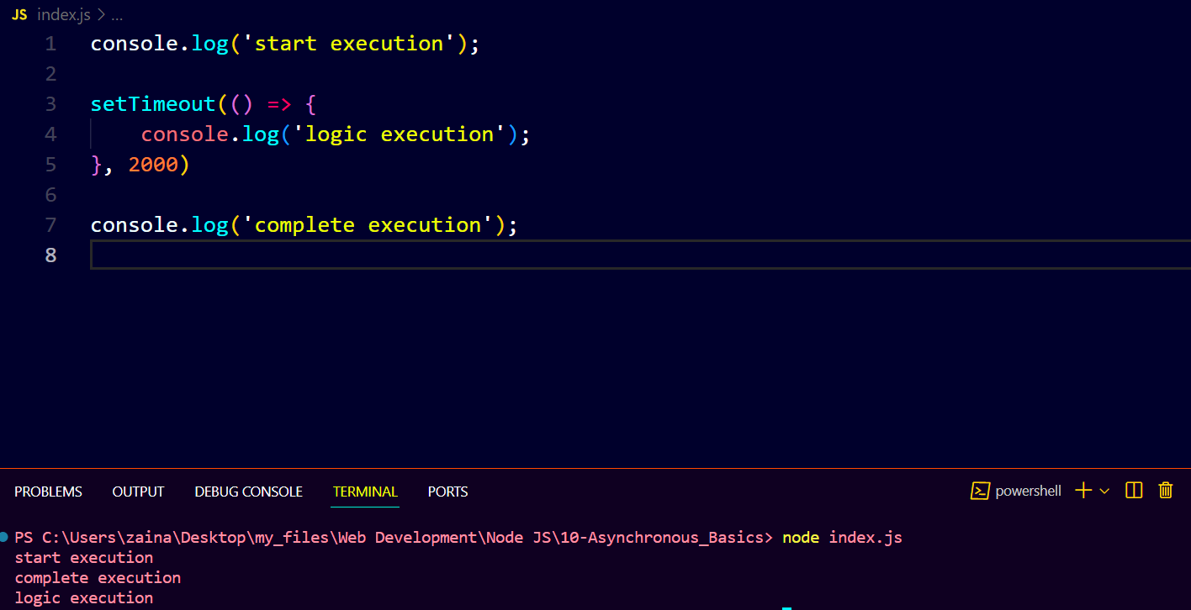in this, you can see 2nd log has been executed after execution of 3rd log because 2nd log had 2 seconds to execute.

There is a drawback, in the following example, you can see the result is 30, but it should be 110 because we have updated ‘b’ as 100 ↓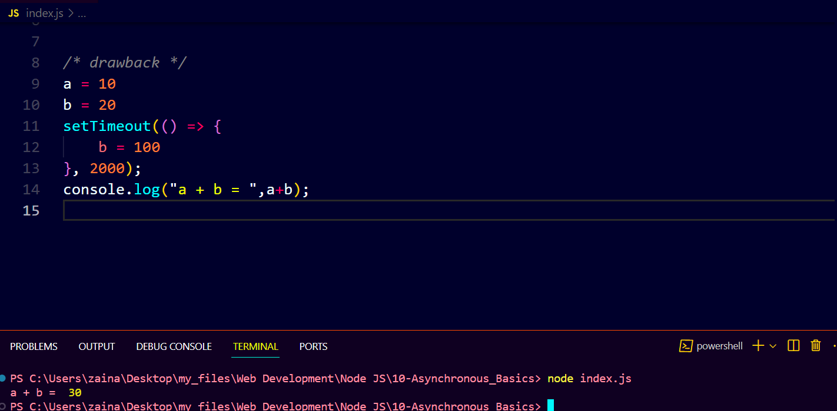

To resolve this problem, we use concept of promises ↓

