Step-1 🡪 run the command 🡪 npm i mongodb

Step-2 🡪 go to mongodb compass and connect with local host

Step-3 🡪 connect like this ↓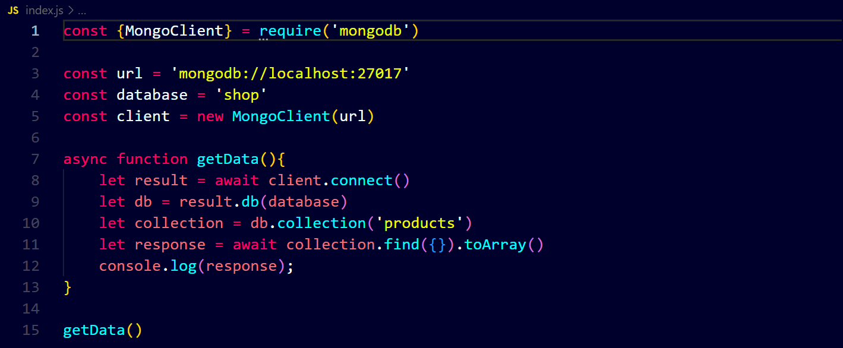

output ↓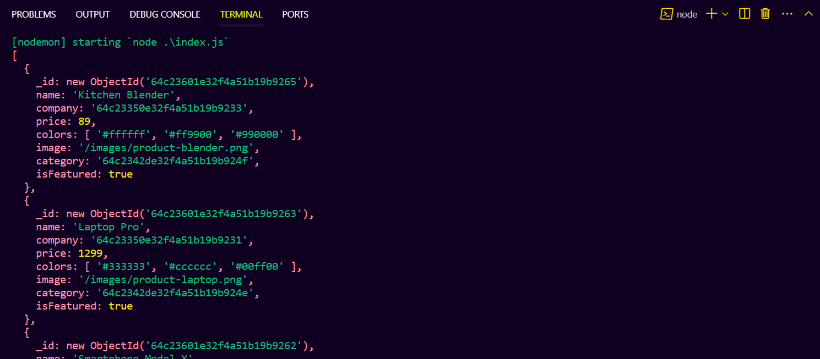

we create a separate file for database connection code and we will create a modern way to read data ↓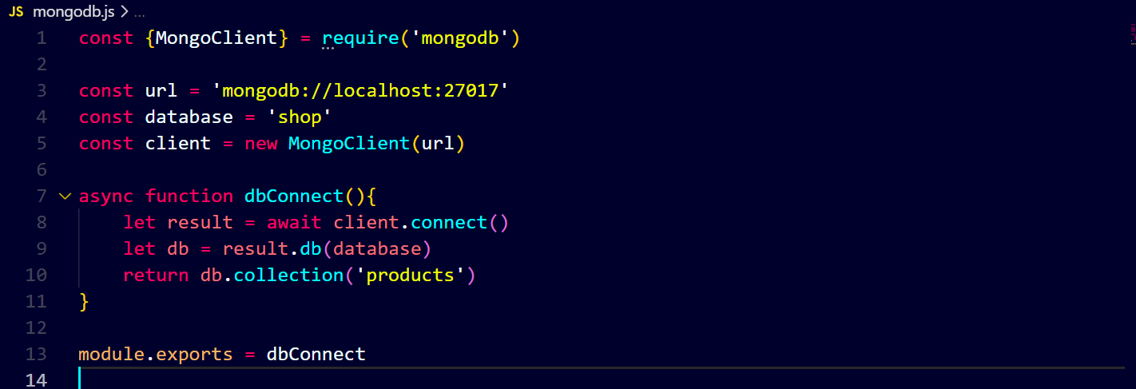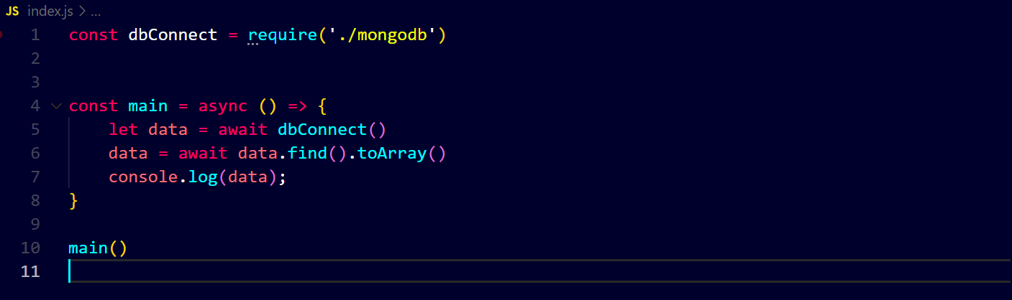

output ↓