In previous lecture, we have seen reading data from mongodb, therefore, we have changed the file name from ‘index.js’ to ‘reading.js’.

In this lecture, we will see inserting data in mogodb.

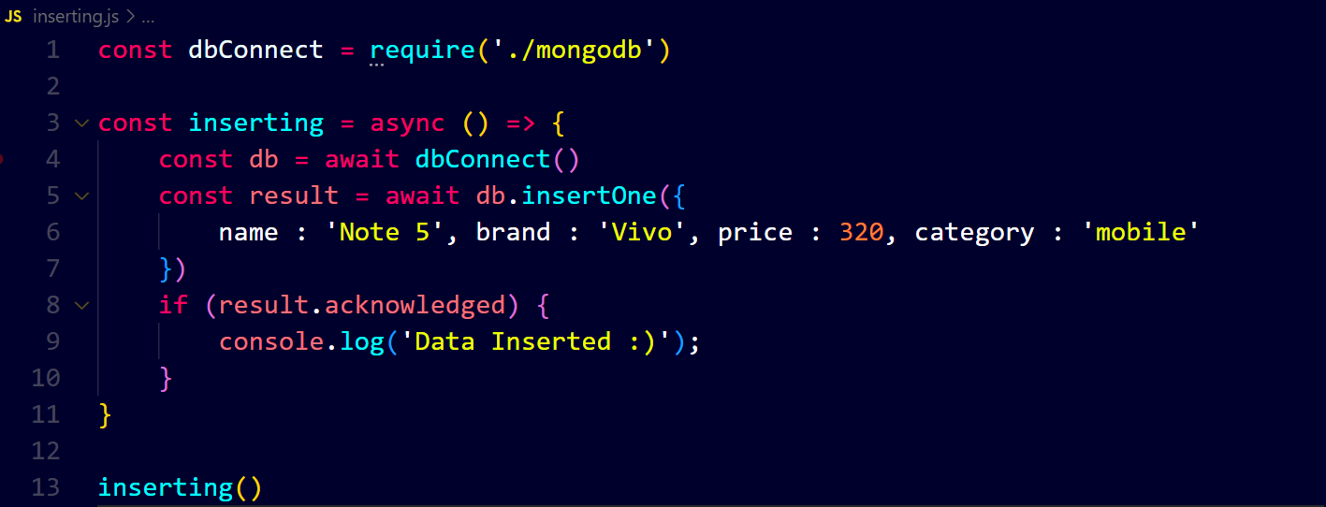

Output ↓

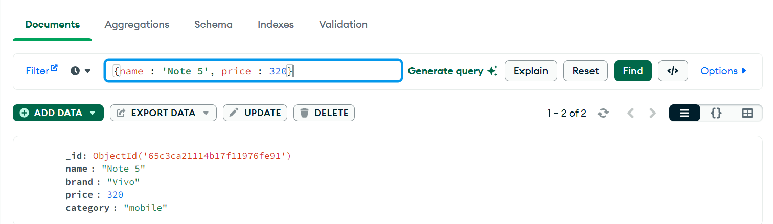

If we want to insert many documents then we use ‘insertMany’ and we use array of objects 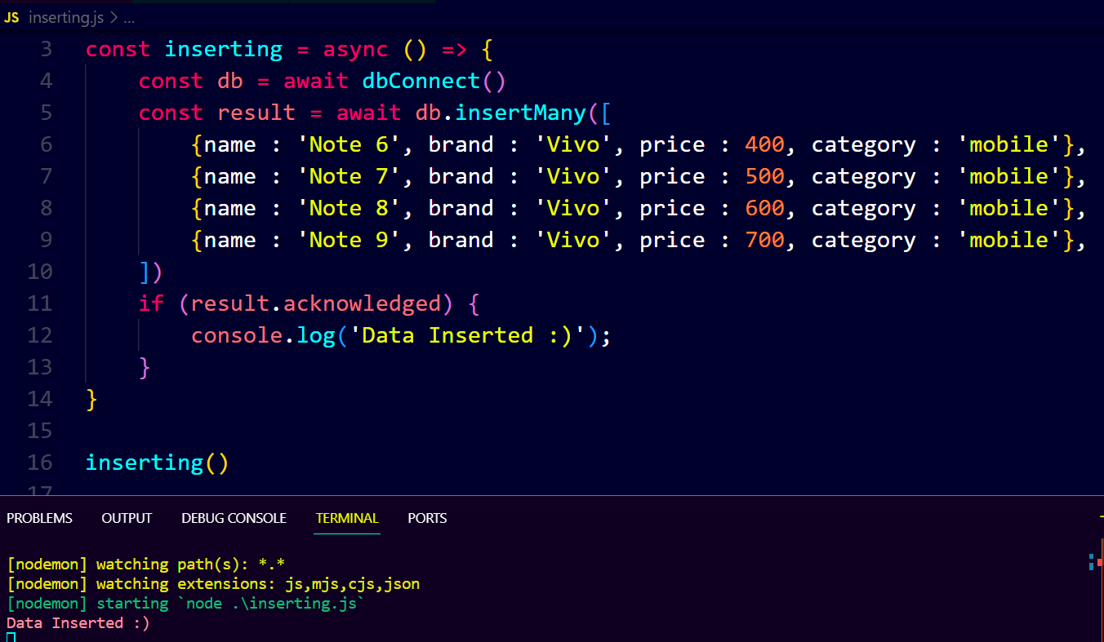

Output ↓