Before deleting ↓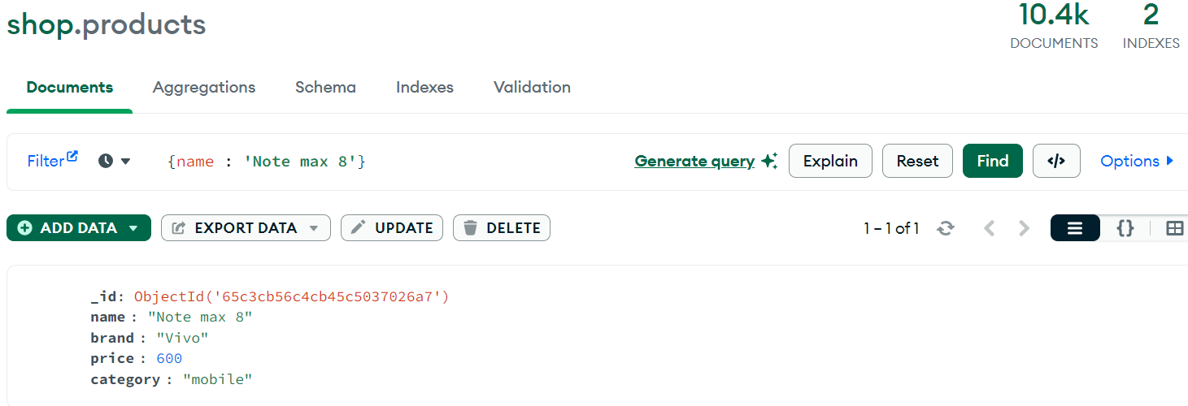Deleting ↓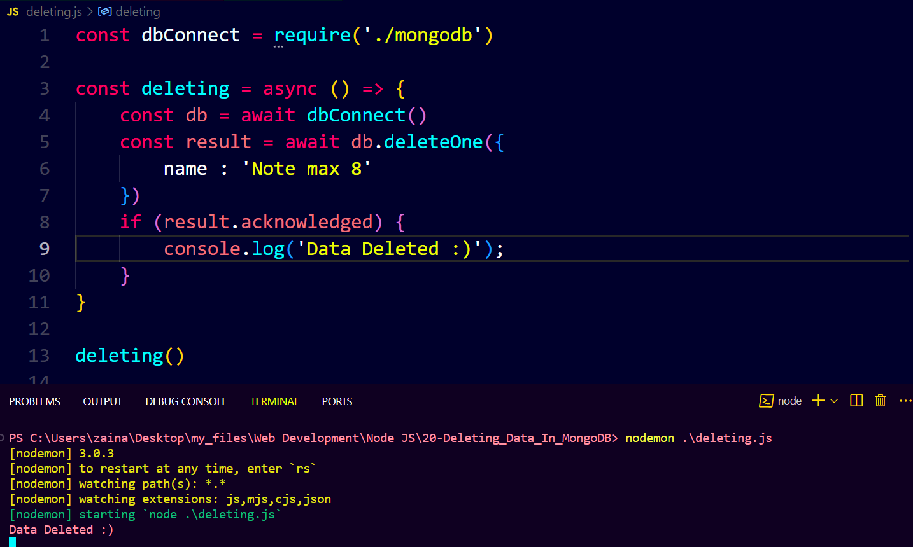After deleting ↓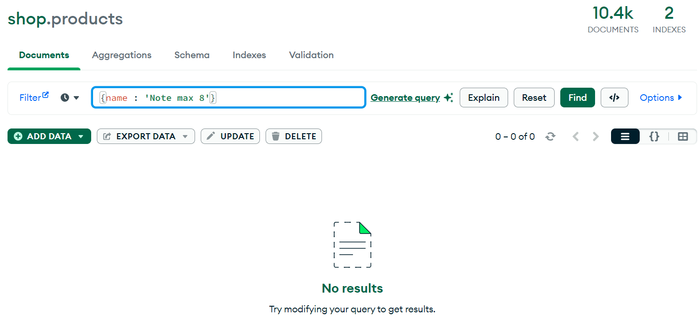

If we want to delete multiple documents then we use ‘deleteMany’.