In POST method, we insert data in database.

We will insert using postman app, so follow the following steps

Step-1 🡪 select POST method

Step-2 🡪 and go to ‘body’ and select ‘raw’ option with JSON

Step-3 🡪 enter document and click the send button

Then we can see the inserted data on cmd.

Code ↓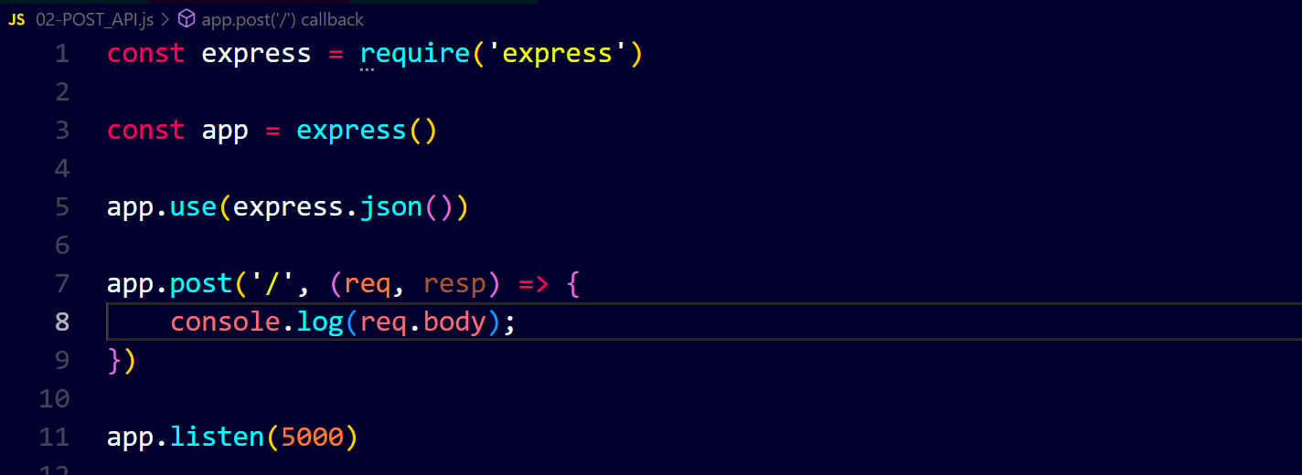Inserting data ↓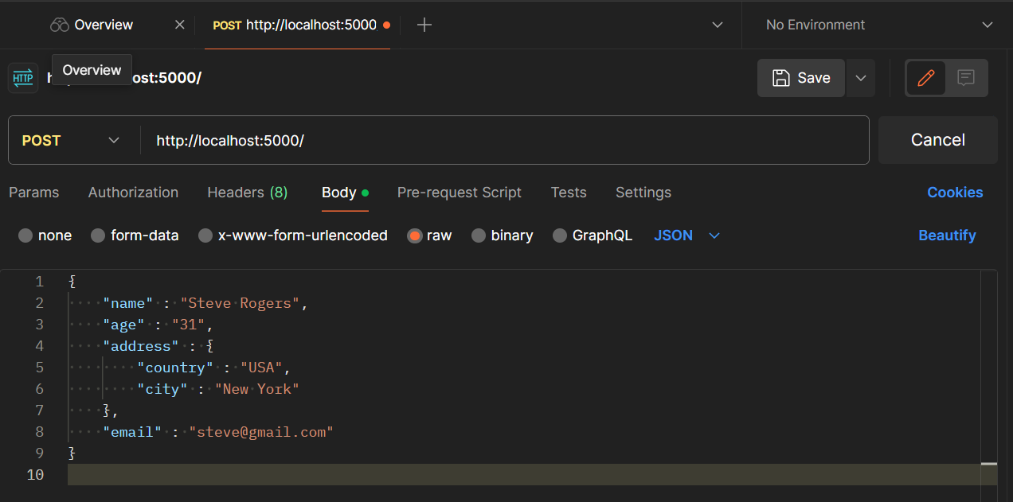Output on cmd ↓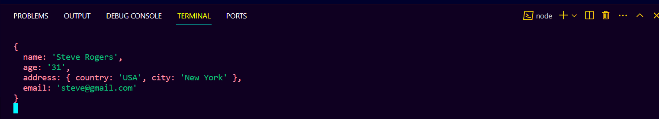

Now we will store data in mongodb. Code ↓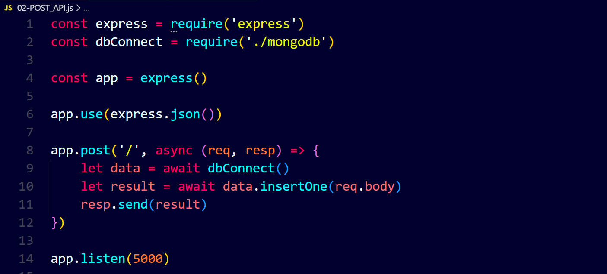Inserting data ↓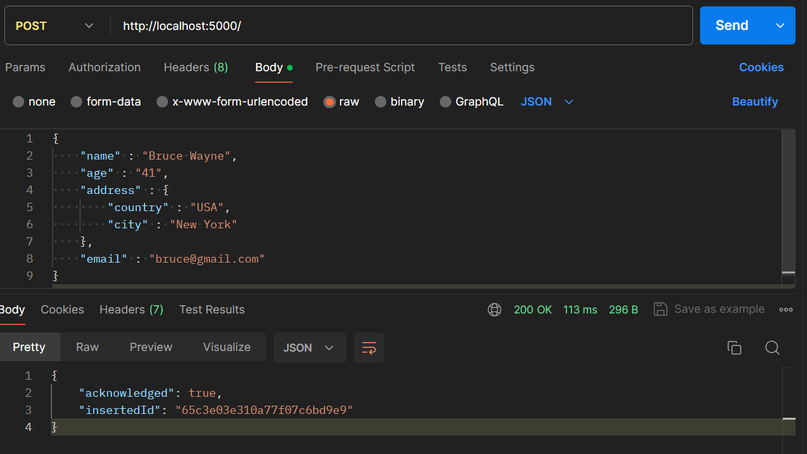In collection ‘learning’ ↓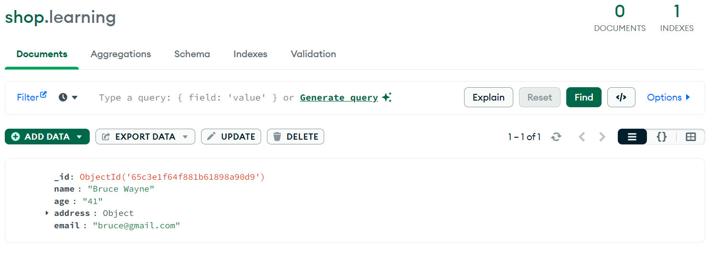

Another example ↓