In mongoose, we can create schema that provides features related to sql database, i.e., we can create fixed no. of fields for each document of a collection and we can specify datatype for each field.

To install mongoose 🡪 npm i mongoose

Schema validate the structure of documents.

Model uses schema to connect mogodb and nodejs.

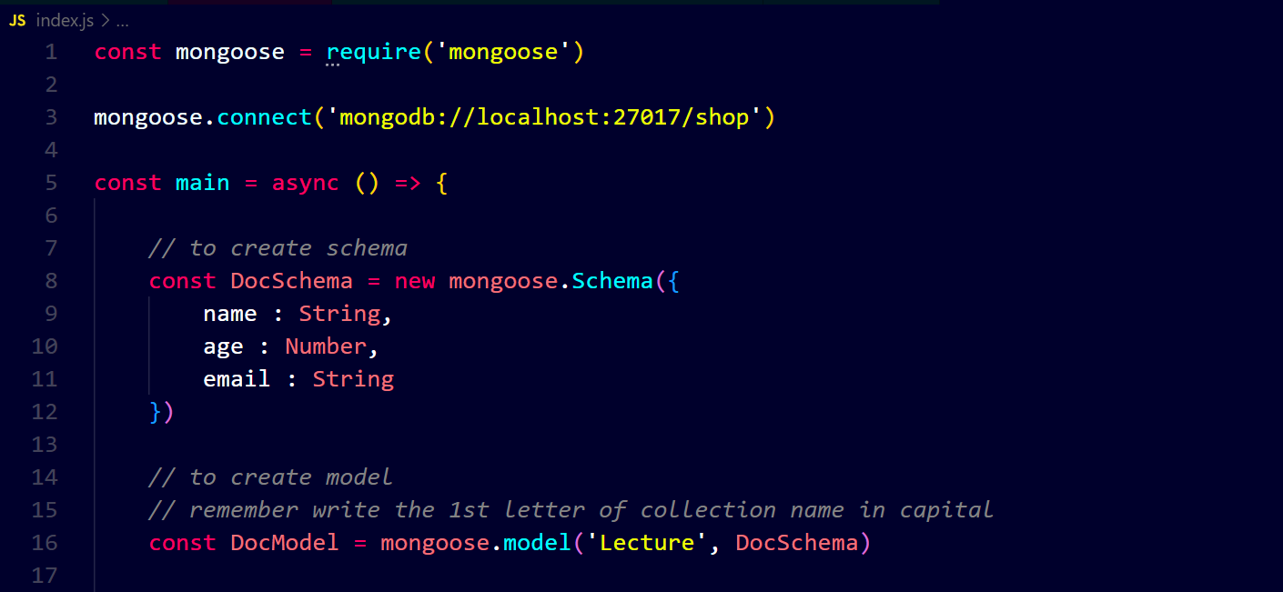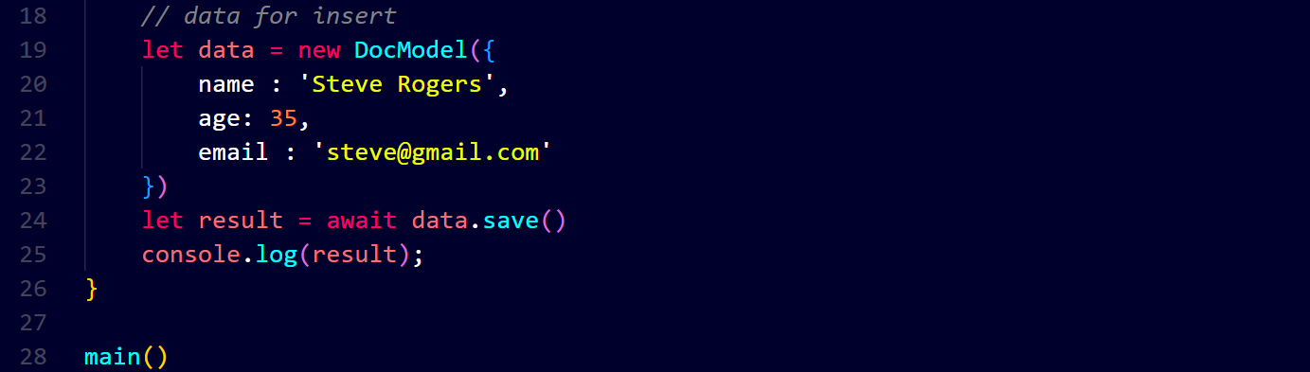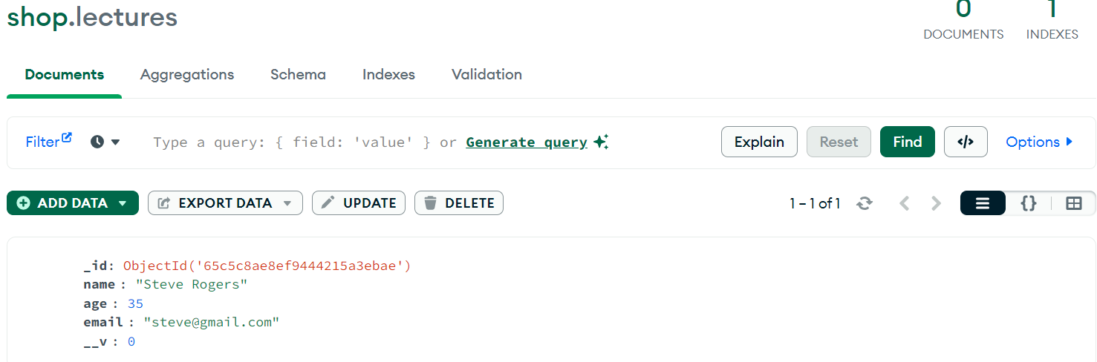

If we put more fields, it will not accept ↓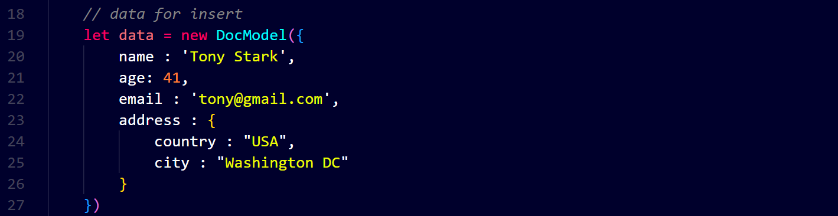You can see that we have added ‘address’ field but it did not accept.