For upload file, we use ‘multer’ package. To install it 🡪 npm i multer

Now we will upload a pdf file ↓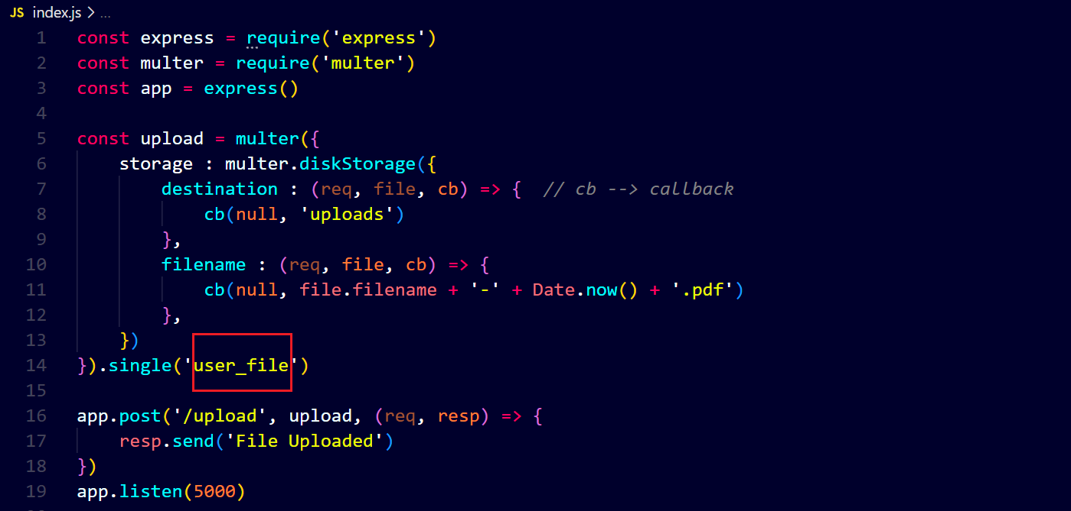

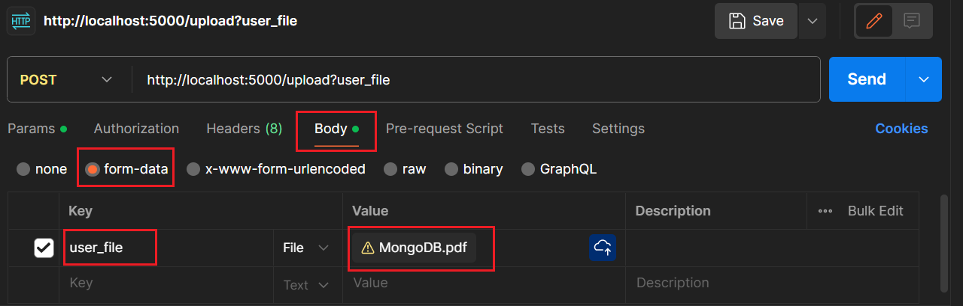

To upload multiple files, use array() instead of single().