Step-1 🡪 install mysql in your system

Step-2 🡪 run the command 🡪 npm i mysql

Step-3 🡪 now we will connect ↓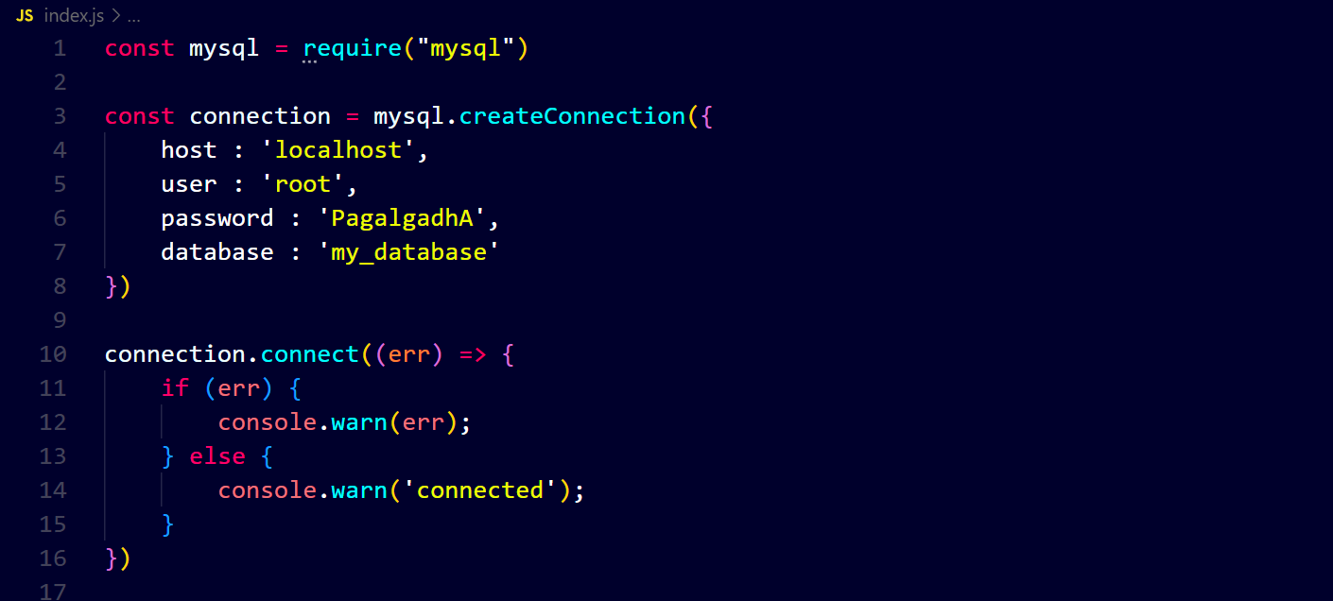

If there is any error in connection then got to workbench and run this command ↓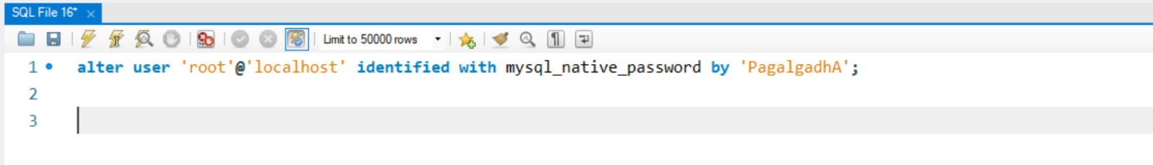

Then you will connect with mysql ↓