**Wrong way to create a copy ↓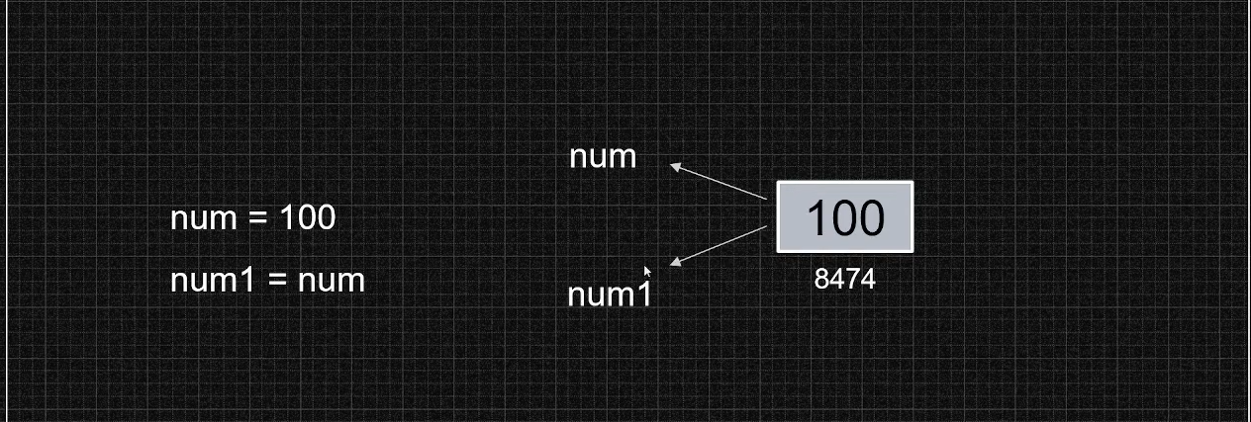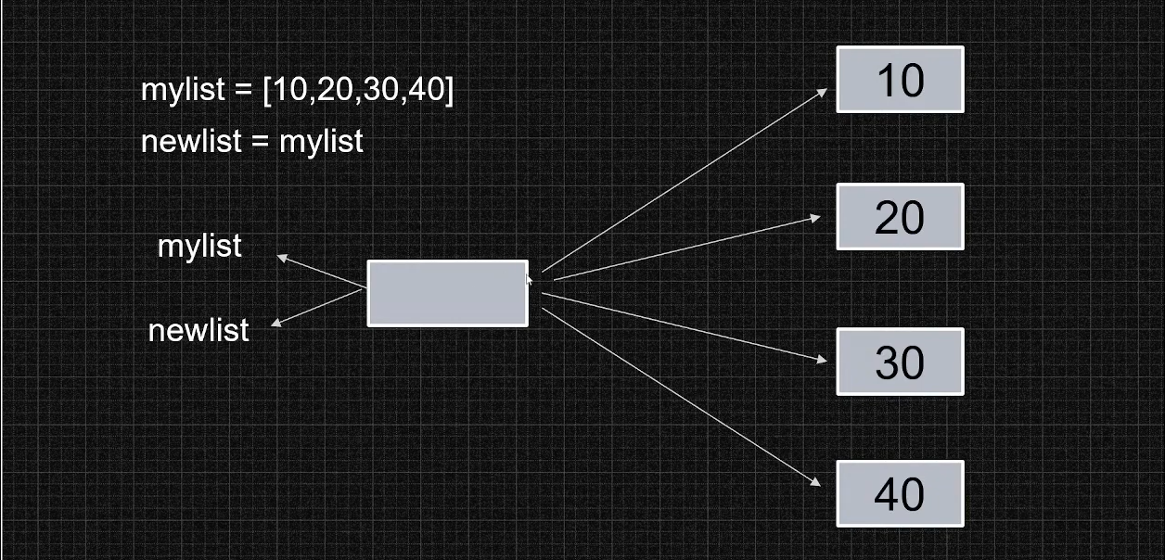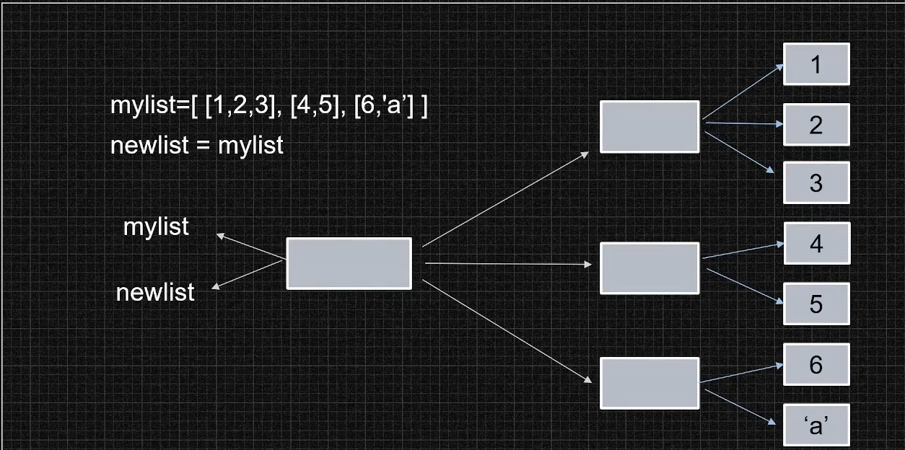new memory does not allocated therefore whenever you will change in a variable, it will be changed in second automatically.**

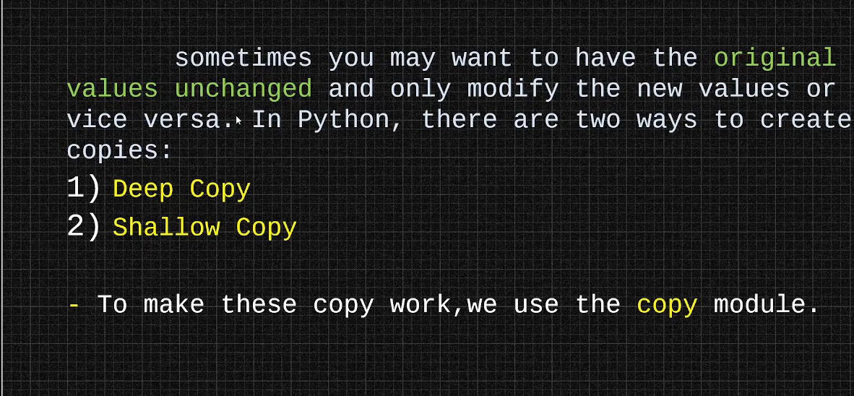

**In shallow copy, new memory is allocated to the copied-variable only and it references to the same memory addresses values as the original-variable do and therefore, on changing in anyone, the change will happen in second.**

**In deep copy, new memory is allocated to the copied-variable and it references to the different memory addresses for the values and therefore, on changing in anyone, the change will not happen in second.**