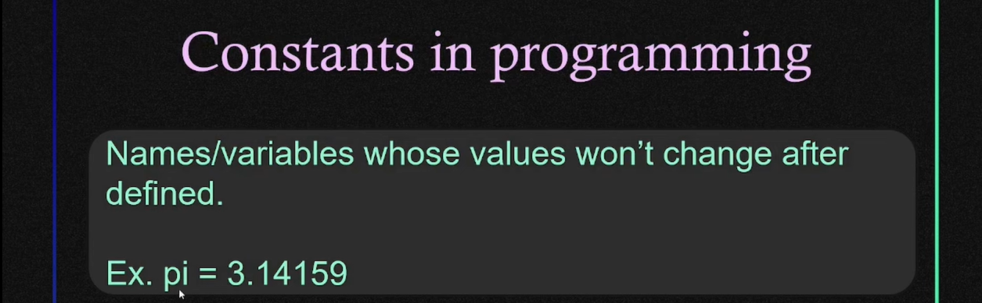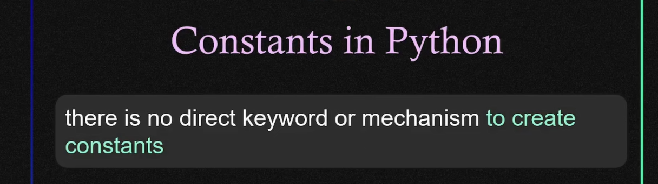

**There are 4 ways to tell yourself and others that it is a constant ↓**