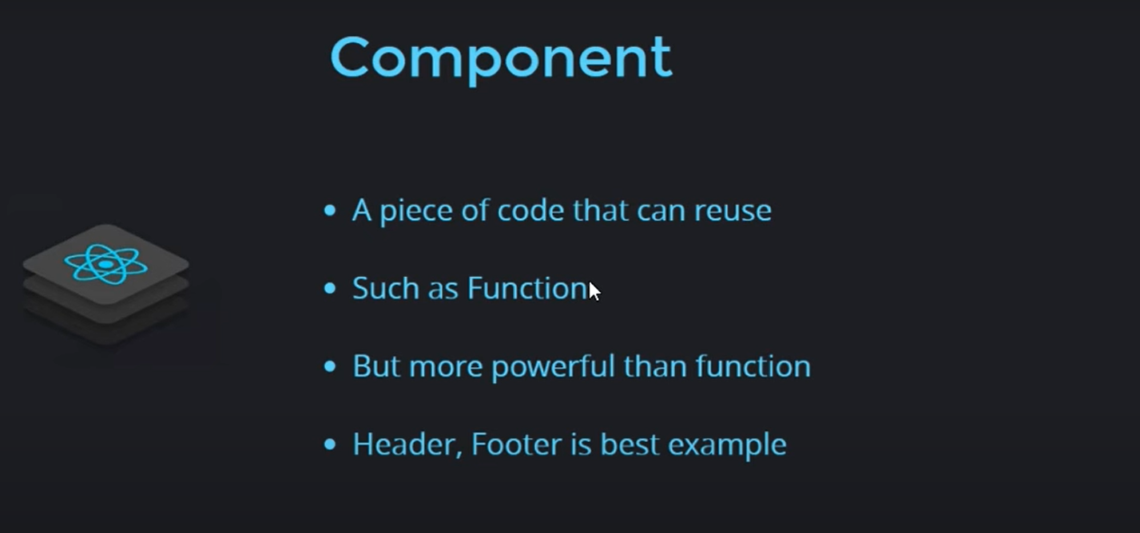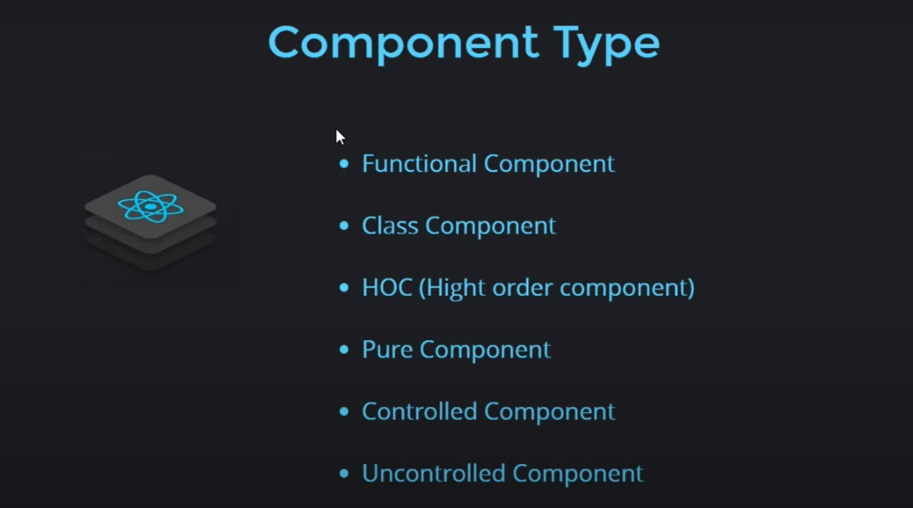

**Function component:**

**Step-1: create a function let us say its name is ‘Func1’**

**Step-2: write a statement in the file having the ‘Func1’, the statement is 🡪 export default func1**

**Step-3: import it in ‘App.js’ or ‘index.js’ file with the statement 🡪 import Func1 from ‘/.file_name’**

**Step-4: add a tag in that file <Func1 />**

**e.g., ↓**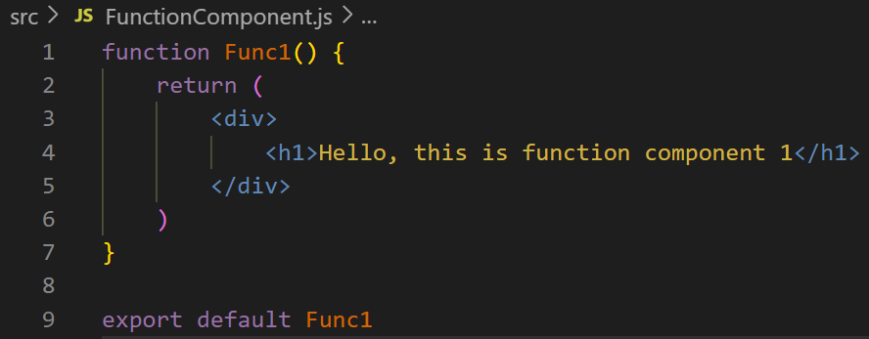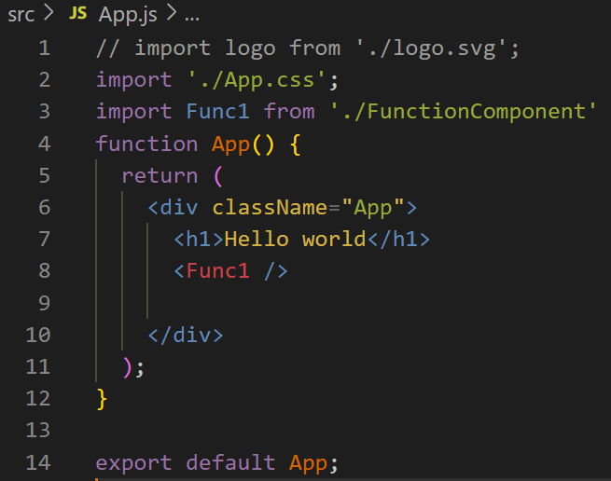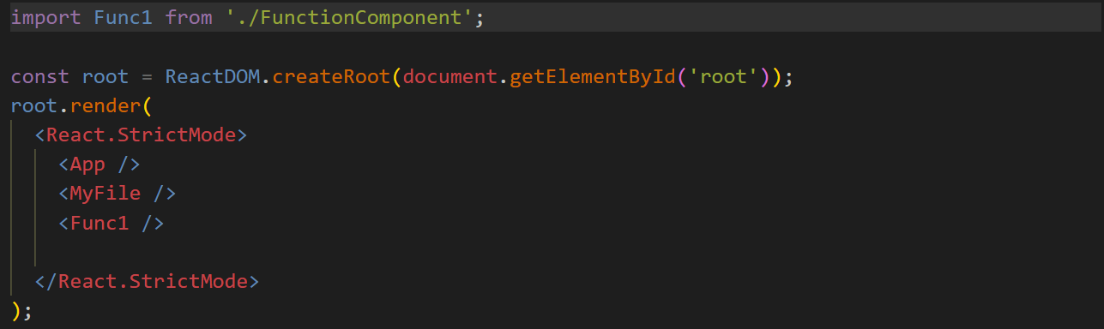

**we can export a function like this ↓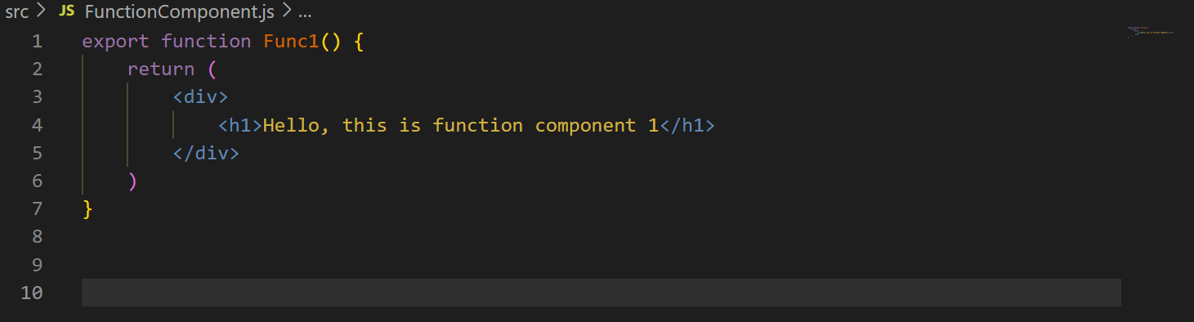then we have to add {} like this {Func1} ↓**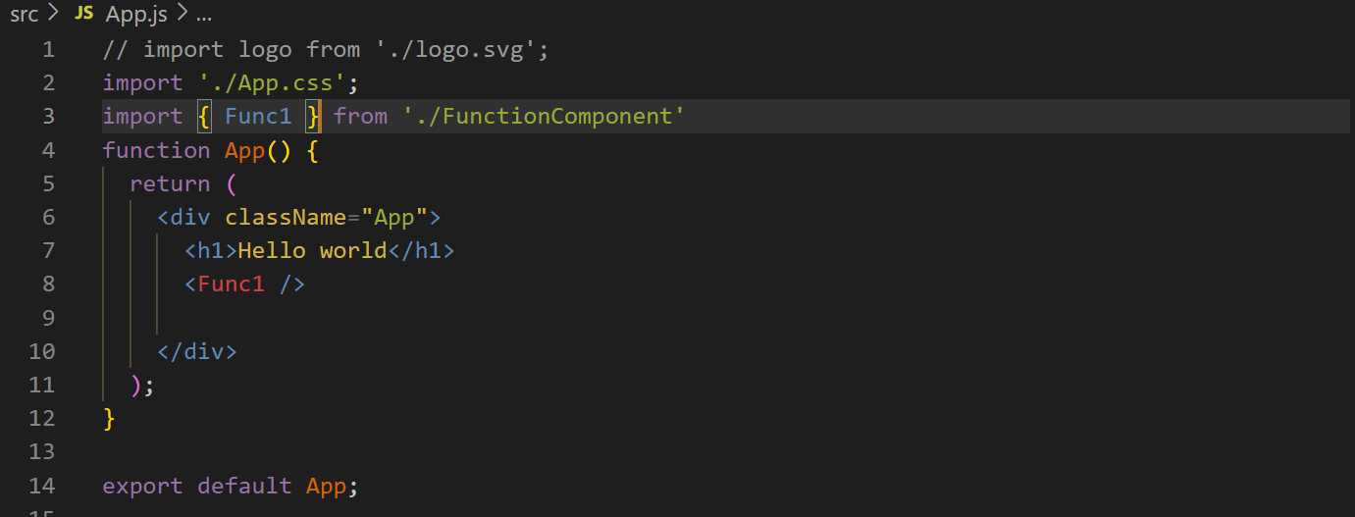

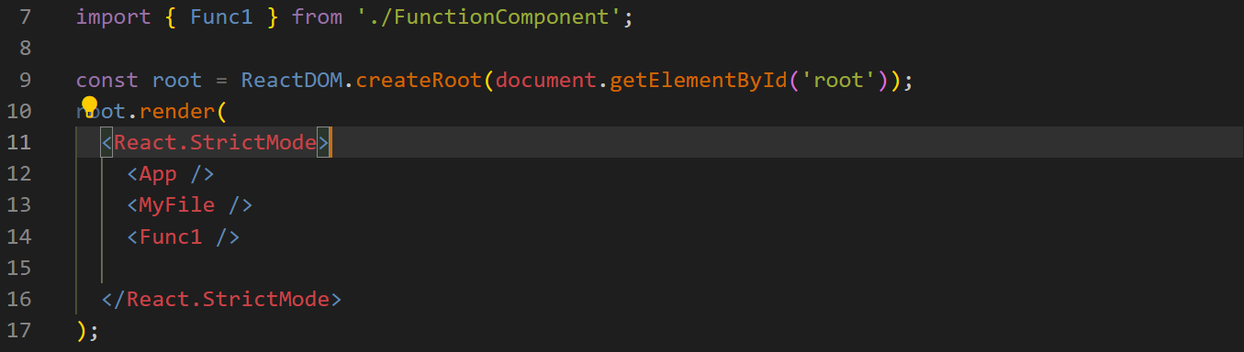

**Class component:**

**Step-1: create a class component, we have created it with name ‘Cl1’ in the file ‘Class Component.js’↓**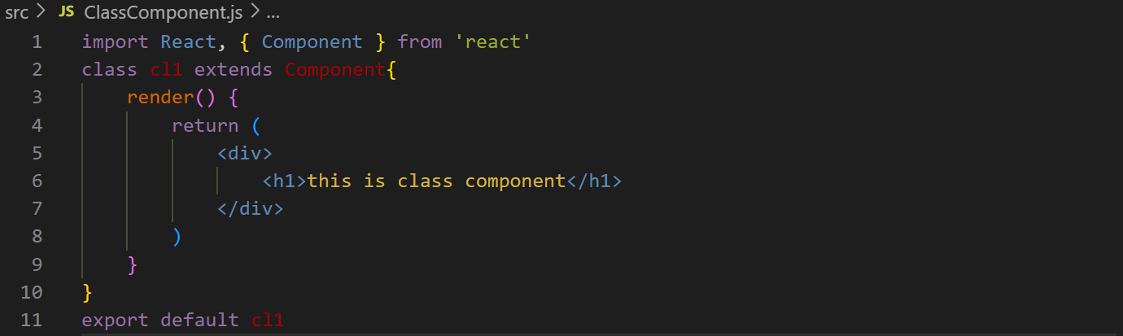

**Step-2: import it↓**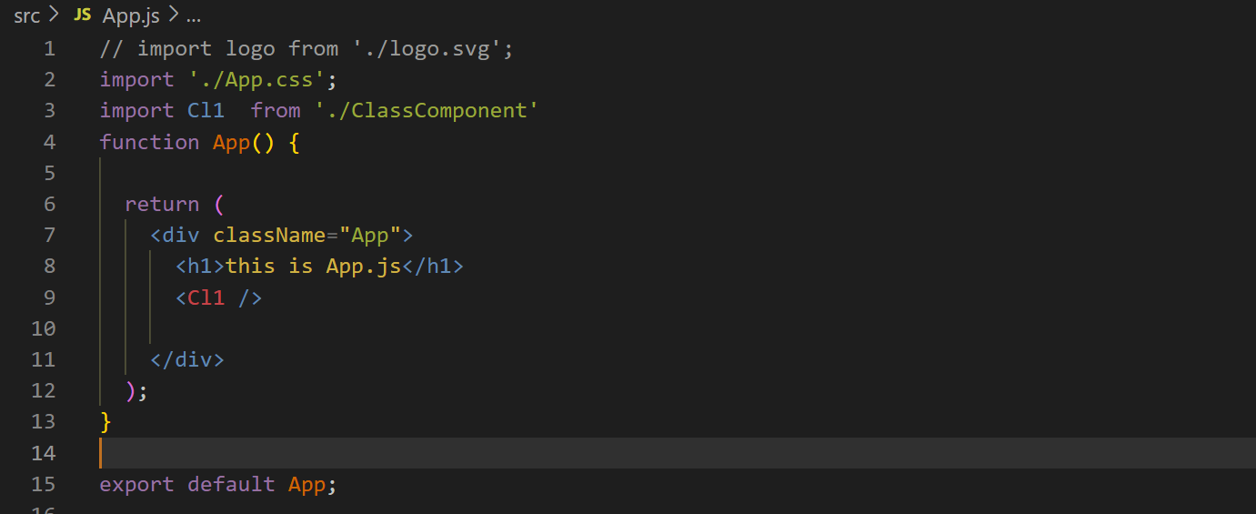

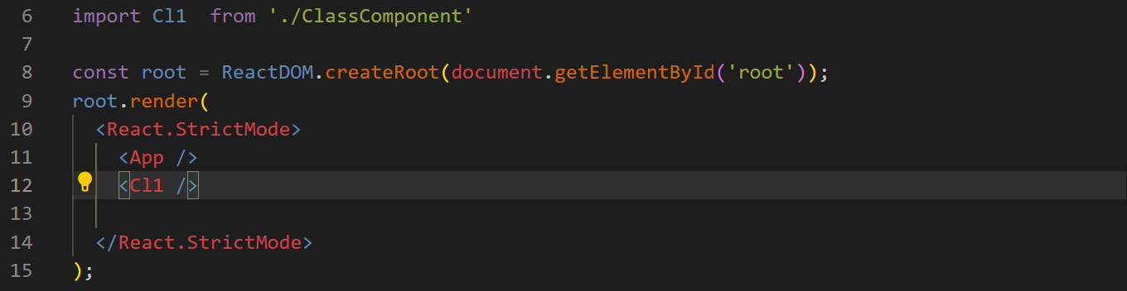

**We can create component in App.js file directly ↓**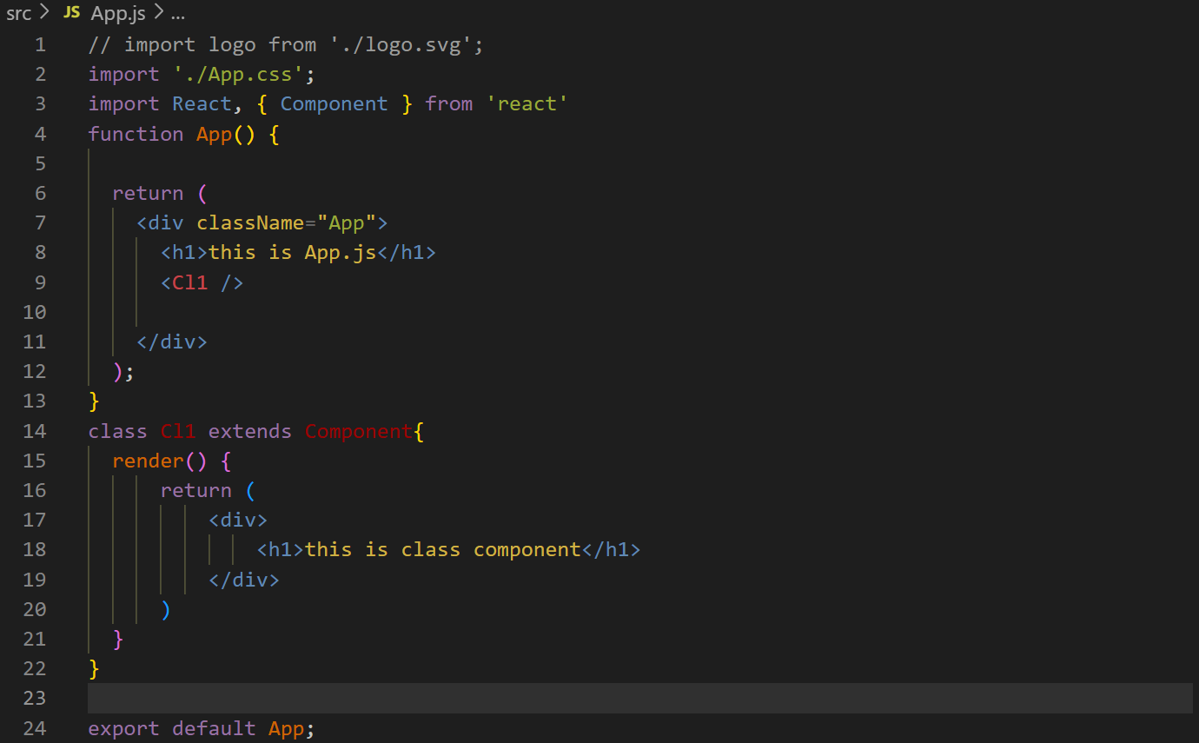

**We can create function component inside of a function component ↓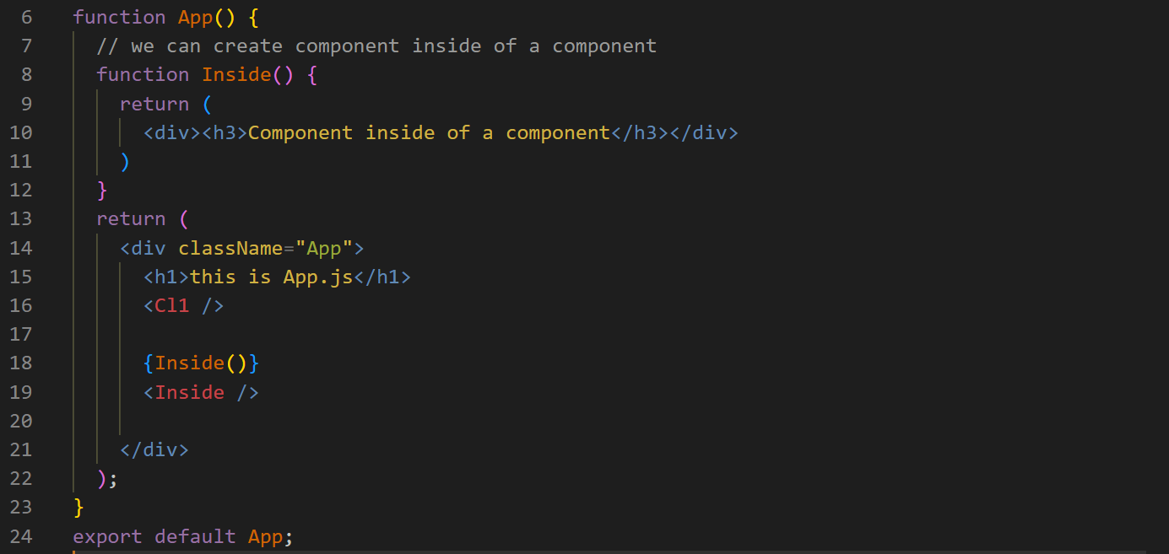we can use the function with two methods as you can see ↓**