**JSX stands for “Javascript Xml”**

**It gives the power to write the HTML directly in a file with extension ‘.js’**

**e.g., we will create a file with ‘.js’ and create a function component and we will use HTML tags ↓**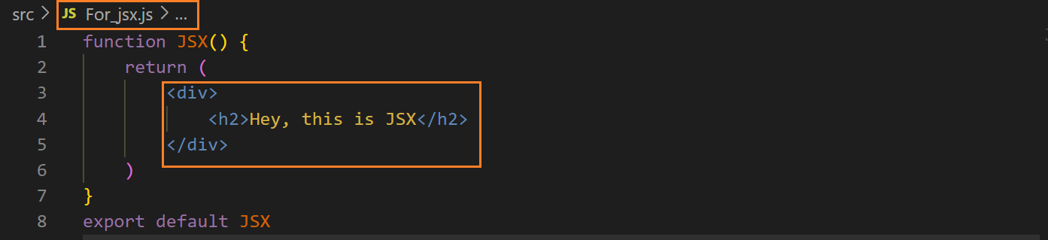

**we have to import it in App.js file to show its content on webpage and use a tag <function_name /> ↓**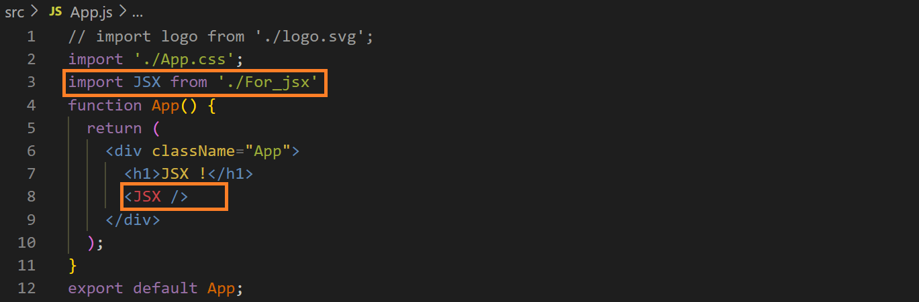

**output ↓**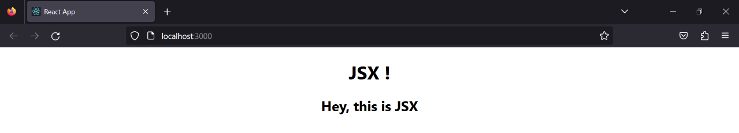

**similarly we can use JS ↓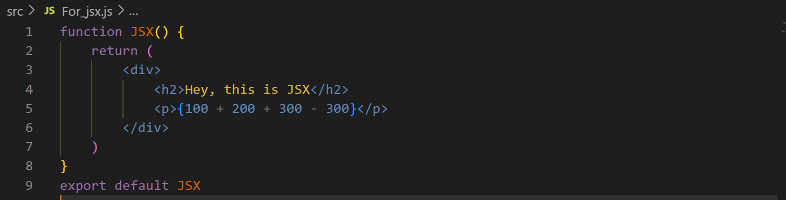output ↓**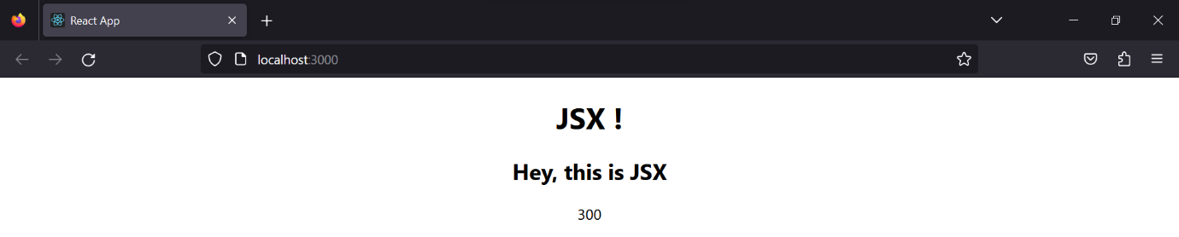

**if e don’t use JSX then we can have to face some complexity, e.g., ↓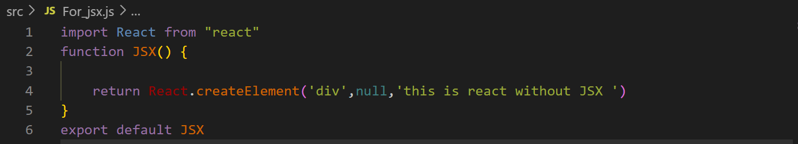output ↓**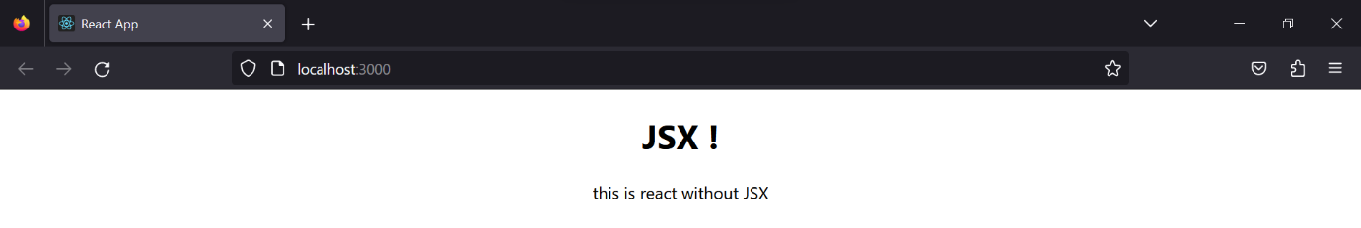

**the function ‘createElement()’ takes three parameters first is the element name like dive div, he, etc., second is the class of the element and third is the content of the element**

**to create its child we have to call this function again in it, e.g., ↓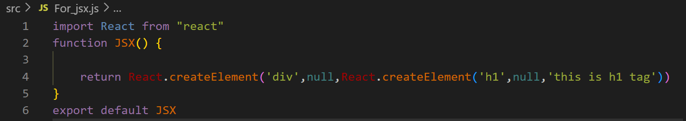output ↓**