**Hide & Show**

**We can hide and show ↓**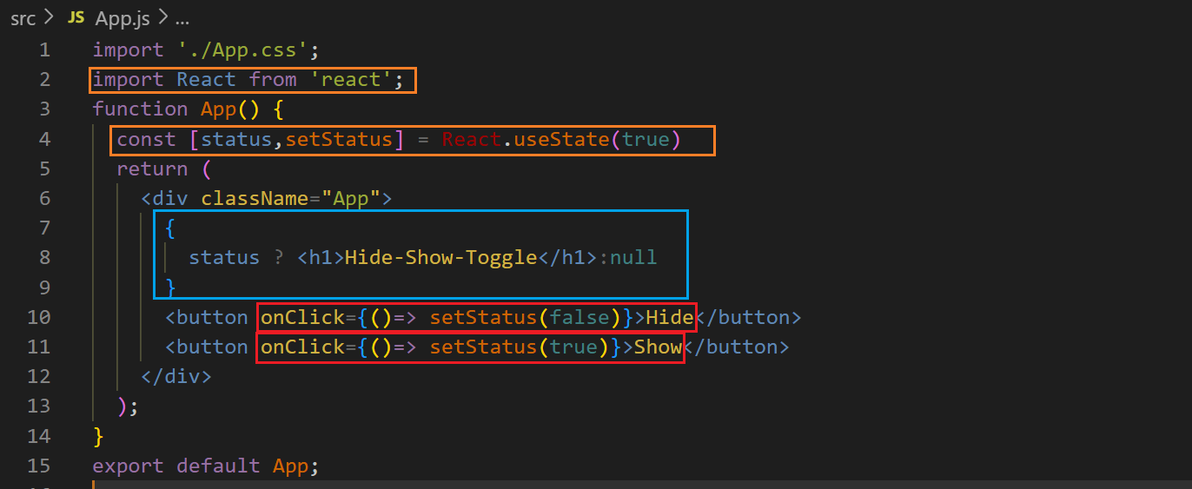

**Before clicking on hide button ↓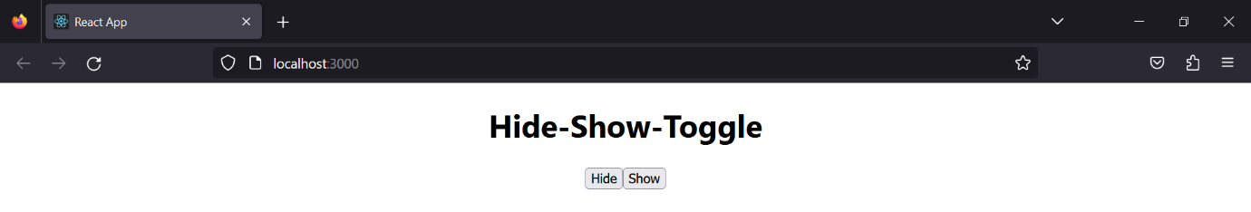 After clicking on hide button↓ After clicking on show button ↓**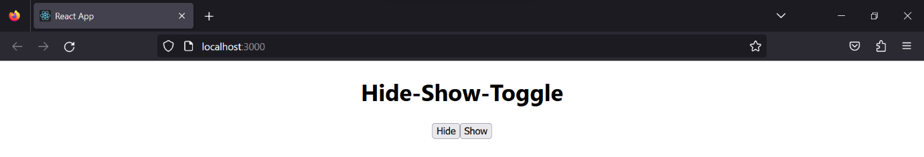

**Toggle ↓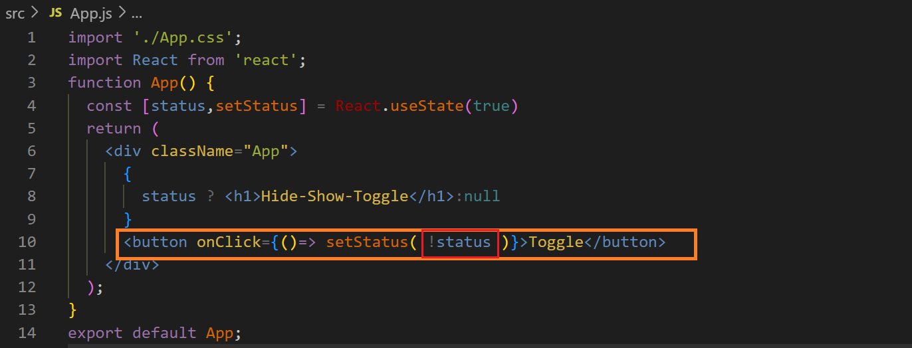before clicking on toggle button ↓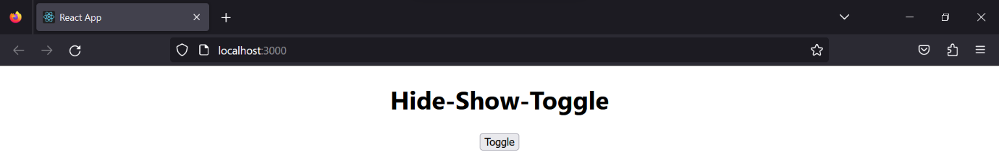 After clicking on toggle button ↓Again clicking on toggle button ↓**