**we will create a form and try to get data from user and store it ↓**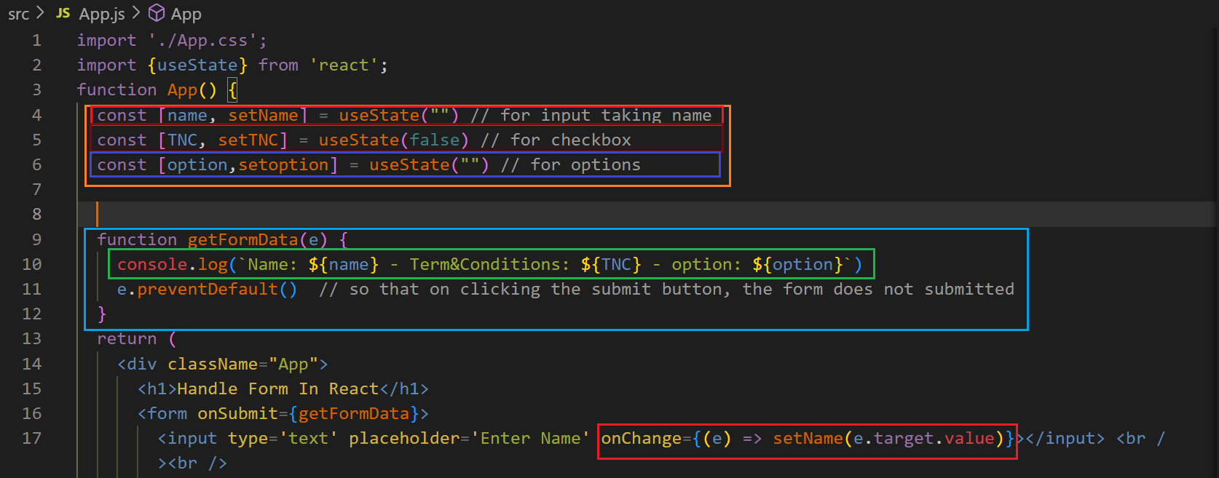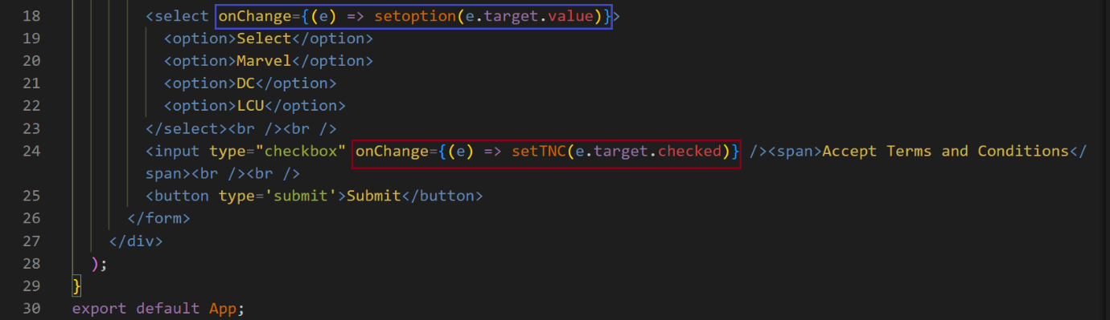

**output ↓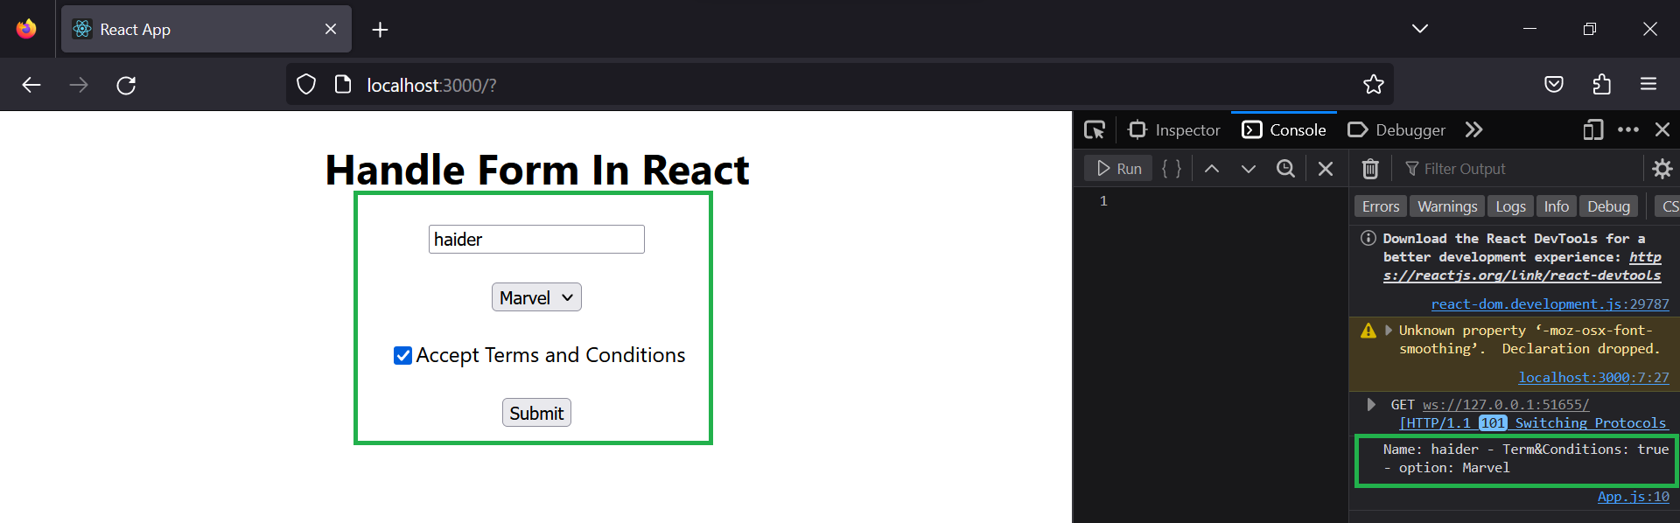similarly ↓**

